#### 5.3.2 Stress–Strain Relation

In this section, we recall the classical theory of elasticity [395]. The solid is treated as a continuous medium (piecewise homogeneous) and the displacement vector is thus a continuous function

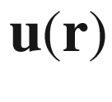

of the spatial coordinates. When the spatial variation

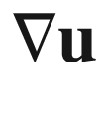

of

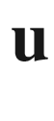

is small, the elastic energy can be written as

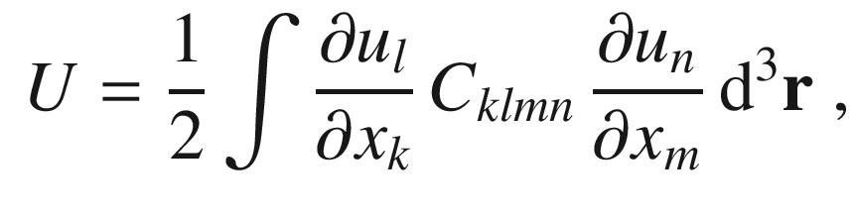

(5.50)

where

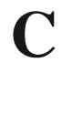

is the (macroscopic) tensor of the elastic coefficients. 21 components of this tensor can be independent. For crystals with cubic symmetry the number of independent constants is reduced to 3. An exchange

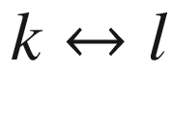

and

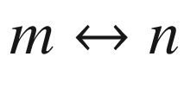

does not matter, only six indices have to be considered (*xx*, *yy*, *zz*, *yz*, *xz*, and *xy*). The strain components

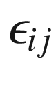

are symmetrized according to

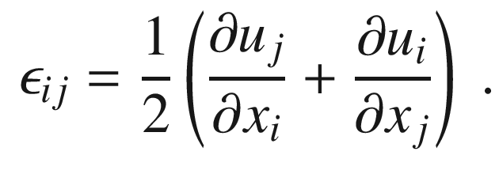

(5.51)

The strains

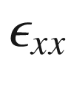

are along the main axes of the crystal as visualized in Fig. [5.29](#u116076_4_En_5_Chapter-Fig29).

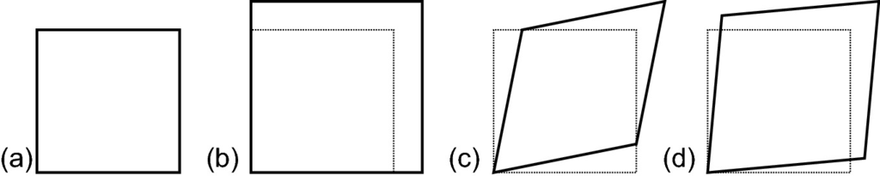

Fig. 5.29

Deformation of a square (**a**). (**b**) Pure hydrostatic deformation (

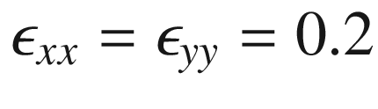

,

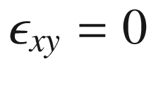

), (**c**) pure shear deformation (

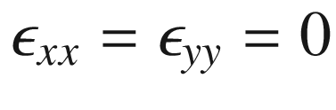

,

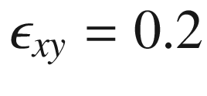

), and (**d**) mixed deformation (

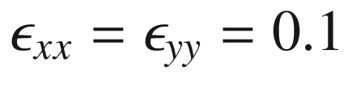

,

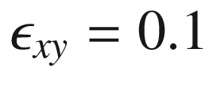

)

The stresses[8](#u116076_4_En_5_Chapter-Fn8)

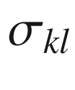

are then given by

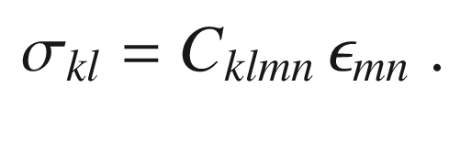

(5.52)

The inverse relation is mediated by the stiffness tensor

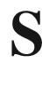

.

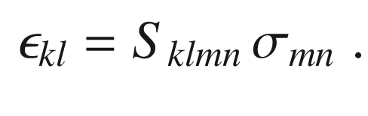

(5.53)

Typically, the strain components

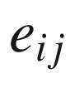

or

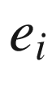

are used with the convention

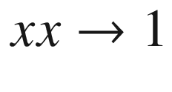

,

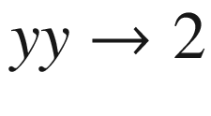

,

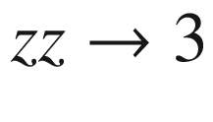

,

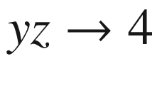

,

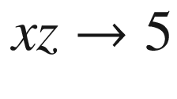

, and

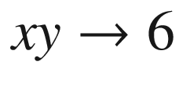

(Voigt notation):

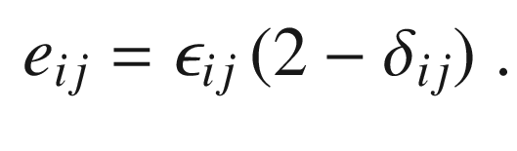

(5.54)

Then,

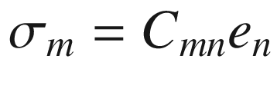

with the

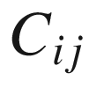

being the elastic constants. The *x*, *y*, and *z* directions are the main axes of the cubic solid, i.e. the

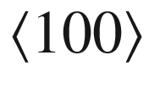

directions.Table 5.2

Elastic constants (in GPa) of some cubic semiconductors at room temperature.

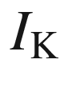

refers to the Keating criterion ([5.59](#u116076_4_En_5_Chapter-Equ63))

| Material | $$C_{11}$$ | $$C_{12}$$ | $$C_{44}$$ | $$I_{\mathrm {K}}$$ |
| --- | --- | --- | --- | --- |
| C | 1076.4 | 125.2 | 577.4 | 1.005 |
| Si | 165.8 | 63.9 | 79.6 | 1.004 |
| Ge | 128.5 | 48.3 | 66.8 | 1.08 |
| BN | 820 | 190 | 480 | 1.11 |
| GaAs | 119 | 53.4 | 59.6 | 1.12 |
| InAs | 83.3 | 45.3 | 39.6 | 1.22 |
| AlAs | 120.5 | 46.86 | 59.4 | 1.03 |
| ZnS | 104.6 | 65.3 | 46.3 | 1.33 |
| MgO | 297 | 156 | 95.3 | 0.80 |

For *zincblende* material, the stress–strain relation reads[9](#u116076_4_En_5_Chapter-Fn9)

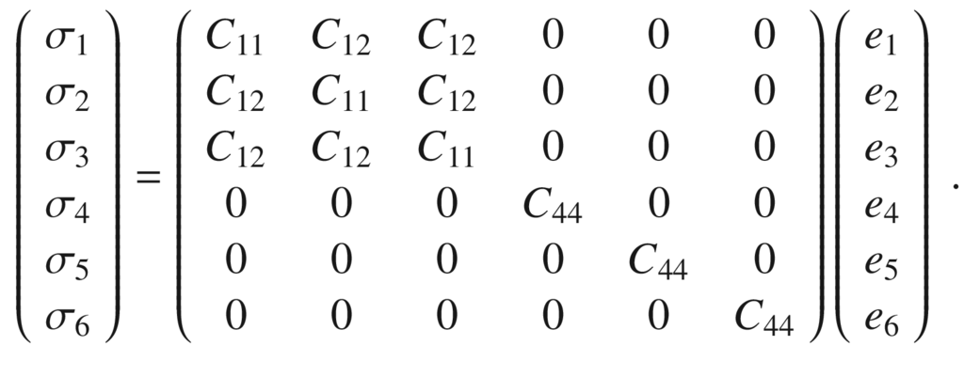

(5.55)

Values of the compliances for several semiconductors are given in Table [5.2](#u116076_4_En_5_Chapter-Tab2). The inverse relation is given by the matrix

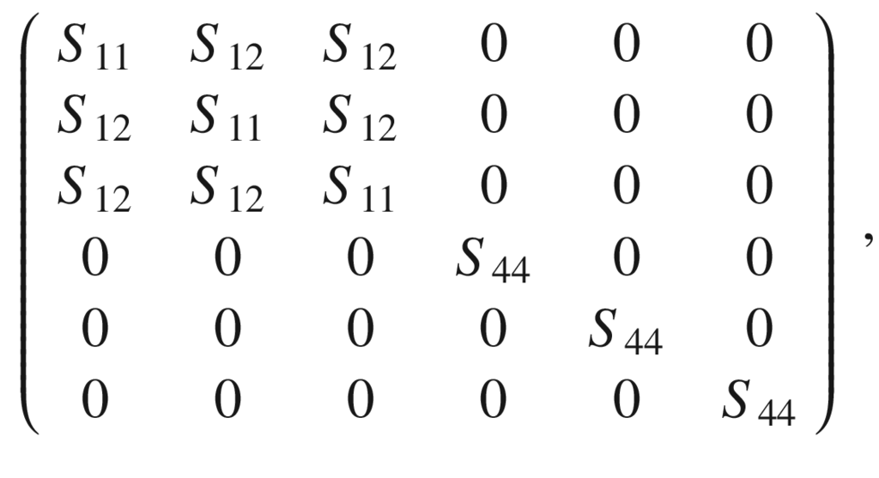

(5.56)

with the stiffness coefficients in this notation given by

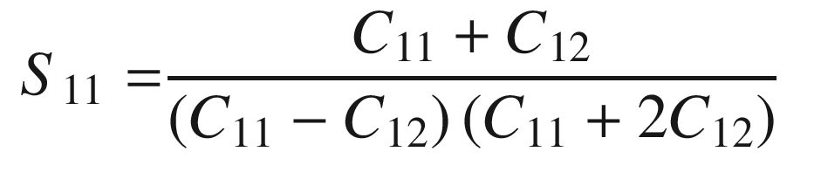

(5.57a)

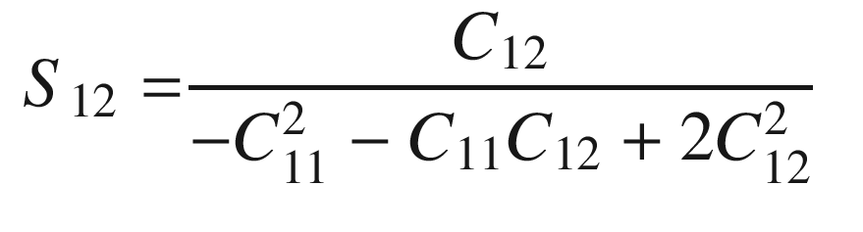

(5.57b)

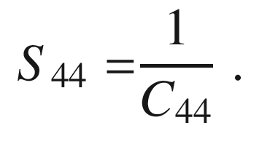

(5.57c)

We emphasize that in this convention (also called the *engineering* convention), e.g.

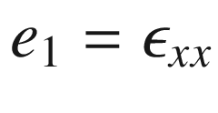

and

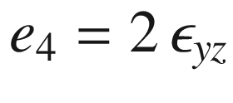

. There is also another convention (the *physical* convention) without this factor of two; in this case the matrix in ([5.55](#u116076_4_En_5_Chapter-Equ57)) contains the elements

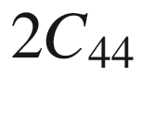

. We introduce

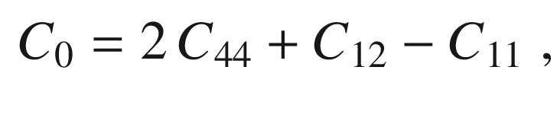

(5.58)

and note that

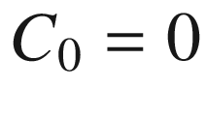

for an isotropic material. The relation

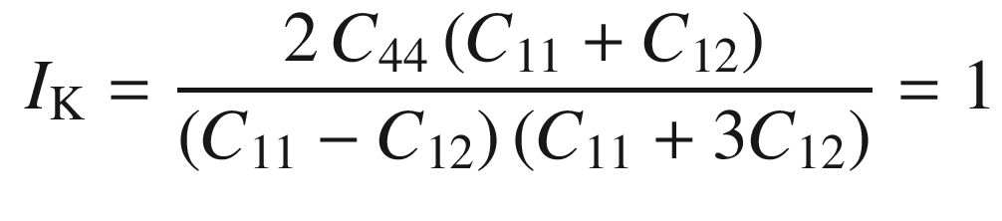

(5.59)

known as the Keating criterion [396, 397], stems from the consideration of bending and stretching of the tetrahedral bonds in the valence force field (VFF) model. It is closely fulfilled (Table [5.2](#u116076_4_En_5_Chapter-Tab2)) for many tetrahedrally bonded semiconductors, in particular for the covalent ones. For MgO, the Keating criterion is not fulfilled because it has (six-fold coordinated) rocksalt structure and is thus not tetrahedrally bonded.

The Young’s modulus *Y*,

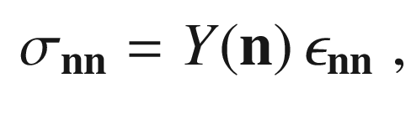

(5.60)

generally depends on the normal direction

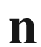

of a strain. It is equivalent to

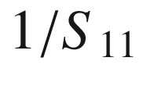

of ([5.57a](#u116076_4_En_5_Chapter-Equ59)).

For *isotropic* material *Y* and the Poisson ratio

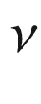

are related to the elastic constants of cubic material by

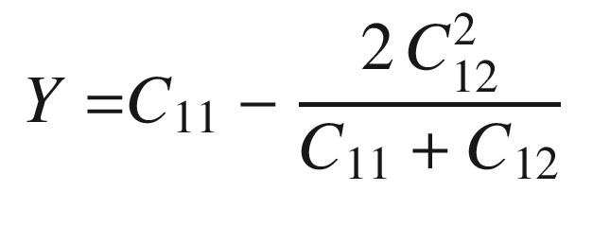

(5.61a)

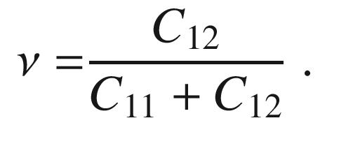

(5.61b)

For isotropic materials also Lamé’s constants

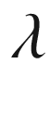

and

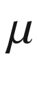

are used. They are given by[10](#u116076_4_En_5_Chapter-Fn10)

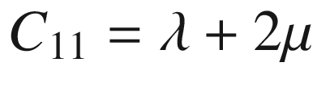

,

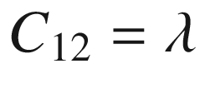

and

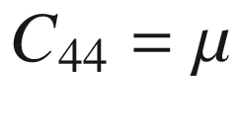

(note that

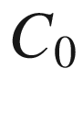

according to ([5.58](#u116076_4_En_5_Chapter-Equ62)) is zero).

The bulk modulus *B* (inverse of the compressibility),

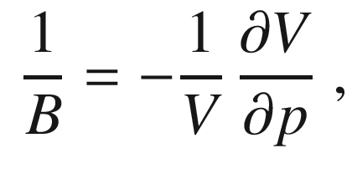

(5.62)

for the zincblende crystal is given as

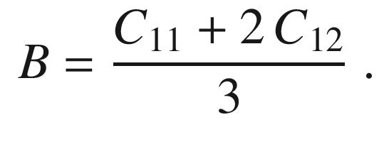

(5.63)

We note that *Y*,



and



of typical materials are both positive. Materials with negative Poisson ratio are called *auxetic* [398–400]. Also materials with negative compressibility are possible [401].

Beyond the dependence of the elastic constants on the bond length (as materialized in the phonon frequencies in Fig. [5.15](The_Physics_of_Semiconductors00002.docx#u116076_4_En_5_Chapter-Fig15)), they depend on the ionicity. In Fig. [5.30](#u116076_4_En_5_Chapter-Fig30), the elastic constants of various zincblende semiconductors are shown as a function of the ionicity

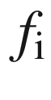

. The values for the elastic constants are normalized by

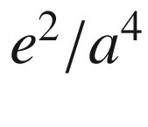

, *a* being the average nearest-neighbor distance.

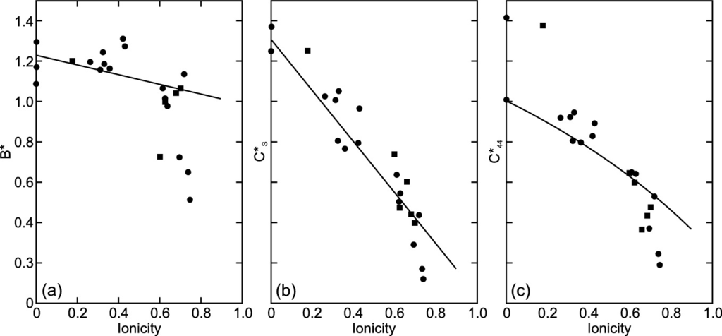

Fig. 5.30

Elastic constants as a function of ionicity for various semiconductors with diamond or zincblende (*circles*) and wurtzite (*squares*) structure. Constants are normalized by the modulus

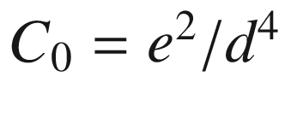

, *d* being the average nearest-neighbor distance. **a** Bulk modulus,

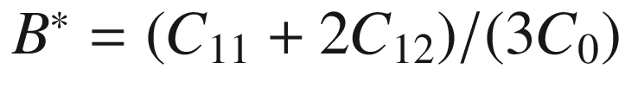

, (**b**, **c**) shear moduli, **b**

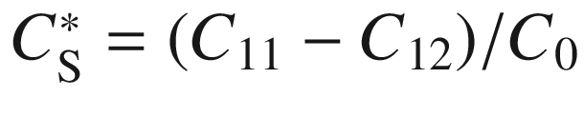

, **c**

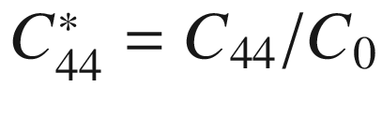

. *Solid lines* are a simple model as discussed in [402].

Adapted from [403]

For *wurtzite* crystals, five elastic constant are necessary for the stress–strain relation that reads[11](#u116076_4_En_5_Chapter-Fn11)

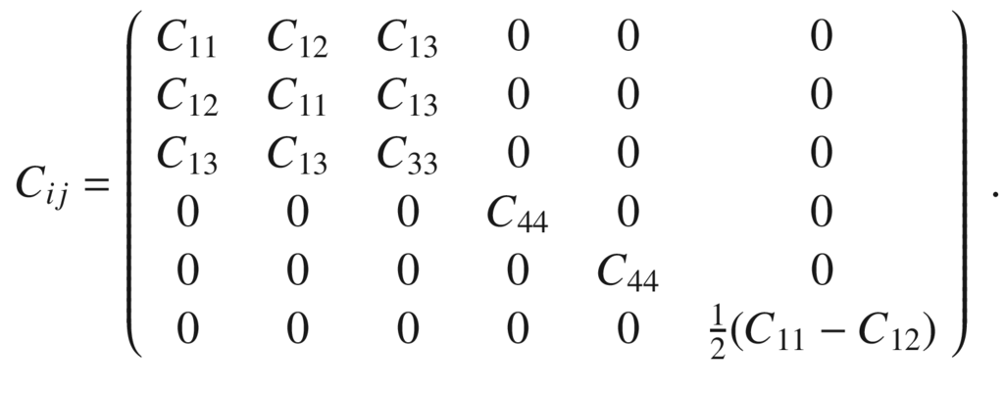

(5.64)

Experimental values for wurtzite materials are given in Table [5.3](#u116076_4_En_5_Chapter-Tab3). The relation of the elastic tensor of wurtzite and zincblende materials, in particular viewed along the

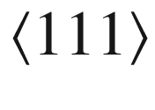

-direction has been discussed in [403, 404].Table 5.3

Elastic constants (in GPa) of some wurtzite semiconductors

| Material | $$C_{11}$$ | $$C_{12}$$ | $$C_{13}$$ | $$C_{33}$$ | $$C_{44}$$ | Refs. |
| --- | --- | --- | --- | --- | --- | --- |
| GaN | 391 | 143 | 108 | 399 | 103 | [405] |
| AlN | 410 | 149 | 99 | 389 | 125 | [406] |
| ZnS | 124 | 60.2 | 45.5 | 140 | 28.6 | [407] |
| ZnO | 206 | 118 | 118 | 211 | 44 | [408] |

The bulk modulus of the wurtzite crystal is given by

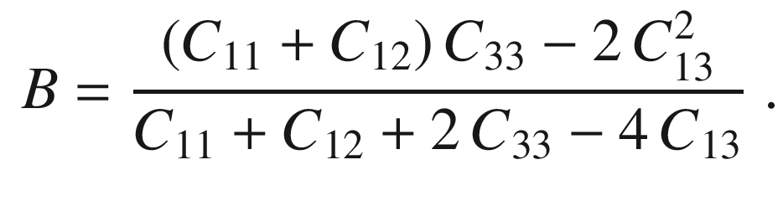

(5.65)

#### 5.3.3 Biaxial Stress

In heteroepitaxy (cf. Sect. [12.​2.​6](The_Physics_of_Semiconductors00005.docx#u116076_4_En_12_Chapter)), a biaxial stress situation arises, i.e. layered material is compressed (or expanded in the case of tensile strain) in the interface plane and is expanded (compressed) in the perpendicular direction.[12](#u116076_4_En_5_Chapter-Fn12) Here, we assume that the substrate is infinitely thick, i.e. that the interface remains planar. Substrate or wafer bending is discussed in Sect. [5.3.5](#u116076_4_En_5_Chapter-Sec18).

The simplest case is epitaxy on the (001) surface, i.e.

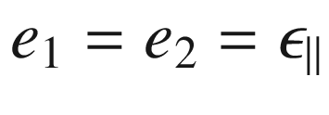

. The component

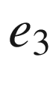

is found from the condition

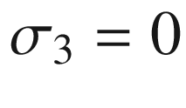

(no forces in the *z* direction). All shear strains are zero. For zincblende material it follows

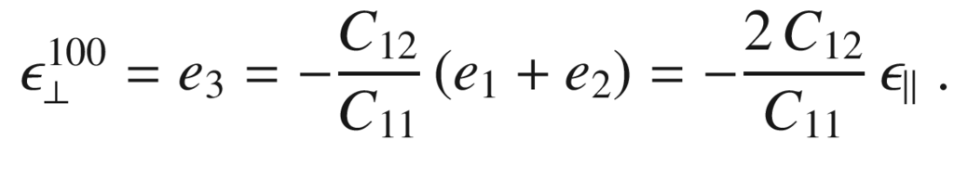

(5.66)

In Fig. [5.31](#u116076_4_En_5_Chapter-Fig31) the ratio

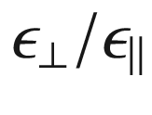

is depicted for GaAs and various crystal orientations; the formulas for other orientations are more involved [409]:

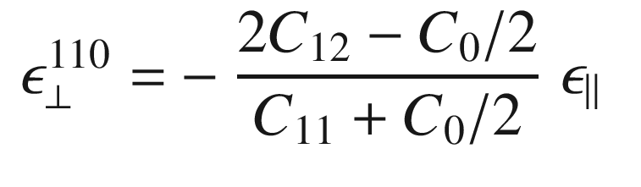

(5.67)

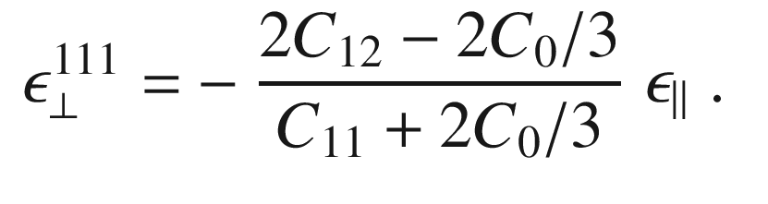

(5.68)

For wurtzite crystals and pseudomorphic growth along [00.1] the strain along the epitaxial direction (*c*-axis) is given by

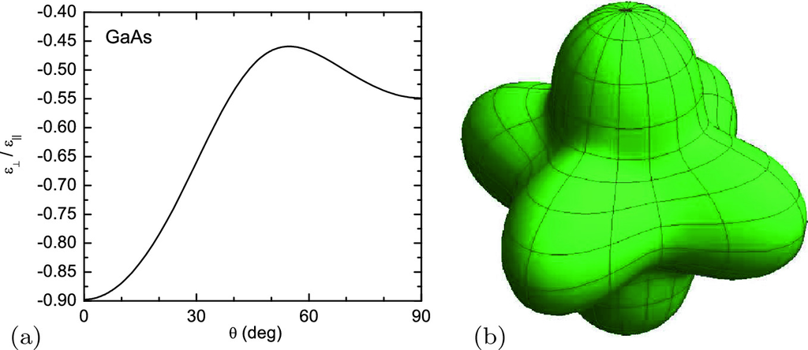

Fig. 5.31

Ratio

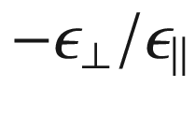

for GaAs under symmetric biaxial stress. The angle

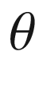

denotes the surface normal in the

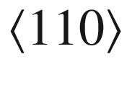

-azimuth (

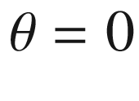

: [001],

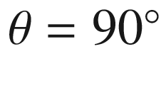

: [110], the maximum of

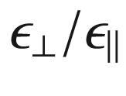

is for [111]). (**b**) is a three-dimensional visualization

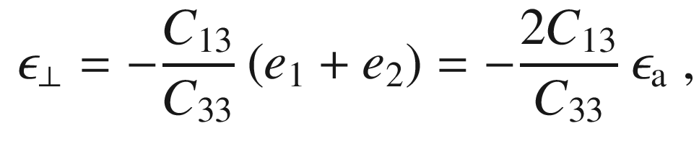

(5.69)

where

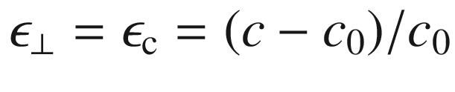

and

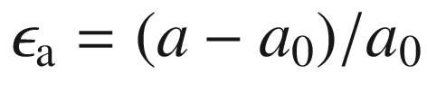

. For symmetric biaxial in-plane stress, the ratio

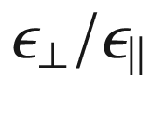

is shown in Fig. [5.32](#u116076_4_En_5_Chapter-Fig32) for GaN and varying angle

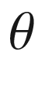

of the *c*-axis against the epitaxy direction. For the growth of wurtzite on wurtzite for

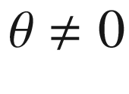

, the epitaxial strain is actually *asymmetric* in the interface plane. For

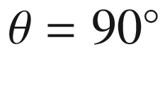

, e.g. the epitaxy on m-plane substrate (cmp. Fig. [3.​37](The_Physics_of_Semiconductors00002.docx#u116076_4_En_3_Chapter-Fig37)) (*c*-axis lies in-plane), the in-plane strains are

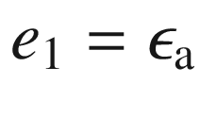

and

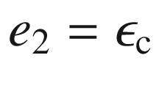

. For

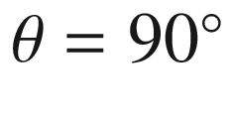

, we find

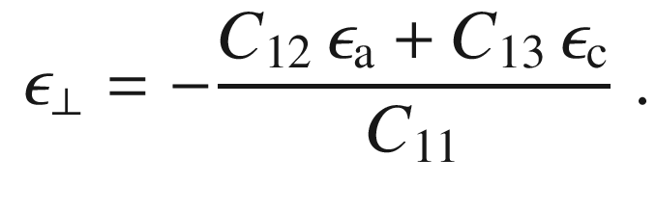

(5.70)

The situation for pseudomorphic growth in the (Al,Ga,In)N system has been discussed for various interface orientations in [410] (cmp. also Fig. [16.​14](The_Physics_of_Semiconductors00006.docx#u116076_4_En_16_Chapter-Fig14)). The strains

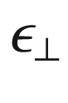

along the epitaxy direction and

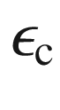

along the *c*-direction are depicted for Al

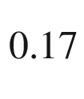

Ga

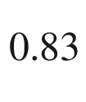

N/GaN and Mg

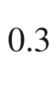

Ga

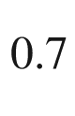

O/ZnO in Fig. [5.33](#u116076_4_En_5_Chapter-Fig33). The different behavior of the nitride and the oxide system, e.g. regarding the sign change of

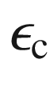

, is due to the fact that

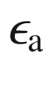

is negative (positive) for Al

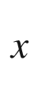

Ga

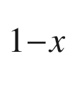

N/GaN (Mg

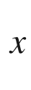

Ga

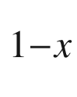

O/ZnO) (

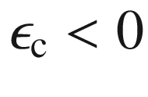

for both cases) [411].

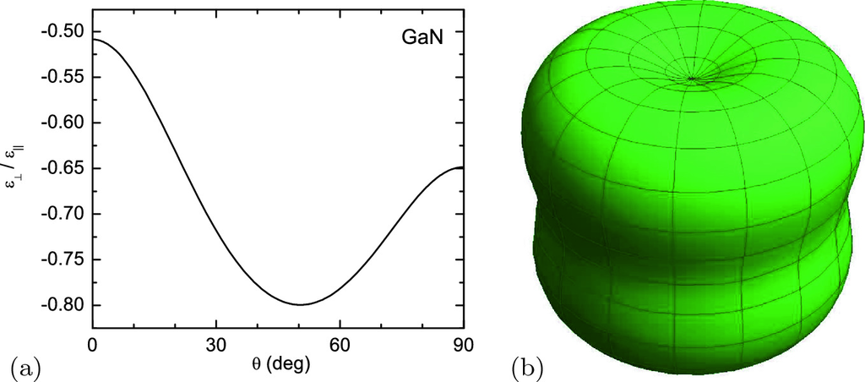

Fig. 5.32

Ratio

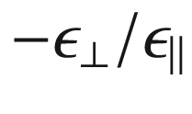

for GaN under symmetric biaxial stress. In **a**

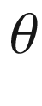

denotes the angle of the c-axis with respect to the surface normal, **b** is a three-dimensional visualization, showing the in-plane isotropy

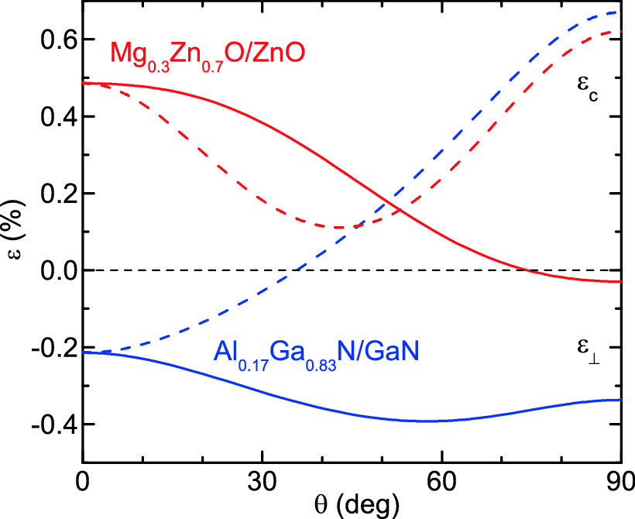

Fig. 5.33

Strains

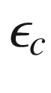

(*dashed lines*) and

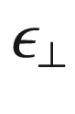

(*solid lines*) for Al

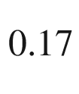

Ga

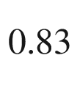

N/GaN (*blue*) and Mg

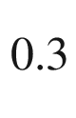

Ga

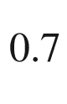

O/ZnO (*red*) as a function of the interface tilt angle

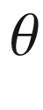

with respect to [00.1]

We note that pseudomorphic growth and biaxial stress of rhombohedral/trigonal (e.g. Al

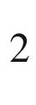

O

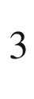

) and monoclinic (e.g.

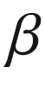

-Ga

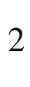

O



) thin films has been discussed as well [412–414]. A general treatment for all crystal symmetries and orientations has been provided in [415].

#### 5.3.4 Three-Dimensional Stress

The strain distribution in two-dimensional or three-dimensional objects such as quantum wires and dots (see also Sect. [14](The_Physics_of_Semiconductors00006.docx#u116076_4_En_14_Chapter)) is more complicated.

A simple analytical solution for the problem of a strained inclusion is only possible for isotropic material parameters [416].

The solution for a sphere can be extended to yield the strain distribution of an inclusion of arbitrary shape. This scheme applies only for isotropic materials and identical elastic properties of the inclusion and the surrounding matrix. The solution will be given in terms of a surface integral of the boundary of the inclusion, which is fairly easy to handle. Several disconnected inclusions can be treated by a sequence of surface integrals.

The strain distribution for the inner and outer parts of a sphere with radius

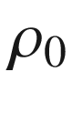

is given (in spherical coordinates) by

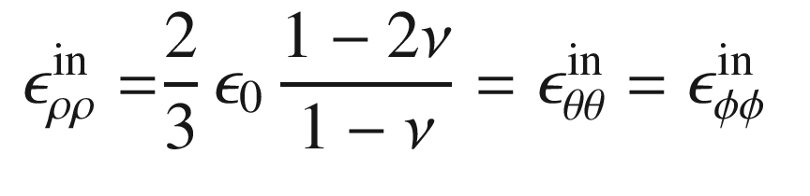

(5.71)

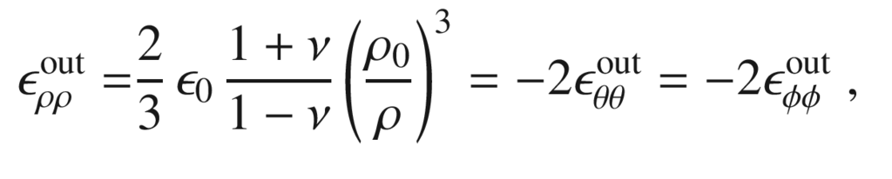

(5.72)

where

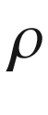

denotes the radius,

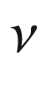

the Poisson ratio, and

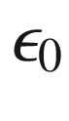

the relative lattice mismatch of the inclusion and the matrix. The radial displacements are

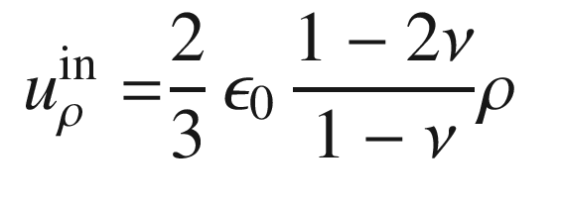

(5.73)

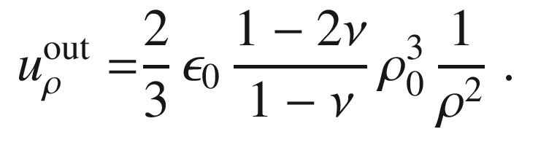

(5.74)

Dividing the displacement by the sphere’s volume, we obtain the displacement per unit volume of the inclusion. From the displacement we can derive the stress

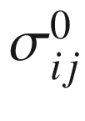

per unit volume.

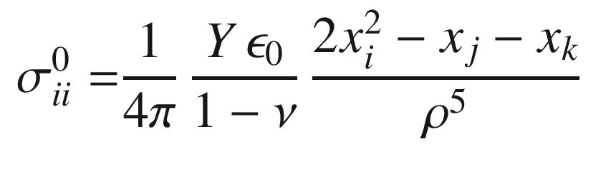

(5.75)

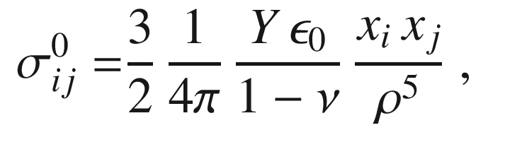

(5.76)

where *i*, *j* and *k* are pairwise unequal indices. Due to the linear superposition of stresses, the stress distribution

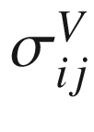

for the arbitrary inclusion of volume *V* can be obtained by integrating over *V*

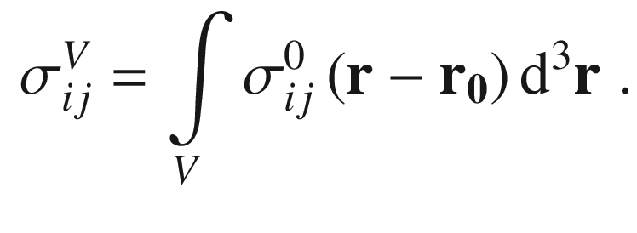

(5.77)

The strains can be calculated from the stresses.

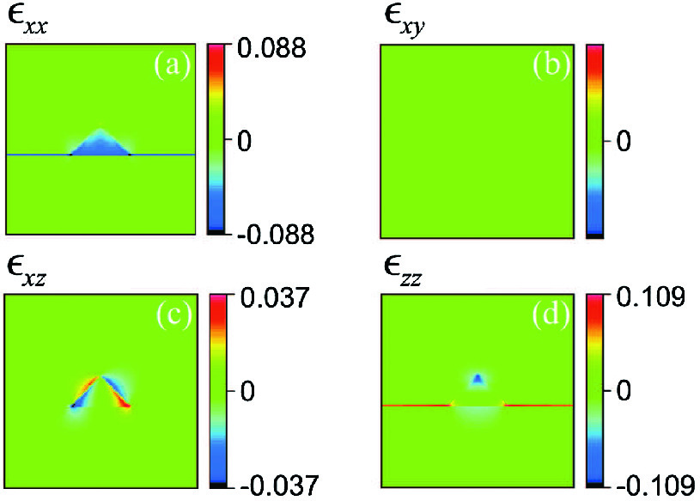

Fig. 5.34

Strain components in an InAs pyramid (quantum dot with

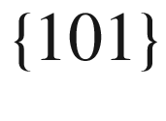

faces), embedded in GaAs. The cross section is through the center of the pyramid. The lattice mismatch between InAs and GaAs amounts to

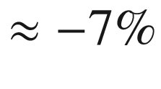

.

Reprinted with permission from [417], ©1995 APS

When

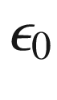

is constant within *V*, the volume integral can be readily transformed into an integral over the surface

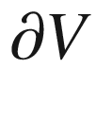

of *V* using Gauss’ theorem. With the ‘vector potentials’

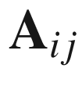

we fulfill

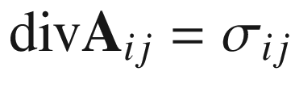

.

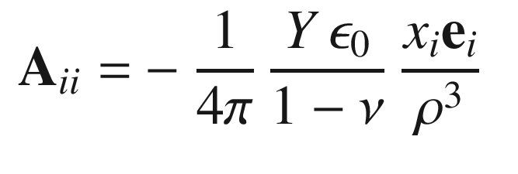

(5.78)

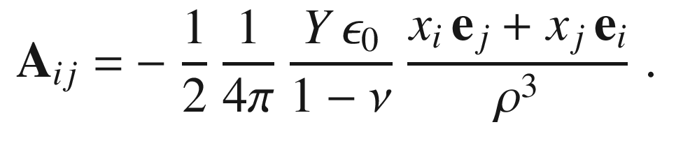

(5.79)

Equation ([5.79](#u116076_4_En_5_Chapter-Equ84)) is valid for the case

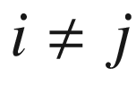

.

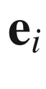

is the unit vector in the *i*-th direction. However, special care must be taken at the singularity

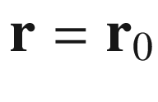

if

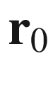

lies within *V* because the stress within the ‘

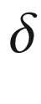

-inclusion’ is not singular (in contrast to the electrostatic analog of a

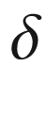

-charge). Thus, we find

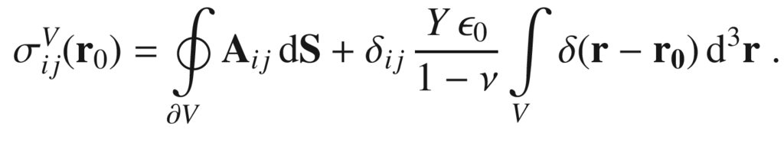

(5.80)

As an example, we show in Fig. [5.34](#u116076_4_En_5_Chapter-Fig34) the numerically calculated strain components [417] (taking into account the different elastic properties of the dot and matrix materials) in the cross section of a pyramidal InAs quantum dot in a GaAs matrix on top of a two-dimensional InAs layer. The strain component

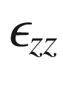

is positive in the 2D layer, as expected from ([5.66](#u116076_4_En_5_Chapter-Equ71)). However, in the pyramid

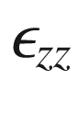

exhibits a complicated dependence and even takes negative values at the apex.

#### 5.3.5 Substrate Bending

If a lattice-mismatched layer is pseudomorphically grown on top of a substrate it suffers biaxial strain. For finite substrate thickness part of the strain will relax via substrate bending. If the substrate is circular, a spherical cap is formed. If the lattice constant of the film is larger (smaller) than that of the substrate, the film is under compressive (tensile) strain and the curvature is convex (concave) with respect to the outward normal given by the growth direction (Fig. [5.35](#u116076_4_En_5_Chapter-Fig35)a). Substrate bending can also be induced by a mismatch of the thermal expansion coefficients

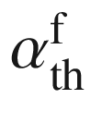

and

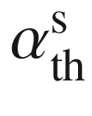

of the film and substrate, respectively. If a film/substrate system is flat at a given temperature, e.g. growth temperature, a decrease of temperature, e.g. during cooling, will lead to compressive (tensile) strain if



is smaller (larger) than



.

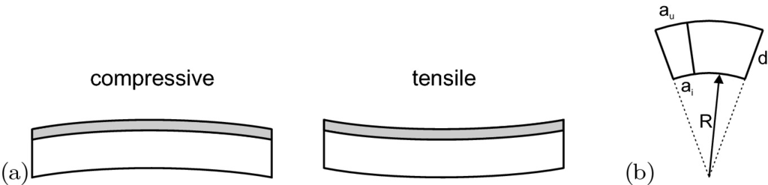

Fig. 5.35

**a** Schematic bending of a film/substrate system for compressive (left) and tensile (right) film strain. **b** Schematic deformation of curved film of thickness *d*. The lattice constants at the inner and outer surface are

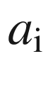

and

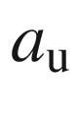

, respectively

In a curved structure, the lattice constant in the tangential direction increases from

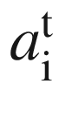

at the inner surface (

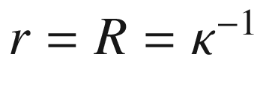

) to

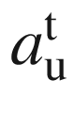

at the outer surface (

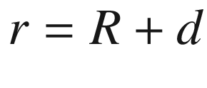

). Thus, the tangential lattice constant varies with the radial position

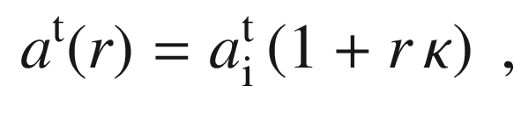

(5.81)

where *d* is the layer thickness (Fig. [5.35](#u116076_4_En_5_Chapter-Fig35)b). Therefore

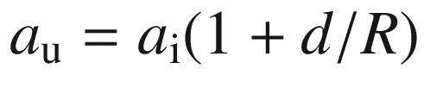

. We note that ([5.81](#u116076_4_En_5_Chapter-Equ86)) holds in all layers of a heterostructure, i.e. the film *and* the substrate.

The lattice constant in the radial direction

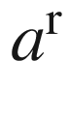

, however, depends on the lattice constant

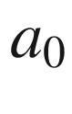

of the local material and is calculated from the biaxial strain condition, such as ([5.66](#u116076_4_En_5_Chapter-Equ71)). The in-plane strain is

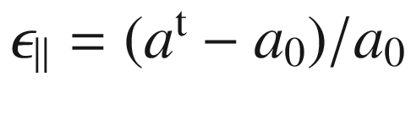

(we assume a spherical cap with

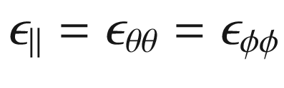

). For an isotropic material we find

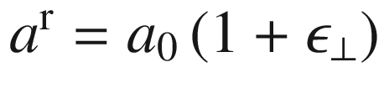

with

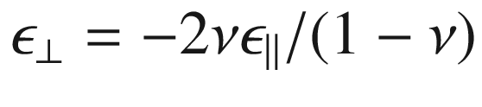

. The local strain energy density *U* is given by

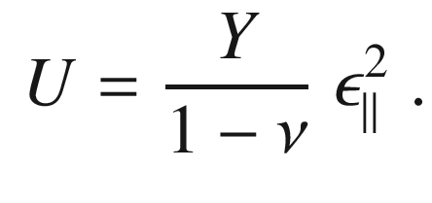

(5.82)

The total strain energy per unit area

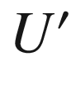

of a system of two layers with lattice constants

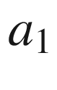

,

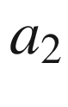

, Young’s moduli

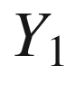

,

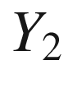

and thickness

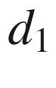

,

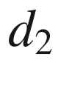

(we assume the same Poisson constant

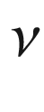

in both layers) is

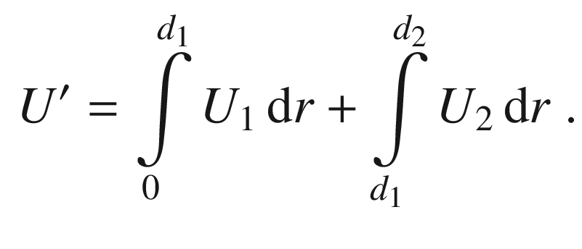

(5.83)

The total strain energy needs to be minimized with respect to

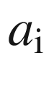

and *R* in order to find the equilibrium curvature

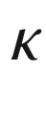

. We find

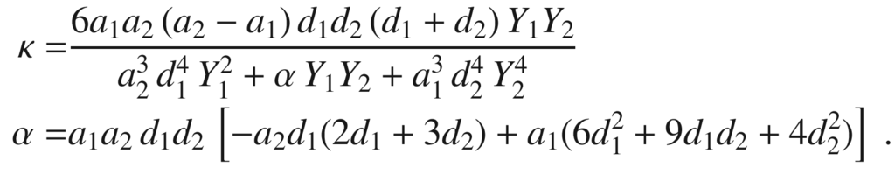

(5.84)

For

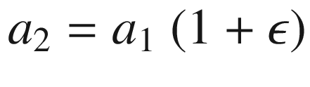

we develop

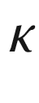

to first order of

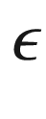

and find (

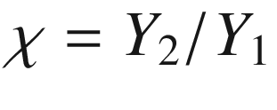

) [418, 419]

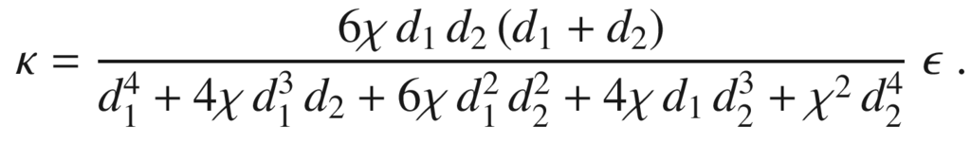

(5.85)

In the case of a substrate (

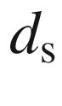

) with a thin epitaxial layer (

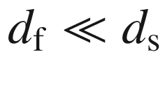

), the radius of curvature is approximately (Stoney’s formula [420])

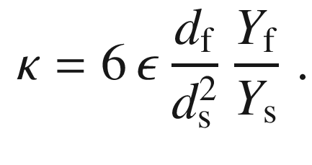

(5.86)

Conversely, if the radius of curvature is measured [421], e.g. optically, the film curvature (and through models also the film strain) can be determined during epitaxy as depicted in Fig. [5.36](#u116076_4_En_5_Chapter-Fig36).

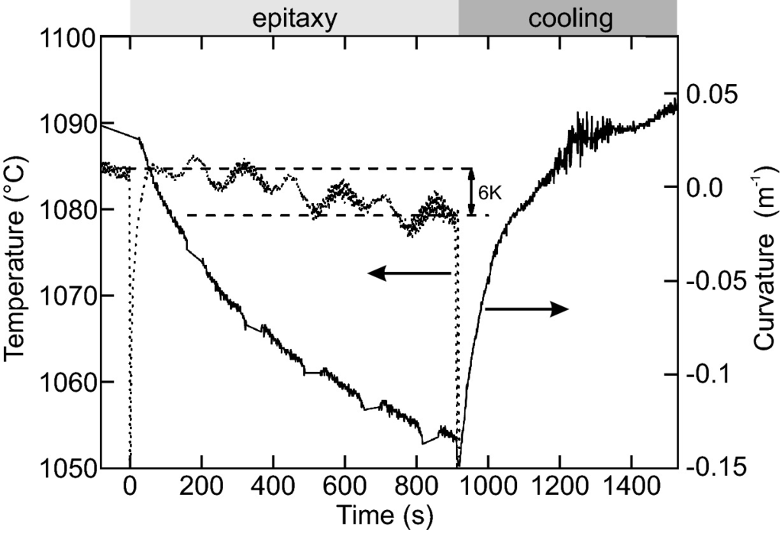

Fig. 5.36

Curvature of the middle of a Si wafer during GaN growth on an AlN interlayer grown at low temperatures on GaN and subsequent cooling. During growth the decrease in curvature indicates convex bowing due to compressive stress; during cooling the wafer flattens and becomes concave due to thermally induced tensile stress.

Adapted from [422]

#### 5.3.6 Scrolling

In some cases cylindrically scrolled structures are important, e.g. for thin-film flexible electronics, nanotubes, nanoscrolls or nanohelixes. The scrolling of thin layers must be avoided by suitable strain management for thin layers that are lifted off from their substrate for transfer to another flat substrate. If the film remains attached to its substrate, a scroll can be fabricated as schematically shown in Fig. [5.37](#u116076_4_En_5_Chapter-Fig37). Such structures were first reported in [423], a review can be found in [424]. The shape of such scroll is investigated in [425] without a priori assumptions on its shape.

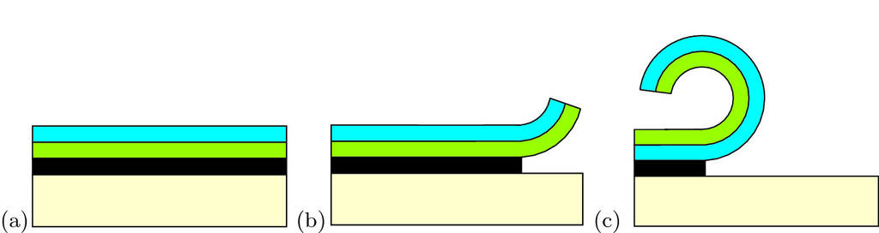

Fig. 5.37

Schematic representation of nanoscroll formation. **a** Strained heterostructure (*blue/green*) that is planar due to large substrate thickness, **b** starting removal of sacrificial layer (*black*), **c** release of thin film into nanoscroll geometry

If bending strain occurs only in *one* of the tangential directions, the energy density is given by

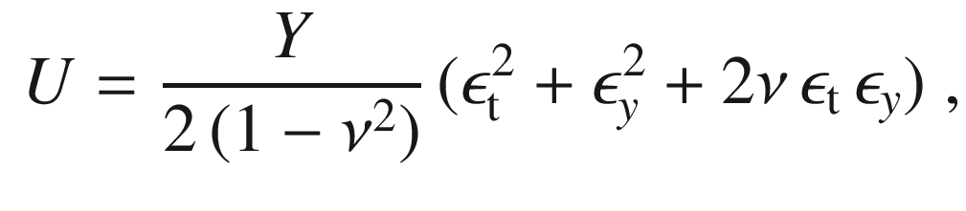

(5.87)

where

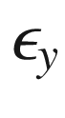

is the strain in the unbent direction (cylinder axis) as shown in Fig. [5.38](#u116076_4_En_5_Chapter-Fig38)a. For a strained heterostructure made up from two layers the curvature is given by (calculated analogous to ([5.85](#u116076_4_En_5_Chapter-Equ90)),

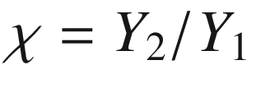

 [419])

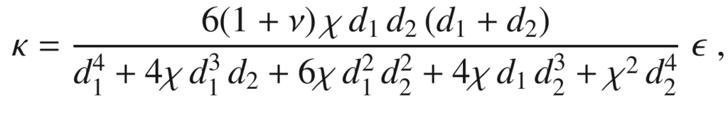

(5.88)

which differs from ([5.85](#u116076_4_En_5_Chapter-Equ90)) only by the factor

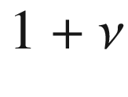

in the nominator.

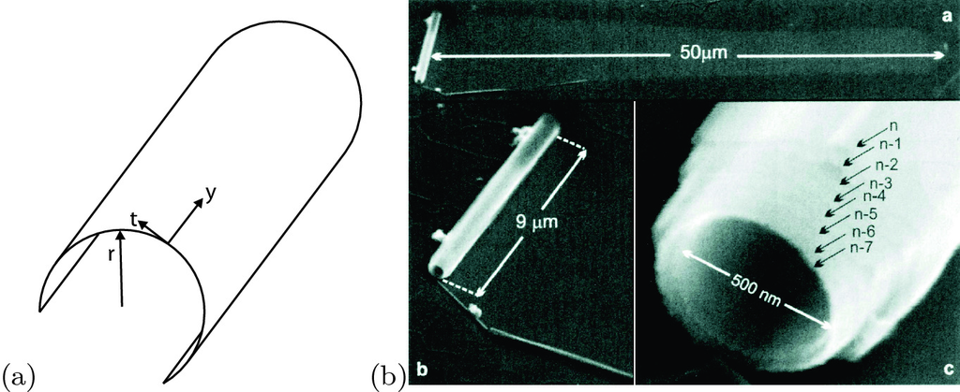

Fig. 5.38

**a** Schematic representation of a cylindrically rolled sheet with radial direction *r*, tangential direction *t* and direction along the cylinder axis *y*. **b** SEM images of multiwall (In,Ga)As/GaAs nanoscroll rolled up over about 50 µm. Part (**b**) from [426]

For cubic material and a (001) surface the energy is given as

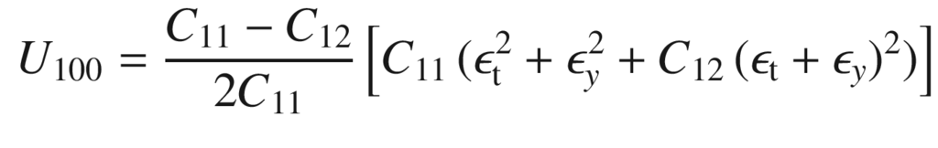

(5.89)

for a scrolling direction along

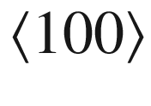

. When the (001)-oriented film winds up along a direction

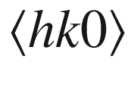

having an angle

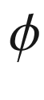

with the [100] direction (

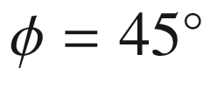

for

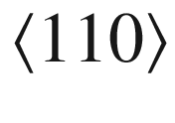

), the strain energy is given by (



is given by ([5.58](#u116076_4_En_5_Chapter-Equ62)))

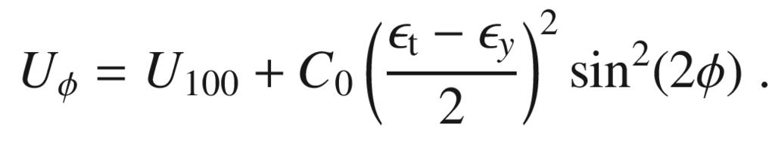

(5.90)

The strain energy versus bending radius (

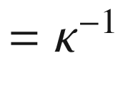

) is shown for a SiGe nanoscroll in Fig. [5.39](#u116076_4_En_5_Chapter-Fig39). First, the relaxation along the cylinder axis plays a minor role. The smallest strain energy is reached for scrolling along

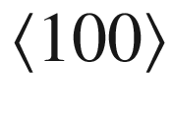

, also yielding the smaller bending radius (larger curvature). Therefore, the film preferentially scrolls along



. This explains the observed ‘curl’ behavior of scrolls winding up for

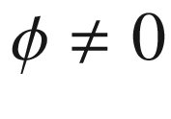

[423, 427] (Fig. [5.39](#u116076_4_En_5_Chapter-Fig39)b). The effect of surface strain needs to be included to yield improved quantitative agreement with experimental values of

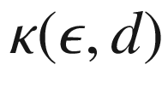

 [428].

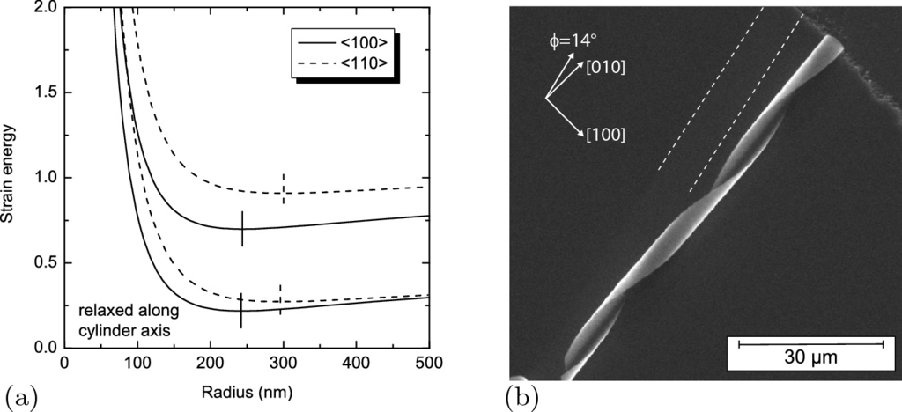

Fig. 5.39

**a** Strain energy (in units of the strain energy of the flat pseudomorphic layers) of a scroll of a 4-layer SiGe structure (Si

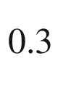

Ge



, Si

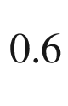

Ge

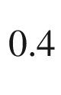

and Si

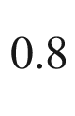

Ge

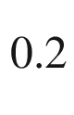

, each 3 nm thick and a 1 nm Si cap) as a function of radius for winding directions along



and

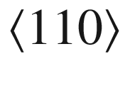

. *Top* (*bottom*) curves without (with complete) strain relaxation along the cylinder axis. *Vertical lines* indicate the positions of the respective energy minima [419]. **b** SEM image of curled (In, Ga)As/GaAs nanoscroll rolled

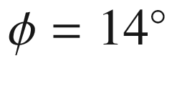

off



. The stripe from which the film was rolled off is indicated by *white dashed lines*. Part (**b**) from [429]

### 5.4 Plasticity

#### 5.4.1 Critical Thickness

Strained epitaxial films are called pseudomorphic when they do not contain defects and the strain relaxes elastically, e.g. by tetragonal distortion. When the layer thickness increases, however, strain energy is accumulated that will lead at some point to plastic relaxation via the formation of defects. In many cases, a grid of misfit dislocations forms at the interface (Figs. [4.​18](The_Physics_of_Semiconductors00002.docx#u116076_4_En_4_Chapter-Fig18) and [5.40](#u116076_4_En_5_Chapter-Fig40)).

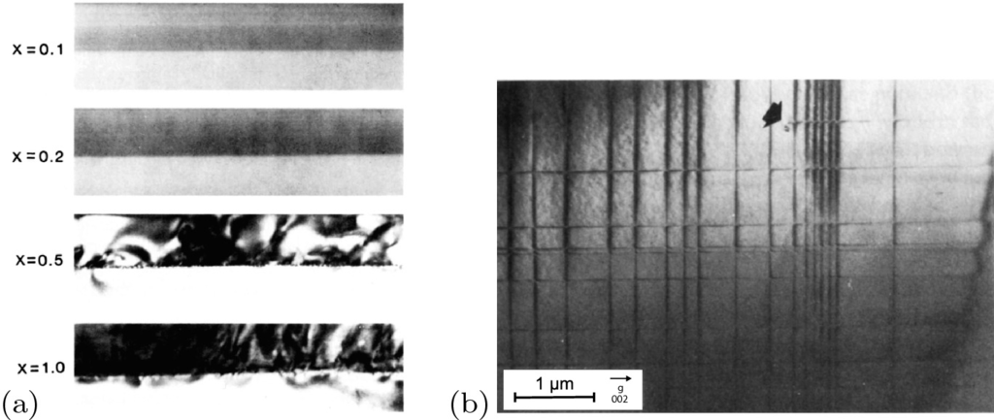

Fig. 5.40

**a** Series of cross-sectional TEM images of 100 nm thick Ge

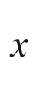

Si

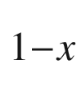

layers on Si(001) with different ternary compositions

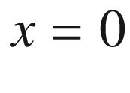

.1, 0.2, 0.5, and 1.0. The growth temperature was 550

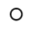

C. The transition from commensurate to incommensurate growth is obvious. Adapted from [430]. **b** Plan view

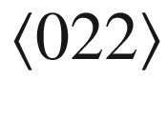

TEM bright field image of a 250 nm Ge

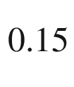

Si

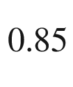

layer on Si (001), annealed at about 700

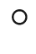

C. The arrow denotes the position of a dislocation loop.

Reprinted with permission from [431], ©1989 AVS

In Fig. [5.41](#u116076_4_En_5_Chapter-Fig41) the strain around misfit dislocations at a GaAs/CdTe heterointerface, as calculated from a TEM image (Fig. [4.​14](The_Physics_of_Semiconductors00002.docx#u116076_4_En_4_Chapter-Fig14)), is shown.

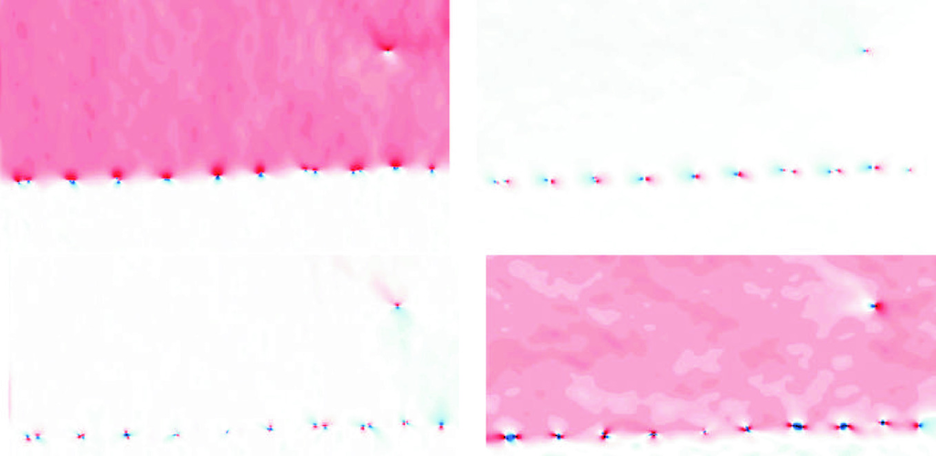

Fig. 5.41

Components

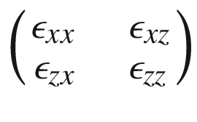

of the strain tensor (with respect to the GaAs lattice constant) of the dislocation array shown in Fig. [4.​14](The_Physics_of_Semiconductors00002.docx#u116076_4_En_4_Chapter-Fig14), *red*/*blue*: positive/negative value, *white*: zero.

From [321]

The average distance *p* of the dislocations is related to the misfit

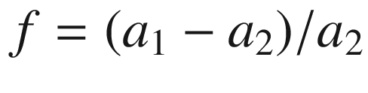

and the edge component

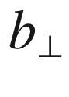

of the Burger’s vector (for a 60

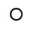

dislocation

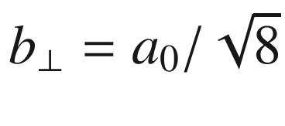

)

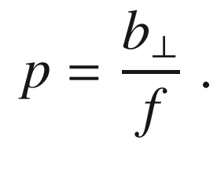

(5.91)

Two mechanisms have been proposed for the formation of misfit dislocations (Fig. [5.42](#u116076_4_En_5_Chapter-Fig42)), the elongation of a grown-in threading dislocation [432, 433] and the nucleation and growth of dislocation half-loops [434]. For the modeling of such systems a mechanical approach based on the forces on dislocations [432] or an energy consideration based on the minimum strain energy necessary for defect formation [434–437] can be followed. Both approaches have been shown to be equivalent [438] (if a periodic array of dislocations is considered). In [439] it was pointed out that the finite speed of plastic flow also has to be considered to explain experimental data. Temperature affects the observed critical thickness and a kinetic model is needed. Another way of introducing dislocations is the plastic relaxation at the edge of coherent strained islands (cmp. Fig. [14.​37](The_Physics_of_Semiconductors00006.docx#u116076_4_En_14_Chapter-Fig37)).

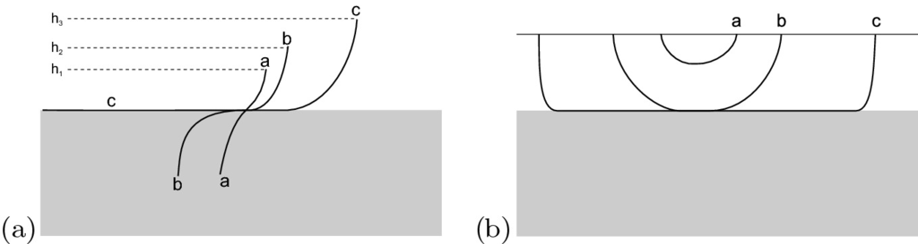

Fig. 5.42

Schematic formation of misfit dislocations by **a** elongation of a grown-in threading dislocation and **b** by the nucleation and growth of dislocation half-loops. **a** depicts a threading dislocation. Initially, for thickness

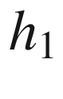

the interface is coherent ‘a’, for larger thickness

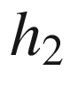

the interface is critical and the force of the interface on the dislocation is equal to the tension in the dislocation line, ‘b’. For larger thickness, e.g.

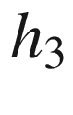

, the dislocation line is elongated in the plane of the interface, ‘c’. In **b** ‘a’ denotes a subcritical dislocation half-loop, ‘b’ depicts a half-loop being stable under the misfit stress and for ‘c’ the loop has grown under the misfit stress into a misfit dislocation line along the interface

In the following, isotropic materials and identical elastic constants of substrate and thin film are assumed, following [438]. The interface plane is the (*x*,*y*)-plane, the growth direction is *z*. The energy

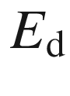

of a periodic dislocation array with period *p* and Burgers vector

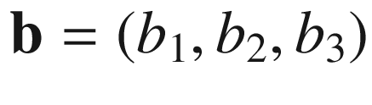

 is

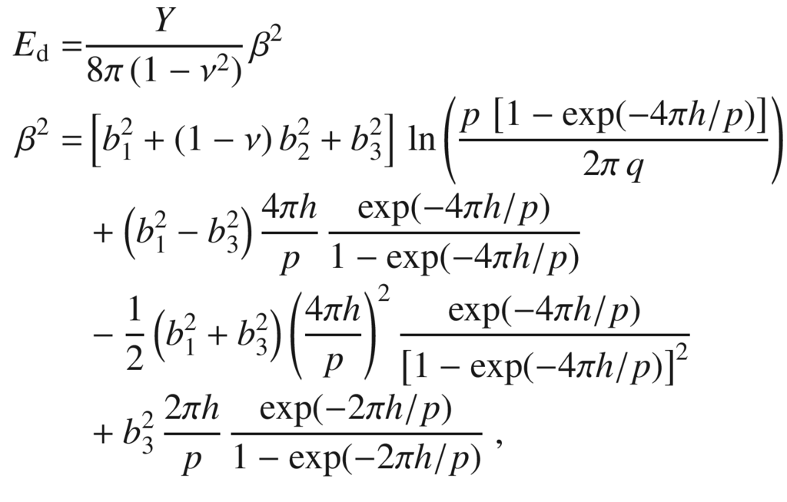

(5.92)

where *h* is the film thickness and *q* denotes the cutoff length for the dislocation core, taken as

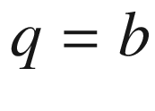

. The misfit strain including the relaxation due to dislocations with Burger’s vectors

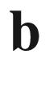

and

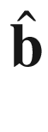

in the two orthogonal interface

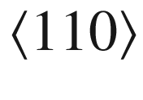

directions

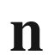

and

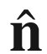

. We chose the coordinate system such that

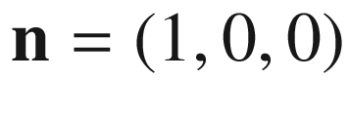

and

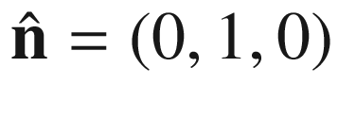

(the *z* direction remains). With respect to these axes the Burger’s vectors are

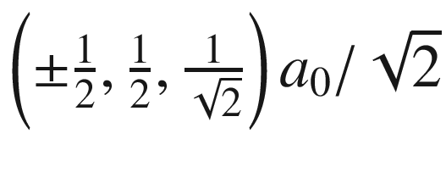

. The misfit strain

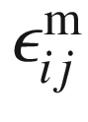

is reduced due to the dislocation formation to the ‘relaxed’ misfit strain

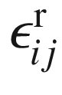

with

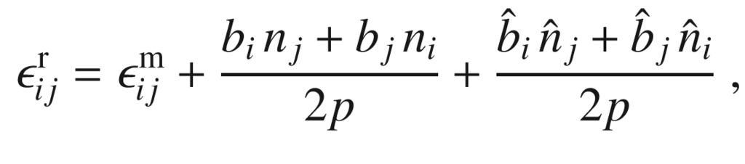

(5.93)

with an associated stress

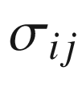

. The strain energy

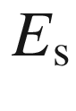

of the layer due to the relaxed misfit is then

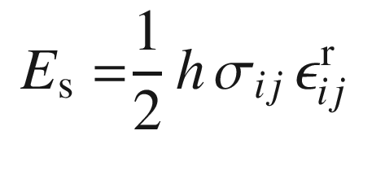

(5.94)

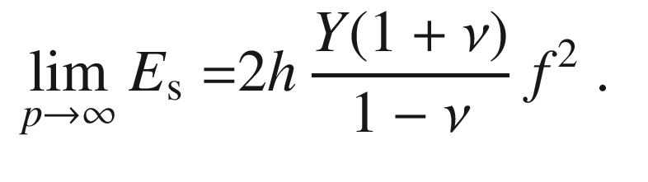

(5.95)

The total strain energy *E* is given by

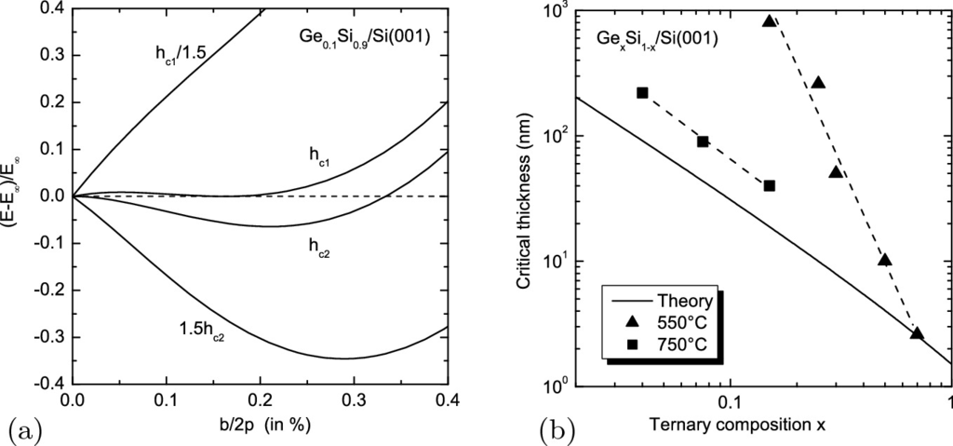

Fig. 5.43

**a** Theoretical calculation for the strain energy versus inverse dislocation density for various thicknesses of Ge

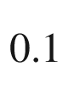

Si

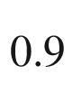

layers on Si (001). The ordinate is *b*/2*p*, *b*/2 being the edge component of the Burgers vector and *p* being the dislocation spacing. The abscissa is the strain energy *E* scaled with

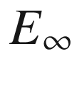

([5.97](#u116076_4_En_5_Chapter-Equ102)). (**b**) Critical thickness for Ge

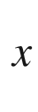

Si

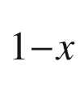

layers on Si (001). The *solid line* is theory (

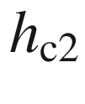

) according to ([5.99](#u116076_4_En_5_Chapter-Equ104)). Data points are from [440] (*squares*, growth temperature of 750

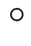

C) and from [430] (*triangles* for growth temperature of 550

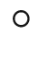

C)

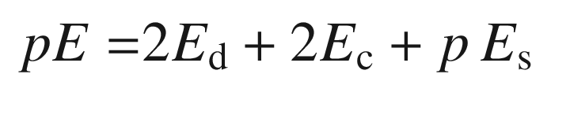

(5.96)

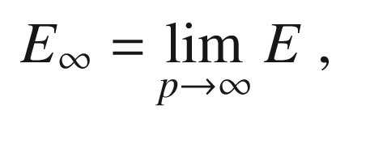

(5.97)

with the core energy

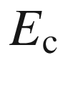

of the dislocation that needs to be calculated with an atomistic model (not considered further here). This energy is shown in Fig. [5.43](#u116076_4_En_5_Chapter-Fig43)a for the material parameters of Ge



Si

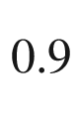

/Si(001) (misfit

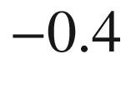

%) for various layer thicknesses as a function of 1/*p*. This plot looks similar to that for a first-order phase transition (with 1/*p* as the order parameter). For a certain critical thickness

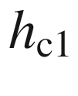

the energy of the layer without any dislocation and the layer with a particular dislocation density

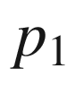

are identical (

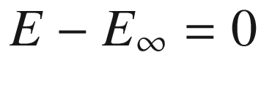

) and additionally

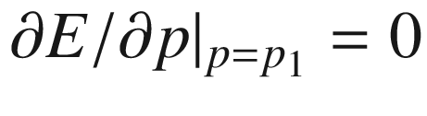

. However, between

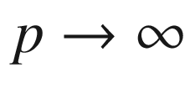

and

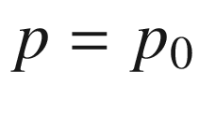

there is an energy barrier. The critical thickness

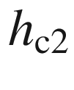

is reached when

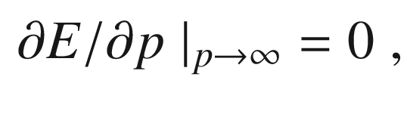

(5.98)

i.e. the energy decreases monotonically for increasing dislocation density up to the global energy minimum at a certain equilibrium dislocation spacing

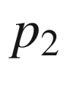

. Equation ([5.98](#u116076_4_En_5_Chapter-Equ103)) leads to the following implicit equation for the determination of

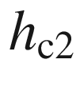

:

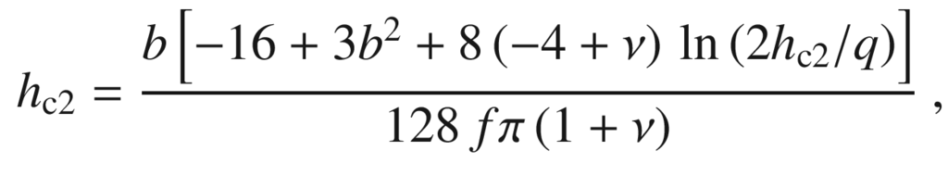

(5.99)

with the length of the Burgers vector

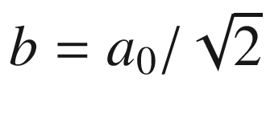

.

The theoretical dependence of

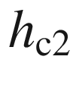

for Ge

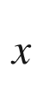

Si

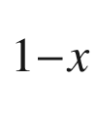

/Si(001) with varying composition is shown in Fig. [5.43](#u116076_4_En_5_Chapter-Fig43)b together with experimental data. The critical thickness for a fairly high growth temperature is much closer to the energetic equilibrium than that deposited at lower temperature. This shows that there are kinetic limitations for the system to reach the mechanical equilibrium state. Also, the experimental determination of the critical thickness is affected by finite resolution for large dislocation spacing, leading generally to an overestimate of

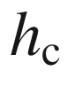

.

In zincblende materials, two types of dislocations are possible,

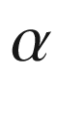

and

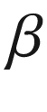

, with Ga- and As-based cores, respectively. They have

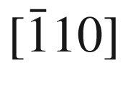

and [110] line directions for a compressively strained interface. The

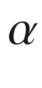

dislocation has the larger glide velocity. Therefore, strain relaxation can be anisotropic with regard to the

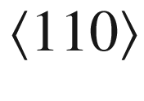

directions for zincblende material, e.g. (In,Ga)As/GaAs [441, 442].

A more complicated relaxation situation is visualized in Fig. [4.​18](The_Physics_of_Semiconductors00002.docx#u116076_4_En_4_Chapter-Fig18) for an Al

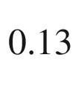

Ga

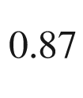

N/GaN heterostructure on

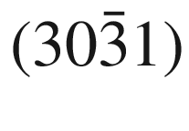

substrate. Below the critical thickness only threading dislocations stemming from the substrate are visible. Above the critical thickness, misfit dislocations have developed along three directions which related to the intersections of the basal *c*-plane (00.1) and two prismatic *m*-plane

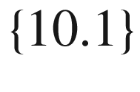

glide systems with the



interface plane [324, 443]. We like to mention that cathodoluminescence (or X-ray imaging) offer a quite high sensitivity for plastic relaxation since a small number of dislocations can be detected in relatively large areas (while TEM finds defects but only within small areas and X-ray diffraction looks at large area but has only a low strain sensitivity).

#### 5.4.2 Cleaving

The cleavage planes of the diamond structure are

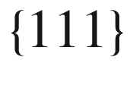

planes (Fig. [5.44](#u116076_4_En_5_Chapter-Fig44)a). It is easiest to break the bonds connecting the double layers in the

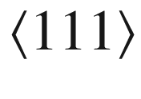

directions.

The cleavage planes of the zincblende structure are

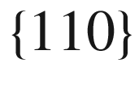

planes (Fig. [5.44](#u116076_4_En_5_Chapter-Fig44)b). Due to the ionic character, breaking the bonds connecting the double layers in the

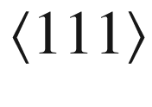

directions would leave charged surfaces, which is energetically unfavorable. The

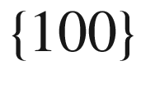

planes contain only one sort of atom and would also leave highly charged surfaces. The



planes contain equal amounts of A- and B-atoms and are neutral. Ideally, the cleaving plane is atomically flat (Fig.  [5.45](#u116076_4_En_5_Chapter-Fig45)a) or exhibits large mono-atomically flat terraces. However, certain dopants in high concentrations, e.g. GaAs:Te, can induce a rough surface due to lattice distortion [444].

The natural cleavage planes of wurtzite (GaN) are

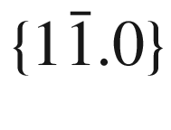

(m-type) planes [445].

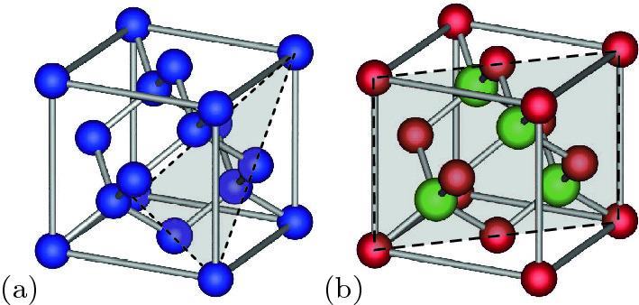

Fig. 5.44

Cleaving planes of the **a** diamond and **b** zincblende lattice

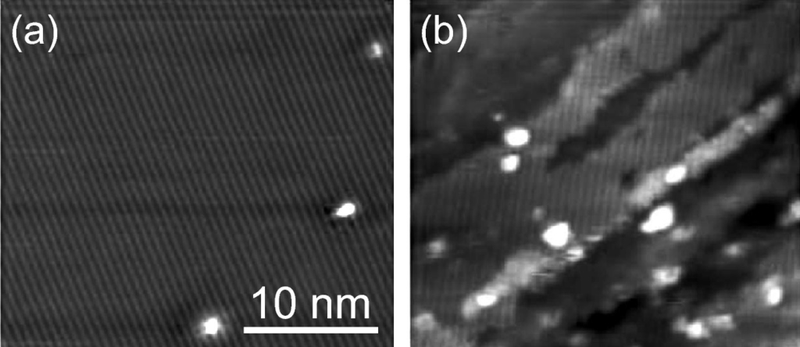

Fig. 5.45

Scanning tunneling microscopy images of a cleaved GaAs (110) surface with **a** good cleave and **b** bad cleave with defects dominating.

Adapted from [446]

#### 5.4.3 Wafer Breakage

The thickness and thus strength of wafers for semiconductor production (cmp. Sect. [12.​2.​2](The_Physics_of_Semiconductors00005.docx#u116076_4_En_12_Chapter)) is an important issue. The wafer should be as thin as possible for saving expensive materials but thick enough to avoid loss due to stress during handling, in particular during the later steps in a process since the value of a wafer increases with number of process steps it has undergone.

Reasons for wafer breakage is the mechanical handling (pick, place, transport) [447], stress loads due to processing (dielectrics, metals, asymmetric structures) and stress during processing for example due to thermal loads in annealing or deposition steps and cutting/dicing. The problem is less important in microelectronics but especially severe in photovoltaics (PV) industry, handling large total areas; on the other hand the profit loss per broken wafer is much higher in the microelectronics industry. An additional problem poses the grain structure of multicrystalline silicon wafers used for PV [448] and the effect of surface cracks and irregularities at wafer edges and corners. Just going from a wafer thickness of 270 µm to 250 µm can more than double the breakage rate at certain process steps [449]. The minimum strength of a wafer with surface cracks is about 100 MPa, while the strength of wafers with cracks at the edge can reach rather low values around 20 MPa. Also the careful shaping of the wafer edge is important to avoid breakage [450].

Footnotes

[1](The_Physics_of_Semiconductors00002.docx#u116076_4_En_5_Chapter-Fn1_source)

For higher dimensions, the integral over a closed path (or surface) can be replaced via Stokes’ theorem with an area (or volume) integral of the Berry flux. Also it is invariant under a ‘gauge transformation’ where

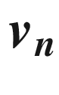

is replaced by

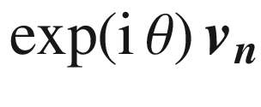

.

[2](The_Physics_of_Semiconductors00002.docx#u116076_4_En_5_Chapter-Fn2_source)

The factor 2 compared to ([5.34](The_Physics_of_Semiconductors00002.docx#u116076_4_En_5_Chapter-Equ36)) stems from the folded Brillouin zone compared to the monoatomic chain model.

[3](The_Physics_of_Semiconductors00002.docx#u116076_4_En_5_Chapter-Fn3_source)

This dependence is the base for Debye law for the

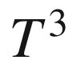

temperature dependence of the heat capacity at low temperatures when only states with sufficiently small wave vector are thermally populated.

[4](The_Physics_of_Semiconductors00002.docx#u116076_4_En_5_Chapter-Fn4_source)

Random element isodisplacement.

[5](The_Physics_of_Semiconductors00002.docx#u116076_4_En_5_Chapter-Fn5_source)

The oscillator strengths *f* shown here have been calculated from the values *S* given in [392] divided by

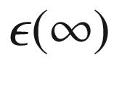

.

[6](The_Physics_of_Semiconductors00002.docx#u116076_4_En_5_Chapter-Fn6_source)

In order to avoid negative values for the masses, not a normal or Gaussian distribution is used but the Gamma distribution with the parameters

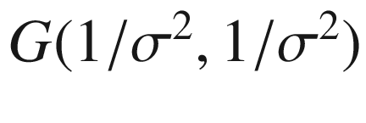

.

[7](The_Physics_of_Semiconductors00002.docx#u116076_4_En_5_Chapter-Fn7_source)

Since the two outer atoms are fixed, the movable parts of the chain consists of B–A dimers (Fig. [5.25](The_Physics_of_Semiconductors00002.docx#u116076_4_En_5_Chapter-Fig25)b), thus the topologically non-trivial case occurs here for

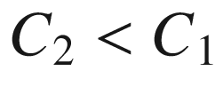

.

[8](#u116076_4_En_5_Chapter-Fn8_source)

The stress is a force per unit area and has the dimensions of a pressure.

[9](#u116076_4_En_5_Chapter-Fn9_source)

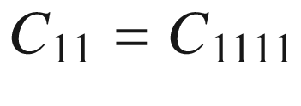

,

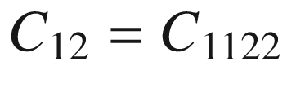

and

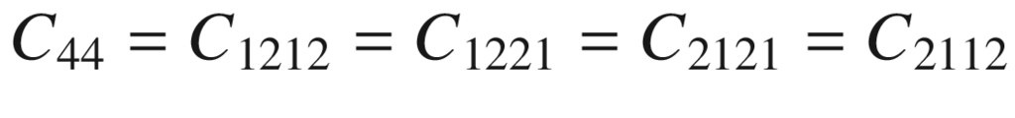

.

[10](#u116076_4_En_5_Chapter-Fn10_source)

For an isotropic material,

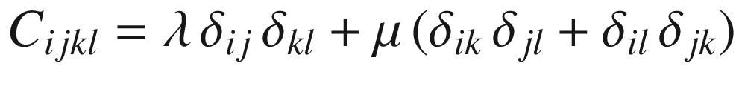

.

[11](#u116076_4_En_5_Chapter-Fn11_source)

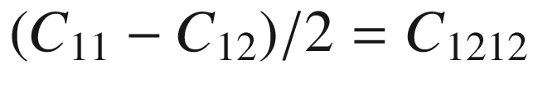

,

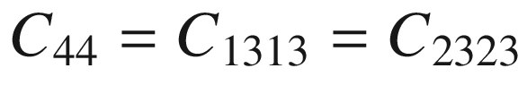

.

[12](#u116076_4_En_5_Chapter-Fn12_source)

In a large amount of literature and in previous editions of this book, this situation has been labelled ‘biaxial *strain*’. However, there is in-plane *and* out-of-plane strain, thus the strain along all directions is non-zero. Since the out-of-plane stress is zero (for zero ambient pressure), it is actually a ‘biaxial *stress*’ situation.

© Springer Nature Switzerland AG 2021

M. Grundmann

The Physics of Semiconductors

Graduate Texts in Physics

<https://doi.org/10.1007/978-3-030-51569-0_6>

## 6. Band Structure

Marius Grundmann[1](#u116076_4_En_6_Chapter-Aff11)

(1)

Felix Bloch Institute for Solid State Physics, Universität Leipzig, Leipzig, Germany

Marius Grundmann

Email:

[grundmann@physik.uni-leipzig.de](mailto:grundmann@physik.uni-leipzig.de)

*Silicon is a metal.*

*A.H. Wilson, 1931* [74]

## Abstract

A treatment of electron states in one-dimensional potentials introduces into the concepts of band gap and effective mass. The band structures of various semiconductors are reviewed. The systematics of band gaps, symmetry considerations, band gaps in alloys, amorphous semiconductors and the effect of strain and temperature are discussed. Electron and hole dispersions are treated and the density of states in various dimensions is derived.

### 6.1 Introduction

Valence electrons that move in the crystals feel a periodic potential

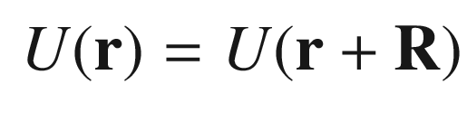

(6.1)

for all vectors

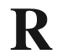

of the direct lattice. The potential[1](#u116076_4_En_6_Chapter-Fn1) is due to the effect of the ion cores and all other electrons. Thus a serious many-body problem is present. In principle, the band structure can be calculated from the periodic arrangements of the atoms and their atomic order number. We note that for some problems, e.g. the design of optimal solar cells, a certain band structure is known to be ideal and a periodic atomic arrangement, i.e. a material, needs to be found that generates the optimal band structure. This problem is called the *inverse band structure problem*.

### 6.2 Electrons in a Periodic Potential

#### 6.2.1 Bloch’s Theorem

First, we will deduce some general conclusions about the structure of the solution as a consequence of the periodicity of the potential. We first investigate the solution of a Schrödinger equation of the type

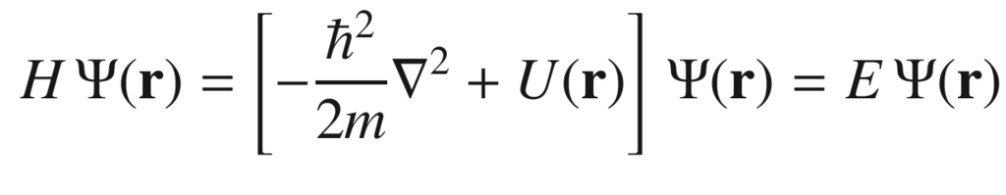

(6.2)

for an electron. *U* will be periodic with the lattice, i.e. it will obey ([6.1](#u116076_4_En_6_Chapter-Equ1)).

Bloch’s theorem says that the eigenstates

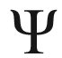

of a one-particle Hamiltonian as in ([6.2](#u116076_4_En_6_Chapter-Equ2)) can be written as the product of plane waves and a lattice-periodic function, i.e.

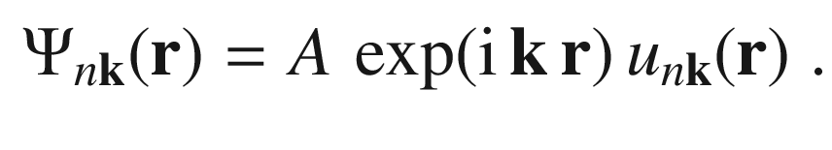

(6.3)

The normalization constant *A* is often omitted. If

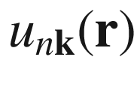

is normalized,

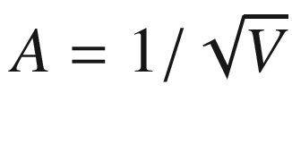

, where *V* is the integration volume. The wavefunction is indexed with a quantum number *n* and the wavevector

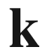

. The key is that the function

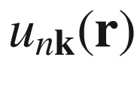

, the so-called Bloch function, is periodic with the lattice, i.e.

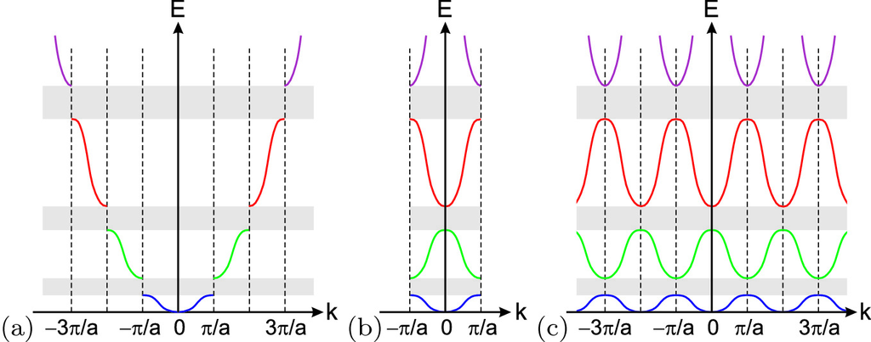

Fig. 6.1

Zone schemes for a band structure: **a** extended, **b** reduced and **c** repetitive zone scheme

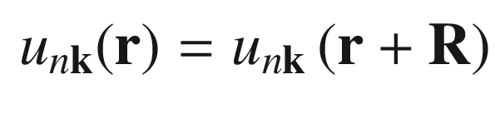

(6.4)

for all vectors

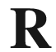

of the direct lattice. The proof is simple in one dimension and more involved in three dimensions with possibly degenerate wavefunctions, see [451].

If

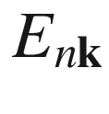

is an energy eigenvalue, then

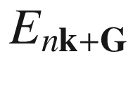

is also an eigenvalue for all vectors

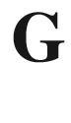

of the reciprocal lattice, i.e.

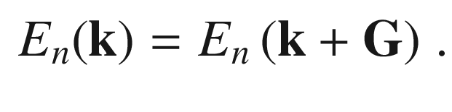

(6.5)

Thus the energy values are periodic in reciprocal space. The proof is simple, since the wavefunction (for

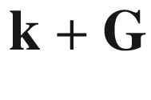

)

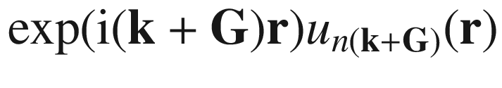

is for

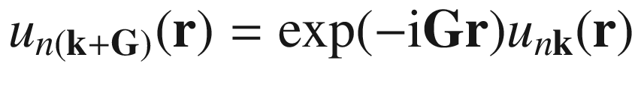

obviously an eigenfunction to

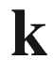

.

A band structure along one

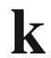

-direction can be displayed in various zone schemes as depicted in Fig. [6.1](#u116076_4_En_6_Chapter-Fig1). The most frequently used scheme is the *reduced* zone scheme. In three dimensions, the band structure is typically shown along particular paths in the Brillouin zone, as depicted, e.g., in Fig. [6.2](#u116076_4_En_6_Chapter-Fig2)c.

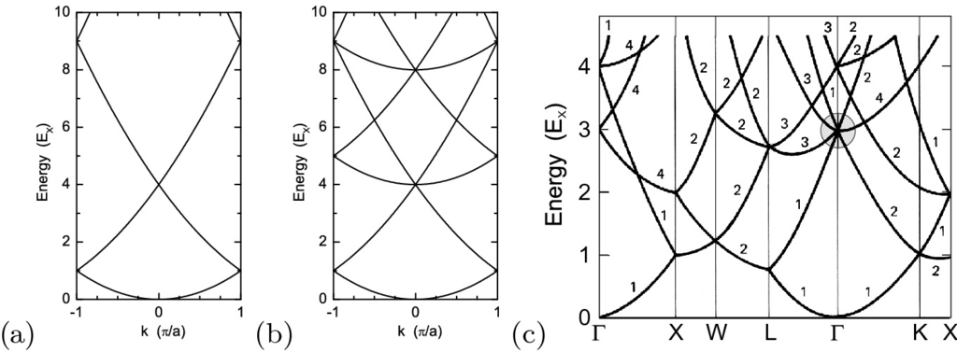

Fig. 6.2

Dispersion of free electrons (empty lattice calculation,

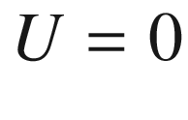

, shown in the first Brillouin zone) in **a** a one-dimensional lattice (

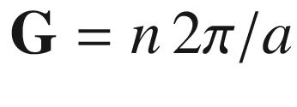

), **b** a simple cubic lattice (

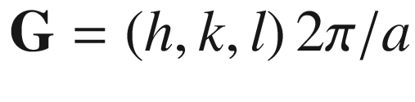

) and **c** in a fcc lattice. The energy is measured in units of the energy at the X-point,

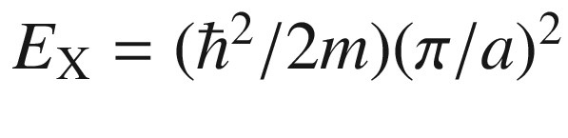

. The *shaded circle* in (**c**) represents the region where the band gap develops for finite periodic potential

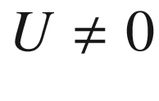

#### 6.2.2 Free-Electron Dispersion

If the entire wavefunction (from ([6.3](#u116076_4_En_6_Chapter-Equ3))) obeys the Schrödinger equation ([6.2](#u116076_4_En_6_Chapter-Equ2)), the Bloch function

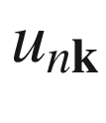

fulfills the equation

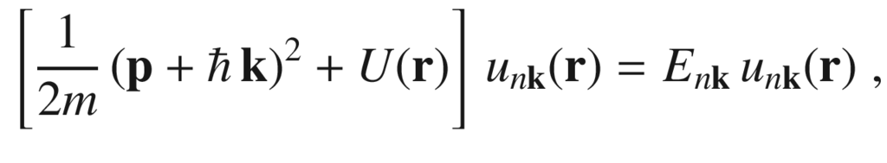

(6.6)

which is easy to see from

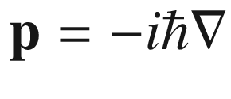

.

First, we discuss the simplest case of a periodic potential,

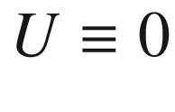

. This calculation is also called the *empty lattice* calculation. The solution of ([6.6](#u116076_4_En_6_Chapter-Equ6)) is then just constant, i.e.

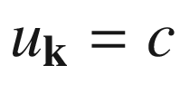

and

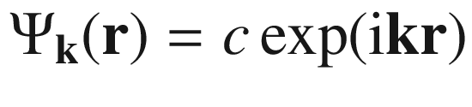

. The dispersion of the free electron is then given by

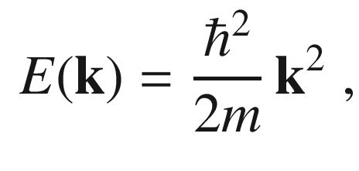

(6.7)

where

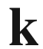

is an arbitrary vector in the reciprocal space.

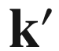

is a vector from the Brillouin zone such that

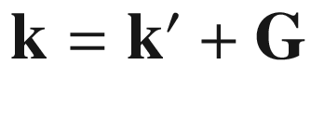

with a suitable reciprocal lattice vector

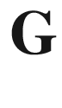

. Because of ([6.5](#u116076_4_En_6_Chapter-Equ5)) the dispersion relation can be written also as

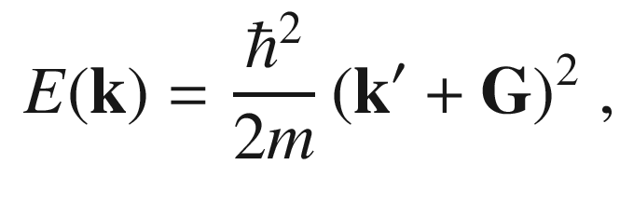

(6.8)

where

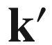

denotes a vector from the Brillouin zone. Thus, many branches of the dispersion relation arise from using various reciprocal lattice vectors in ([6.8](#u116076_4_En_6_Chapter-Equ8)).

The resulting dispersion relation for the free electron is shown in Fig. [6.2](#u116076_4_En_6_Chapter-Fig2)a for a one-dimensional system (

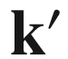

and

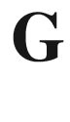

are parallel) and in Fig. [6.2](#u116076_4_En_6_Chapter-Fig2)b for the simple cubic lattice (in the so-called reduced zone scheme). In Fig. [6.2](#u116076_4_En_6_Chapter-Fig2)c, the (same) dispersion of the free electron is shown for the fcc lattice.

#### 6.2.3 Non-Vanishing Potential

Now the effect of a non-vanishing periodic potential on electron motion will be discussed. A simple, analytically solvable model that visualizes the effect of a periodic potential on the dispersion relation of the electrons and the formation of a (one-dimensional) band structure with gaps is the Kronig-Penney model [71] which is discussed in the Appendix F.

##### 6.2.3.1 General Wave Equation

In this section, we will discuss the solution of a general wave equation for electrons in a periodic potential. The solution is investigated particularly at the zone boundary. The potential *U* is periodic with the lattice ([6.1](#u116076_4_En_6_Chapter-Equ1)). It can be represented as a Fourier series with the reciprocal lattice vectors (lattice vector expansion, cf. ([3.​19](The_Physics_of_Semiconductors00001.docx#u116076_4_En_3_Chapter))):

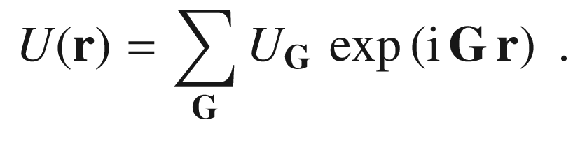

(6.9)

Since *U* is a real function,

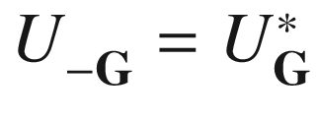

. The deeper reason for the success of such an approach is that for typical crystal potentials, the Fourier coefficients decrease rapidly with increasing

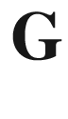

, e.g. for the unscreened Coulomb potential

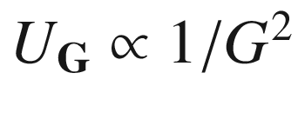

. The wavefunction is expressed as a Fourier series (or integral) over all allowed (Bloch) wavevectors

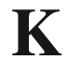

,

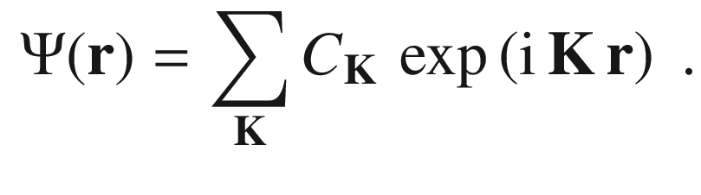

(6.10)

The kinetic and potential energy terms in the Schrödinger equation ([6.6](#u116076_4_En_6_Chapter-Equ6)) are

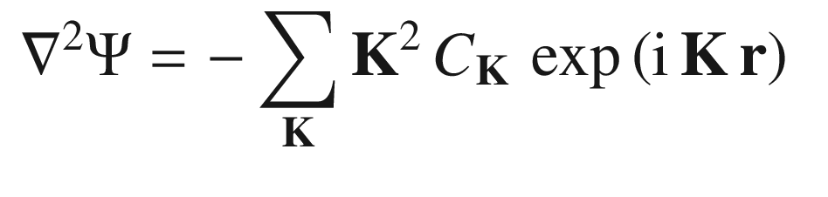

(6.11a)

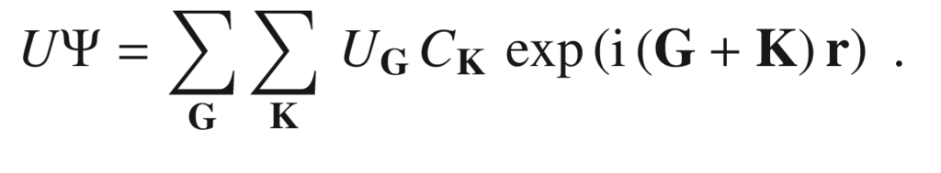

(6.11b)

With

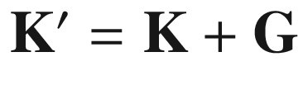

, ([6.11b](#u116076_4_En_6_Chapter-Equ12)) can be rewritten as

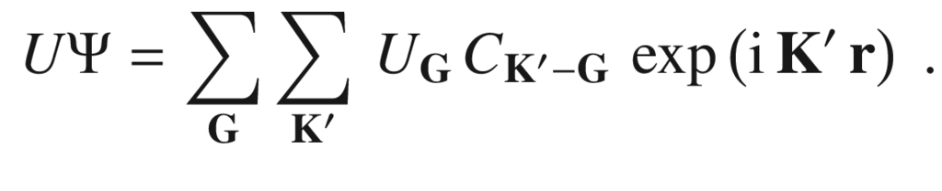

(6.12)

Now, the Schrödinger equation can be written as an (infinite) system of algebraic equations:

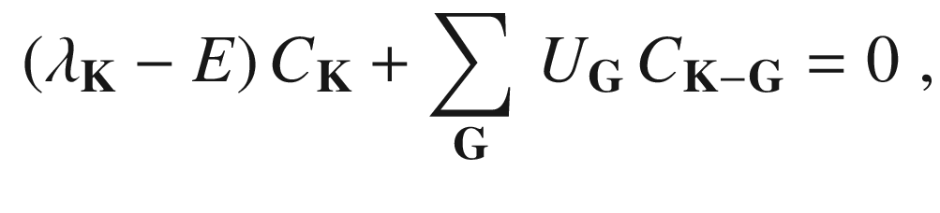

(6.13)

with

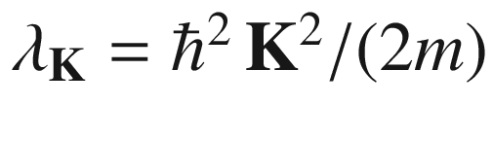

.

##### 6.2.3.2 Solution for One Fourier Coefficient

The simplest (non-trivial) potential energy has only one important Fourier coefficient

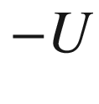

(

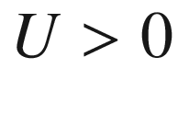

) for the shortest reciprocal lattice vector



. Also, we have

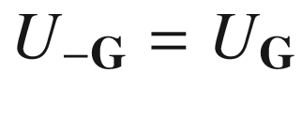

. Thus, the (one-dimensional) potential has the form

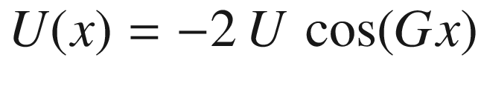

. Then the equation system ([6.13](#u116076_4_En_6_Chapter-Equ14)) has only two equations for

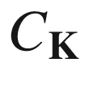

and

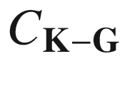

, leading to the condition

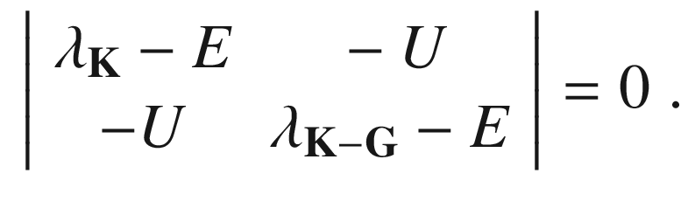

(6.14)

We find two solutions

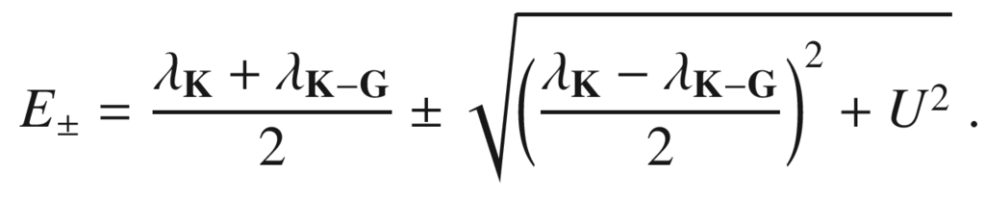

(6.15)

##### 6.2.3.3 Solution at the Zone Boundary

We consider the solution at the zone boundary, i.e. at

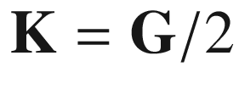

. The kinetic energy is then the same for

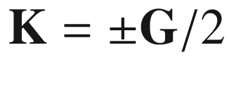

, i.e.

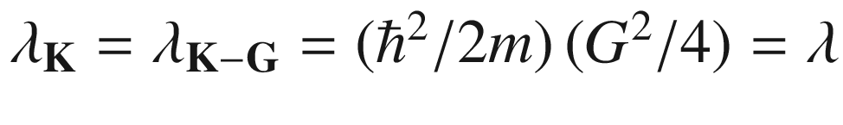

. The determinant ([6.14](#u116076_4_En_6_Chapter-Equ15)) reads then

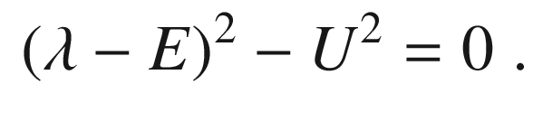

(6.16)

Thus the energy values at the zone boundary are

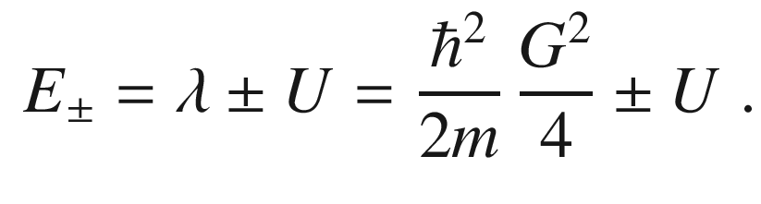

(6.17)

At the zone boundary, a splitting of the size

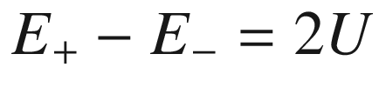

occurs. The center of the energy gap is given by the energy

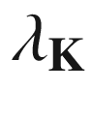

of the free-electron dispersion. The ratio of the coefficients is

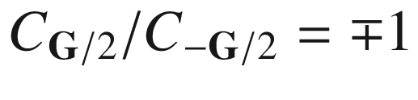

. The ‘−’ solution of ([6.17](#u116076_4_En_6_Chapter-Equ18)) (lower energy) is a standing cosine wave (

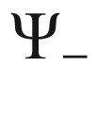

), the ‘

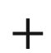

’ solution (

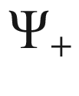

) is a standing sine wave as visualized in Fig. [6.3](#u116076_4_En_6_Chapter-Fig3). For the lower-energy (binding) state the electrons are localized at the potential minima, i.e. at the atoms, for the upper state (antibinding) the electrons are localized between the atoms. Both wavefunctions have the same periodicity since they belong to the same wavevector

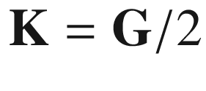

. We note that the periodicity of

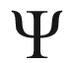

is 2*a*, while the periodicity of

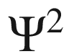

is equal to the lattice constant *a*.

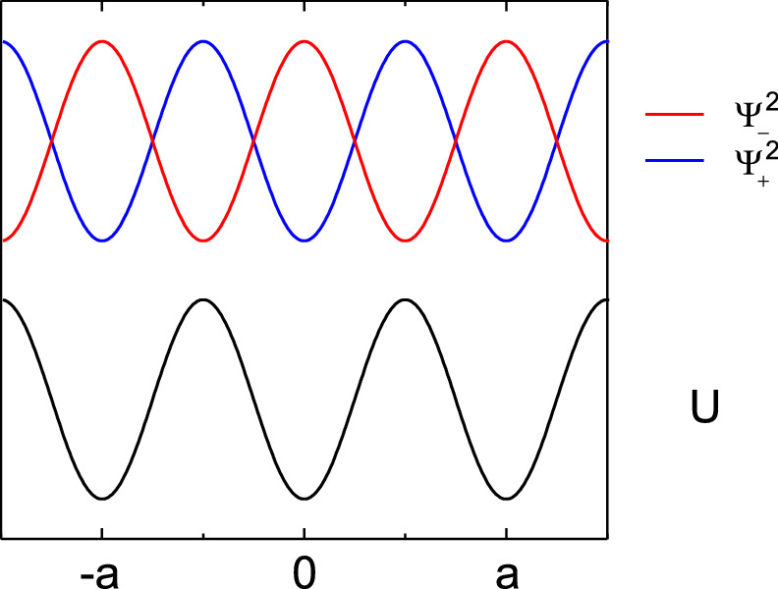

Fig. 6.3

Periodic potential U (one-dimensional cosine, *black*) and the squares of the wavefunctions

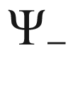

(*red*) and

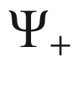

(*blue*) for the wavevector at the zone boundary,

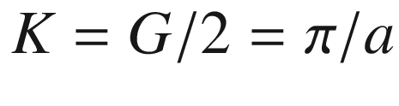

##### 6.2.3.4 Gap States

For energies within the gap, solutions with a *complex* wavevector

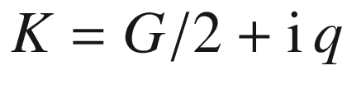

exist. Solving ([6.16](#u116076_4_En_6_Chapter-Equ17)) results (in terms of

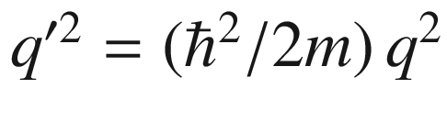

) to

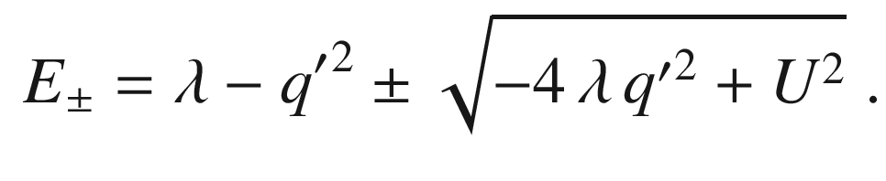

(6.18)

For energies

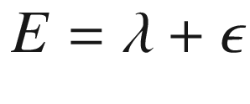

with

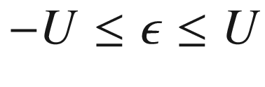

, the complex part of the wavevector is given by

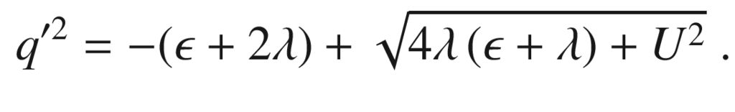

(6.19)

The maximum value of *q* is in the center of the band gap (

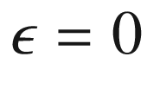

); for

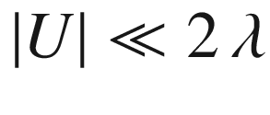

, it is

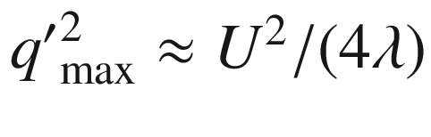

. At the band edges (

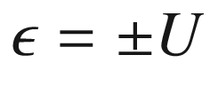

),

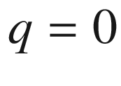

. *q* is the characteristic length of an exponentially decaying wave function. Such solutions occur at surfaces or interfaces. For larger band gaps, the localization length is smaller (larger *q*) (Fig. [6.4](#u116076_4_En_6_Chapter-Fig4)).

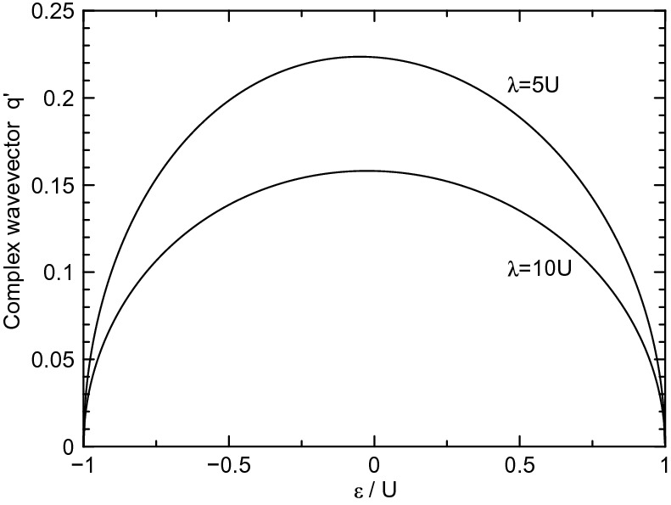

Fig. 6.4

Complex band structure

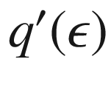

according to ([6.19](#u116076_4_En_6_Chapter-Equ20)) for two different values of

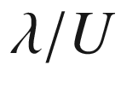

##### 6.2.3.5 Solution in the Vicinity of the Zone Boundary

For

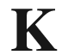

in the vicinity of the zone boundary the solutions ([6.15](#u116076_4_En_6_Chapter-Equ16)) can be developed. Therefore, we use the (small) distance from the zone boundary

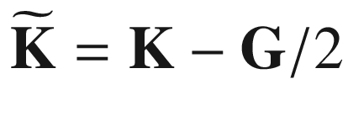

. With

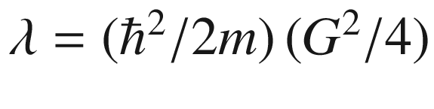

we rewrite still exactly ([6.15](#u116076_4_En_6_Chapter-Equ16)):

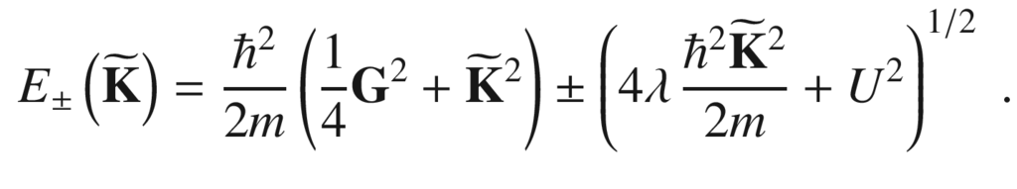

(6.20)

For small

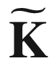

with

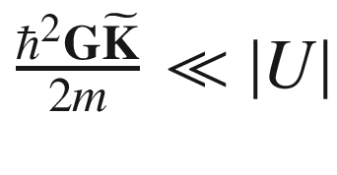

, the energy is then approximately given by

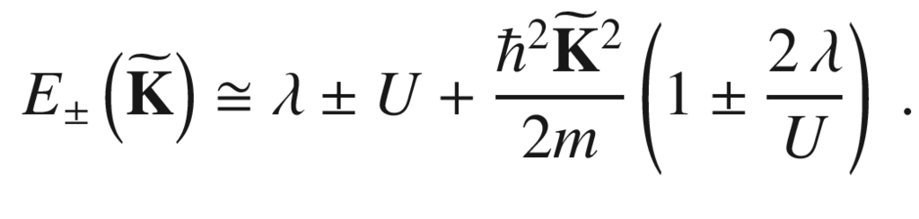

(6.21)

Thus the energy dispersion in the vicinity of the zone boundary is parabolic. The lower state has a negative curvature, the upper state a positive curvature. The curvature is

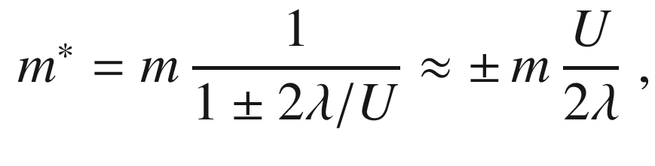

(6.22)

and will be later related to the *effective mass*. The approximation in ([6.22](#u116076_4_En_6_Chapter-Equ23)) is valid for

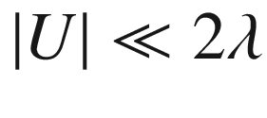

. We note that in our simple model

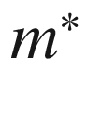

increases linearly with increasing band gap 2*U* (see Fig. [6.34](#u116076_4_En_6_Chapter-Fig34) for experimental data).

#### 6.2.4 Kramer’s Degeneracy

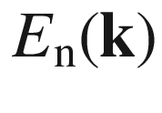

is the dispersion in a band. The time-reversal symmetry (Kramer’s degeneracy) implies

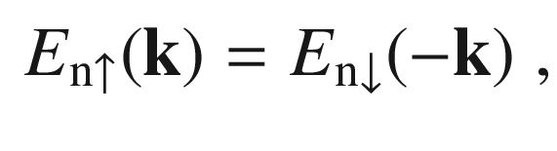

(6.23)

where the arrow refers to the direction of the electron spin. If the crystal is symmetric under inversion, we have additionally

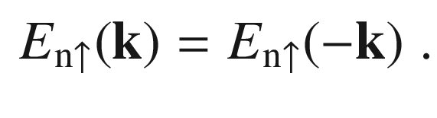

(6.24)

With both time reversal and inversion symmetry the band structure fulfills

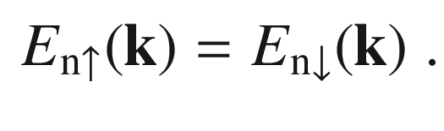

(6.25)

The inversion symmetry is particularly important for the spin-orbit interaction. In the absence of inversion symmetry, e.g. in (non-centrosymmetric) zincblende crystals (Fig. [3.​16](The_Physics_of_Semiconductors00002.docx#u116076_4_En_3_Chapter-Fig16)b) or in heterostructures (Fig. [12.​35](The_Physics_of_Semiconductors00005.docx#u116076_4_En_12_Chapter-Fig35)b), a spin splitting, e.g.

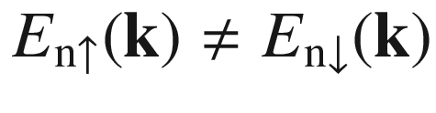

, is present. It can be thought of as provoked by an effective magnetic field. Bulk inversion asymmetry (BIA) leads to the Dresselhaus spin splitting [452, 453] that is shown in Fig. [6.5](#u116076_4_En_6_Chapter-Fig5) for GaAs (cmp. Fig. [6.10](#u116076_4_En_6_Chapter-Fig10)a). The spin splitting due to structural inversion asymmetry (SIA) is described by the Bychkov-Rashba Hamiltonian [454, 455]. A review on these topics can be found in [456].

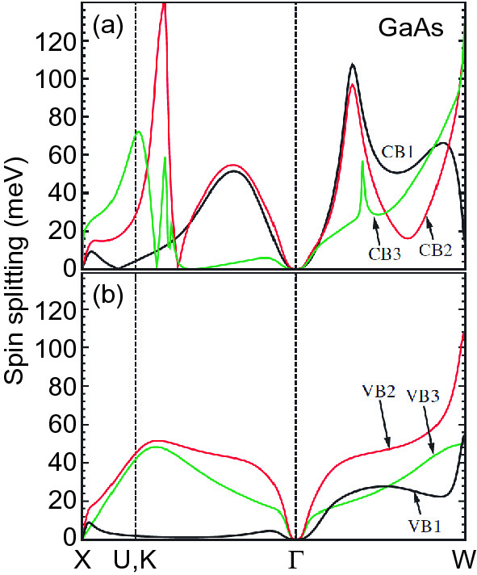

Fig. 6.5

Theoretical calculation of the spin splitting of **a** the three lowest conduction bands (CB1, CB2, and CB3) and **b** the top three valence bands (VB1, VB2, and VB3) of GaAs.

Adapted from [453]

#### 6.2.5 Symmetry Considerations

In general the symmetry of the lattice is a symmetry of the system’s Hamiltonian and thus transfers into the electronic (and other) properties of the semiconductor. The means to formulate this mathematically is group theory and representation theory. At a given reciprocal lattice point, the wave function must fulfill the given spatial symmetry. Additional symmetry due to spin and spin-orbit interaction enters via the double-group scheme. This problem has been treated for the 32 point groups (cmp. Table B.2) in [457] and in [458] particularly for the pc, fcc, bcc and hcp lattices. A detailed treatment for the zincblende [459] and wurtzite [460] structures have been given. The most popular Hamiltonians are treated in [461].

The symmetry at particular points in direct or reciprocal space is denoted by the irreducible representations of the symmetry (point) group, e.g. by the

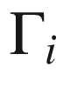

-symbols used in Figs. [6.9](#u116076_4_En_6_Chapter-Fig9), [6.10](#u116076_4_En_6_Chapter-Fig10) or also Fig. [6.44](#u116076_4_En_6_Chapter-Fig44). As an example, base functions with the symmetry of the irreducible representations of tetraeder group

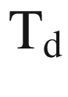

are listed in Table [6.1](#u116076_4_En_6_Chapter-Tab1). With the knowledge of the wave functions at the points of high symmetry, it is possible to deduce the general nature of the energy bands in the vicinity of such symmetry points.Table 6.1

Representations of the tetraeder group (zincblende structure) in molecular, BSW [462] and Koster [457] notation and (examples of) corresponding base functions (c.p.: cyclic permutations)

| molecular | BSW | Koster | base functions |
| --- | --- | --- | --- |
| A  $$_1$$ | $$\Gamma _1$$ | $$\Gamma _1$$ | $$x \, y \, z$$  ,  $$x^2+y^2+z^2$$ |
| A  $$_2$$ | $$\Gamma _2$$ | $$\Gamma _2$$ | $$x^4 \, (y^2-z^2)$$  + c.p. |
| E | $$\Gamma _{12}$$ | $$\Gamma _3$$ | $$2\,z^2 - (x^2+y^2)$$  ,  $$(x^2-y^2)$$ |
| T  $$_2$$ | $$\Gamma _{15}$$ | $$\Gamma _4$$ | *x*, *y*, *z*, *xy*, *xz*, *yz* |
| T  $$_1$$ | $$\Gamma _{25}$$ | $$\Gamma _5$$ | $$z \, (x^2-y^2)$$  and c.p. |

#### 6.2.6 Topological Considerations

Starting with research on the quantum Hall effect and based on previous mathematical theorems, it has become clear that the band structure of ‘insulators’ has topological properties which in turn lead to a elegant classification of materials (and many effects/phases) [370, 463, 464]. In this context, the term ‘insulator’ means a material with gap between filled and empty states, i.e. semiconductors are exactly like this if the temperature is not too high (related to the gap divided by

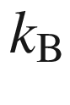

). We recall the discussion of the diatomic linear chain in Sect. [5.​2.​3](The_Physics_of_Semiconductors00002.docx#u116076_4_En_5_Chapter) where the bands turned out to have different topological properties depending on the ratio of sporing constants.

Topology is a branch of mathematics where objects that are related to each other by a smooth deformation are classified as the same. For example, a sphere and an ellipsoid are topologically the same. Also, a doughnut and a cup are the same since they have one hole. A quantity that is independent of such smooth transformations is termed ‘topological invariant’. Such a number is the *genus* *g* of a surface that counts the number of holes. According to the Gauss-Bonnet theorem, the integral of the Gaussian curvature *K* over a closed surface *S* is given by

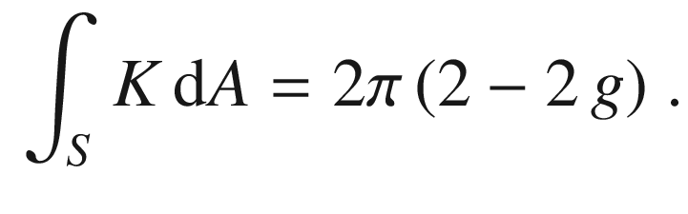

(6.26)

The Gaussian curvature

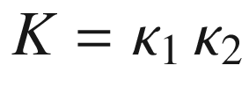

of a (differentiable) surface in 3D is the product of the principal curvatures

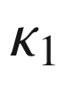

and

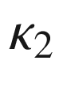

(maximum and minimum curvature of the curves from all normal planes that contain the normal vector intersecting with the surface). For a sphere of radius *r*, the Gaussian curvature is

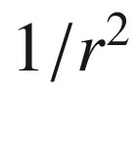

everywhere and the integral in ([6.26](#u116076_4_En_6_Chapter-Equ27)) is

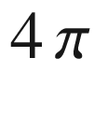

, making

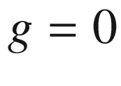

. For a topologically different example we look at a torus (all points that have the fixed distance *r* from a circle of radius *R*,

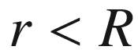

). It is parametrized by

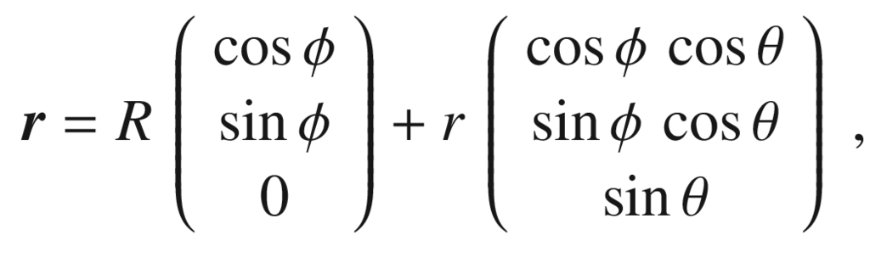

(6.27)

with both the angles

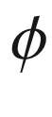

and

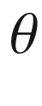

running between 0 and

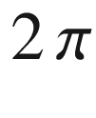

. The principal curvature

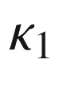

along the



-direction is 1/*r* (for all



). The other principal curvature

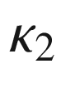

in azimuthal (



) direction changes sign with

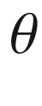

(positive outside, negative inside) and is also independent of

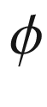

. Its integral over the outer and inner part cancel exactly, thus the integral of

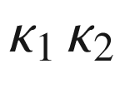

over the entire torus is zero and therefore

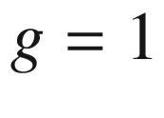

.

Next, we connect the periodicity of the Brillouin zone in two dimensions with variables on a torus in 3D as shown in Fig. [6.6](#u116076_4_En_6_Chapter-Fig6) (cmp. Fig. [5.​3](The_Physics_of_Semiconductors00002.docx#u116076_4_En_5_Chapter-Fig3) for the 1D case). This concept can be generalized for a 3D band structure and a torus in four dimensions.

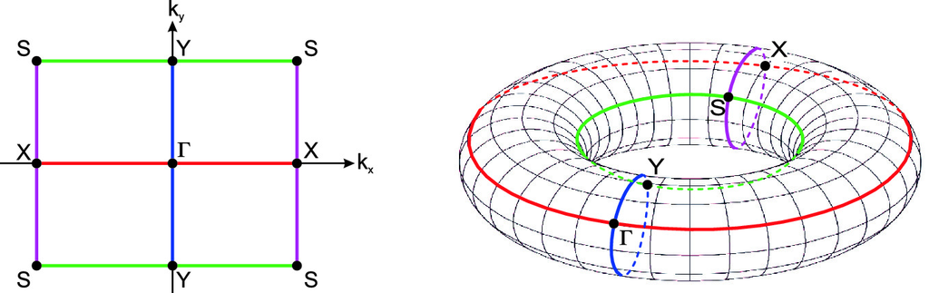

Fig. 6.6

Brillouin zone of a two-dimensional rectangular lattice and mapping to a torus

If a constant function

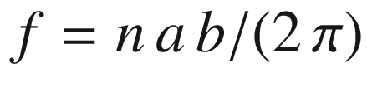

is integrated over the Brillouin zone (X is at

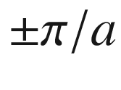

, Y is at

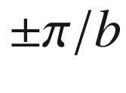

), the integral is

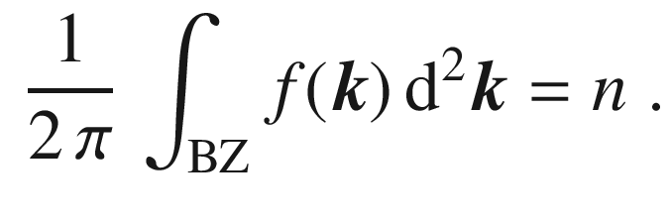

(6.28)

If for example another function *f* that is independent of

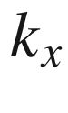

and changes sign in

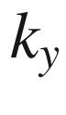

-direction with

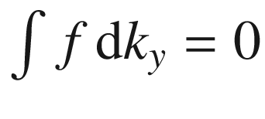

, similar to the curvature of the torus, is integrated over the Brillouin zone, the results will be zero. This is schematically shown in Fig. [6.7](#u116076_4_En_6_Chapter-Fig7) if the integrand is interpreted as curvature.

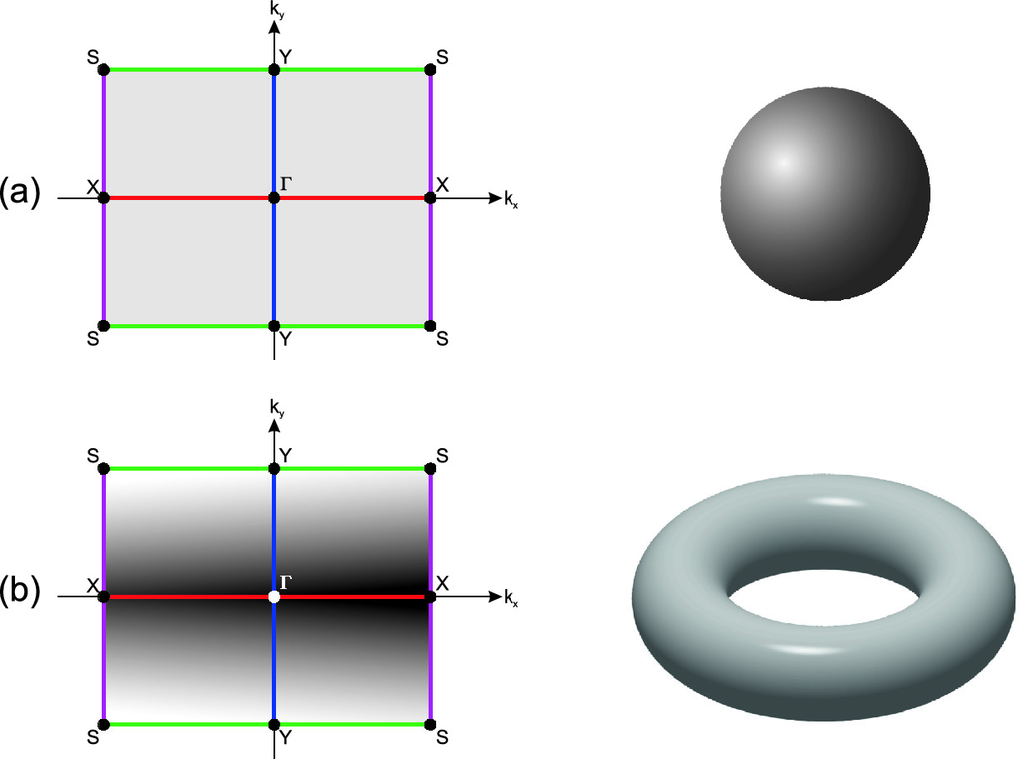

Fig. 6.7

Brillouin zone of a rectangular lattice with **a** a constant function and **b** a function that changes sign. On the right the topology of the situation is visualized

The generalization of the Berry phase [369]  to Bloch states has been made in [465, 466]. For a two-dimensional system with Bloch bands and with Bloch functions

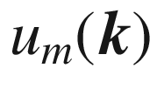

as in ([6.3](#u116076_4_En_6_Chapter-Equ3)), the integrand leading to a topological invariant is given by the Berry connection (cmp. ([5.​29](The_Physics_of_Semiconductors00002.docx#u116076_4_En_5_Chapter)))

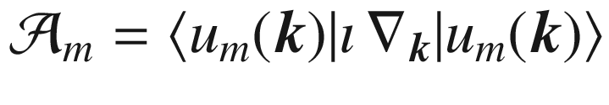

and its Berry curvature or Berry flux in three-dimensional notation

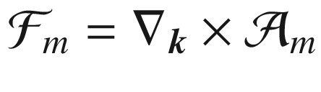

. The Chern number

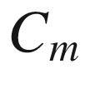

for a band (separated by gaps from other bands), defined as integral over the Brillouin zone,

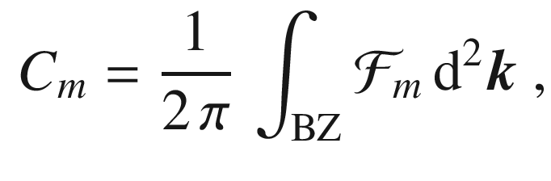

(6.29)

takes only integer values and is a topological invariant. That means that small variations of the Hamilton operator behind the band structure do not change its value. In the case of degeneracies, still the sum of Chern numbers over all occupied bands,

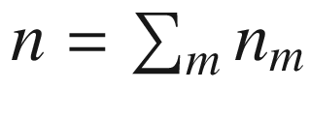

, is a topological invariant as long as the empty states are separated by a gap. For a three-dimensional crystal and

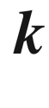

-space several topological invariants exist but a Chern number can be assigned to the Fermi surface or surface states (cmp. Sect. [11.​6.​3](The_Physics_of_Semiconductors00005.docx#u116076_4_En_11_Chapter)).

As an schematic example we show Fig. [6.8](#u116076_4_En_6_Chapter-Fig8) for a topological trivial and non-trivial band structure. In the trivial bandstructure (as most semiconductors), the phase character of the wavefunction changes only little within the Brillouin zone, mostly p-type (negative parity) for the valence band and mostly s-type (positive parity) for the conduction band (Fig. [6.8](#u116076_4_En_6_Chapter-Fig8)a). In the topologically non-trivial bandstructure, band inversion takes place and the character of the wave function changes within a band (Fig. [6.8](#u116076_4_En_6_Chapter-Fig8)c). This sketch should be compared to Fig. [5.​8](The_Physics_of_Semiconductors00002.docx#u116076_4_En_5_Chapter-Fig8) where a similar situation had been discussed for the lattice vibrations. An example for a semiconductor with band inversion is HgTe while CdTe or MnTe have trivial topology. Alloying leads at the transition from trivial to non-trivial (Fig. [6.8](#u116076_4_En_6_Chapter-Fig8)b) to zero-gap semiconductors (cf. Sect. [6.11](#u116076_4_En_6_Chapter-Sec39)).

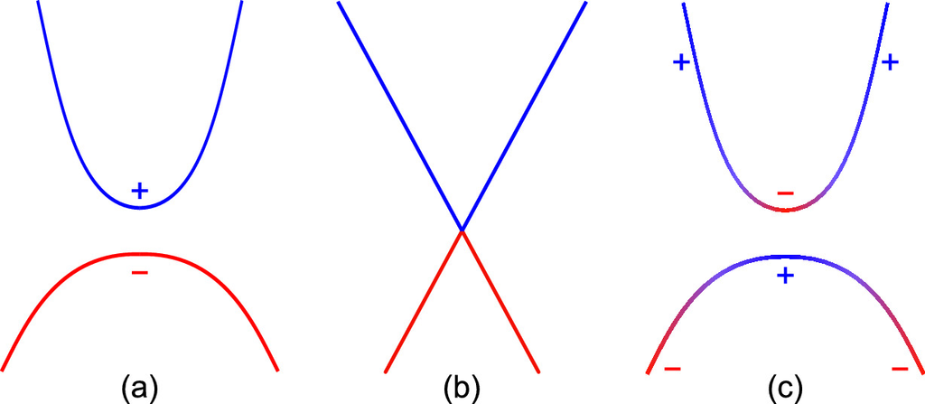

Fig. 6.8

Schematic band structures with (**a**) topologically trivial wave functions and **c** topologically non-trivial wave functions where within one band the character changes from s (*blue*, ‘

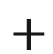

’ for positive parity) to p (*red*, ‘−’ for negative parity). In **b** the crossing point is visualized

### 6.3 Band Structures of Selected Semiconductors

In the following, the band structures of various important and prototype semiconductors are discussed. The band below the energy gap is called the valence band; the band above the gap is the conduction band. The band gap

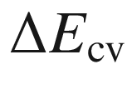

, mostly denoted as

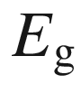

, is the energy separation between the highest valence-band state and the lowest conduction-band state. The maximum of the valence band is for most semiconductors at the

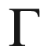

point .

#### 6.3.1 Silicon

For silicon, an elemental semiconductor, (Fig. [6.9](#u116076_4_En_6_Chapter-Fig9)a) the minimum of the conduction band is located close to the X-point at

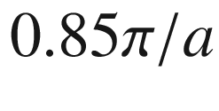

in the

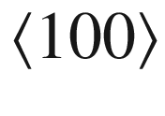

direction. Thus, it is not at the same point in

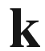

space as the top of the valence band. Such a band structure is called *indirect*. Since there are six equivalent

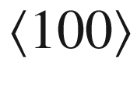

directions, there are six equivalent minima of the conduction band.

#### 6.3.2 Germanium

Germanium, another elemental semiconductor, (Fig. [6.9](#u116076_4_En_6_Chapter-Fig9)b) also has an indirect band structure. The conduction minima are at the L point in the

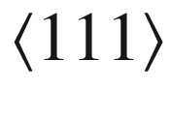

direction. Due to symmetry there are eight equivalent conduction-band minima.

#### 6.3.3 GaAs

GaAs (Fig. [6.10](#u116076_4_En_6_Chapter-Fig10)a) is a compound semiconductor with a *direct* band gap since the top of the valence band and the bottom of the conduction band are at the same position in



space (at the

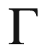

-point). The next highest (local) minimum in the conduction band is close to the L point.

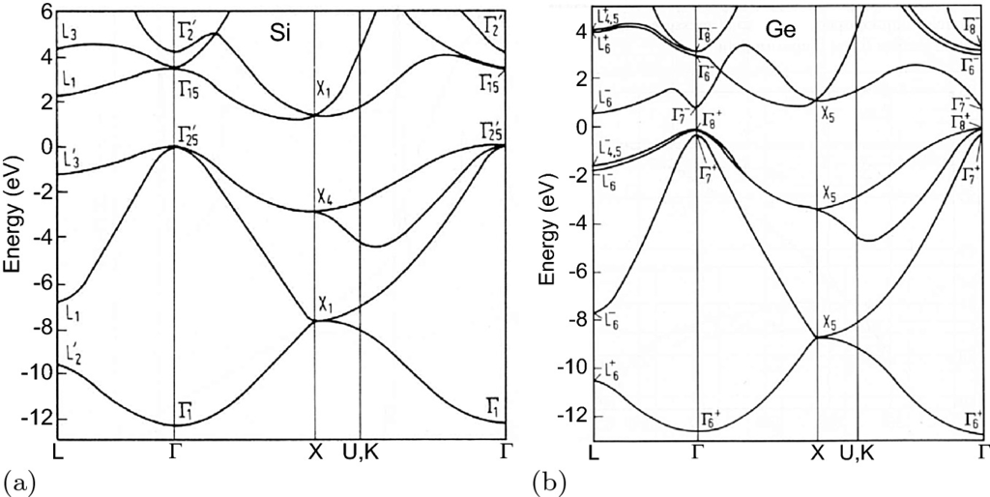

Fig. 6.9

Band structure of **a** silicon (indirect) and **b** germanium (indirect). In Si, the minima of the conduction band are in the

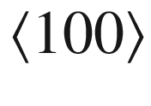

direction, for germanium in the

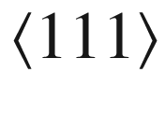

direction. Adapted from [164], based on [467]

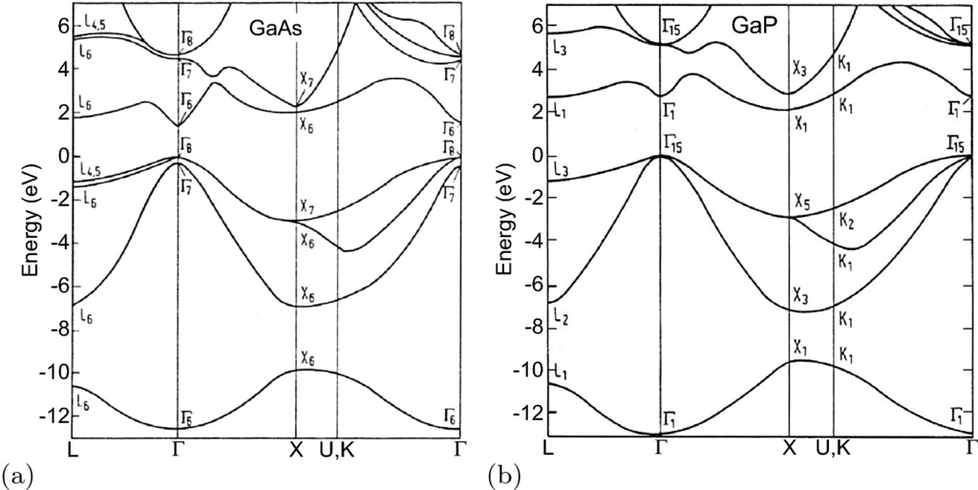

Fig. 6.10

Band structure of **a** GaAs (direct) and **b** GaP (indirect). For GaAs the minimum of the conduction band is at

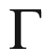

, for GaP in the



direction. Adapted from [164], based on [467]

#### 6.3.4 GaP

GaP (Fig. [6.10](#u116076_4_En_6_Chapter-Fig10)b) is an indirect compound semiconductor. The conduction-band minima are along the

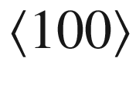

directions.

#### 6.3.5 GaN

GaN (Fig. [6.11](#u116076_4_En_6_Chapter-Fig11)) is a direct semiconductor that has wurtzite structure but can also occur in the metastable cubic (zincblende) phase.

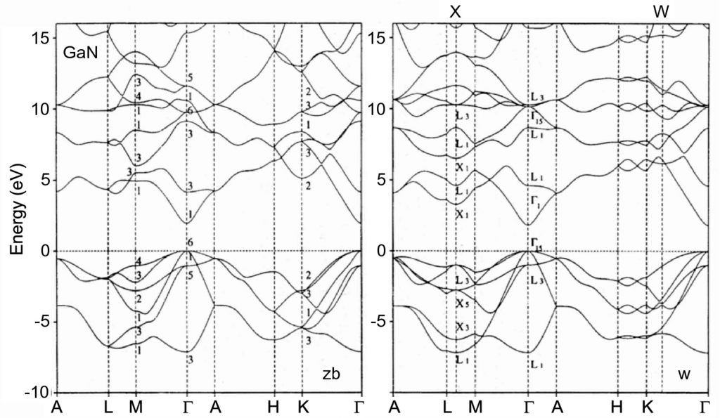

Fig. 6.11

Band structure of GaN (direct) in zincblende (zb) modification (*left*) and wurtzite (w) modification (*right*), both displayed in the wurtzite Brillouin zone to facilitate comparison

#### 6.3.6 Lead Salts

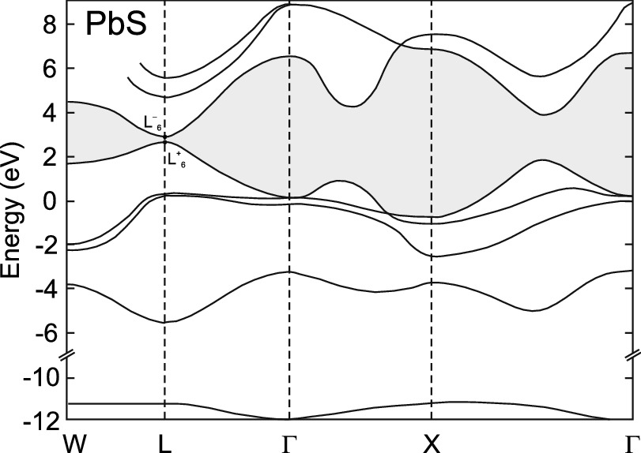

Fig. 6.12

Calculated band structure of PbS (direct). The energy gap is at the L point. The forbidden band is shown in *grey*. Adapted from [468]

The band gap of PbS (Fig. [6.12](#u116076_4_En_6_Chapter-Fig12)), PbSe and PbTe is direct and located at the L point. The lead chalcogenide system shows the anomaly that with increasing atomic weight the band gap does not decrease monotonically. At 300 K, the band gaps are 0.41, 0.27 and 0.31 eV for PbS, PbSe and PbTe, respectively.

#### 6.3.7 MgO, ZnO, CdO

Cadmium oxide is a cubic semiconductor in the rocksalt structure. Due to symmetry considerations, coupling (repulsion) of oxygen 2p- and cadmium 3d-orbitals does not occur at the zone center in the rocksalt structure. Repulsion occurs though away from the



-point and therefore the valence band maximum is not located at the zone center (Fig. [6.13](#u116076_4_En_6_Chapter-Fig13)). Thus CdO is an indirect semiconductor. A similar effect would occur in rs-ZnO due to zinc 3d orbitals; however, ZnO has wurtzite structure for which p–d coupling at the

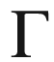

-point is allowed; thus ZnO is direct. In MgO, Mg of course only possesses populated s- and p-orbitals and no such repulsion is present; thus MgO even with its rocksalt structure is also direct [469].

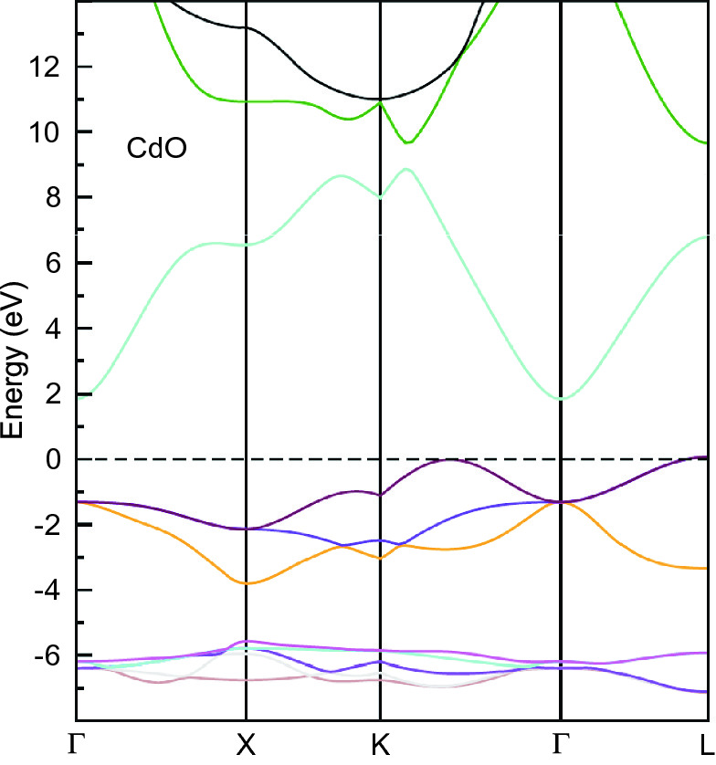

Fig. 6.13

Calculated indirect band structure of CdO. The top of the valence band is at

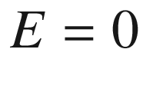

. Adapted from [470]

#### 6.3.8 Chalcopyrites

The experimental band gaps of a number of chalcopyrite semiconductors are listed in Table [6.2](#u116076_4_En_6_Chapter-Tab2). The band structures of CuAlS

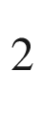

, CuAlSe

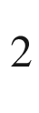

, and CuGaSe

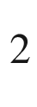

are compared in Fig. [6.14](#u116076_4_En_6_Chapter-Fig14).Table 6.2

Band gaps of various chalcopyrite semiconductors

| Material | $$E_{\mathrm {g}}$$  (eV) |  | $$E_{\mathrm {g}}$$  (eV) |  | $$E_{\mathrm {g}}$$  (eV) |
| --- | --- | --- | --- | --- | --- |
| CuAlS  $$_2$$ | 3.5 | CuGaS  $$_2$$ | 2.5 | CuInS  $$_2$$ | 1.53 |
| CuAlSe  $$_2$$ | 2.71 | CuGaSe  $$_2$$ | 1.7 | CuInSe  $$_2$$ | 1.0 |
| CuAlTe  $$_2$$ | 2.06 | CuGaTe  $$_2$$ | 1.23 | CuInTe  $$_2$$ | 1.0–1.15 |
| AgAlS  $$_2$$ | 3.13 | AgGaS  $$_2$$ | 2.55 | AgInS  $$_2$$ | 1.87 |
| AgAlSe  $$_2$$ | 2.55 | AgGaSe  $$_2$$ | 1.83 | AgInSe  $$_2$$ | 1.24 |
| AgAlTe  $$_2$$ | 2.2 | AgGaTe  $$_2$$ | 1.1–1.3 | AgInTe  $$_2$$ | 1.0 |
| ZnSiP  $$_2$$ | 2.96 | ZnGeP  $$_2$$ | 2.34 | ZnSnP  $$_2$$ | 1.66 |
| ZnSiAs  $$_2$$ | 2.12 | ZnGeAs  $$_2$$ | 1.15 | ZnSnAs  $$_2$$ | 0.73 |
| CdSiP  $$_2$$ | 2.45 | CdGeP  $$_2$$ | 1.72 | CdSnP  $$_2$$ | 1.17 |
| CdSiAs  $$_2$$ | 1.55 | CdGeAs  $$_2$$ | 0.57 | CdSnAs  $$_2$$ | 0.26 |

In Fig. [6.15](#u116076_4_En_6_Chapter-Fig15), the theoretical band structure of GaN and its closest related chalcopyrite ZnGeN

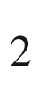

are compared, both shown in the chalcopyrite (orthorhombic) Brillouin zone. The band gap of ZnGeN



is smaller than that of GaN and the difference of 0.4 eV is fairly well reproduced by the calculation[2](#u116076_4_En_6_Chapter-Fn2) (giving 0.5 eV).

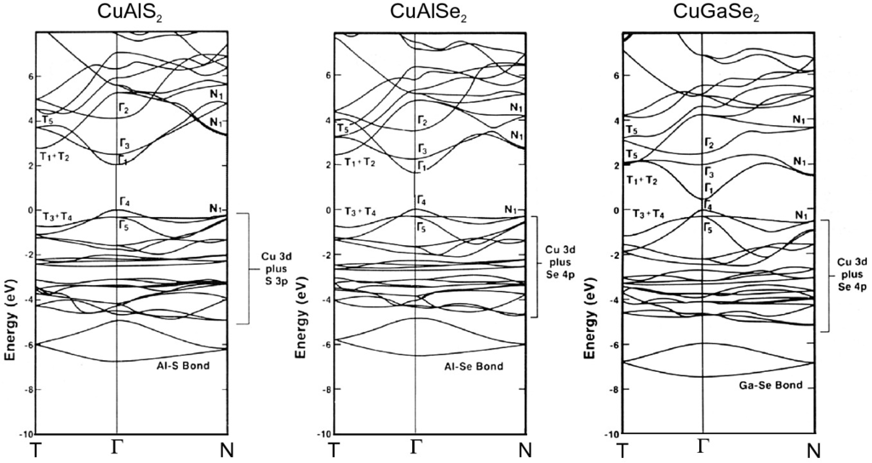

Fig. 6.14

Calculated band structures of CuAlS

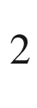

, CuAlSe



, and CuGaSe



. The absolute values of the gap energies are incorrect due to LDA calculation. Adapted from [471]

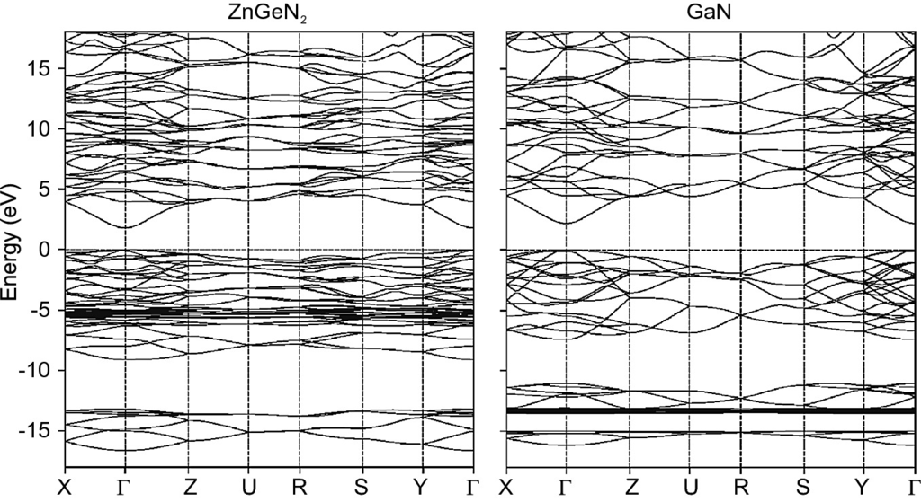

Fig. 6.15

Calculated (within LDA) band structures of ZnGeN



and its related III–V compound GaN, both displayed in the chalcopyrite (orthorhombic) Brillouin zone to facilitate comparison. Adapted from [472]

#### 6.3.9 Spinels

The band structure of spinels (in particular CdIn



S

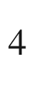

) has been discussed in [473], the band structure of ZnM



O

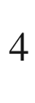

has been calculated in [470] for (M = Co, Rh, Ir) (Fig. [6.16](#u116076_4_En_6_Chapter-Fig16)) and in [474] for (M = Al, Ga, In).

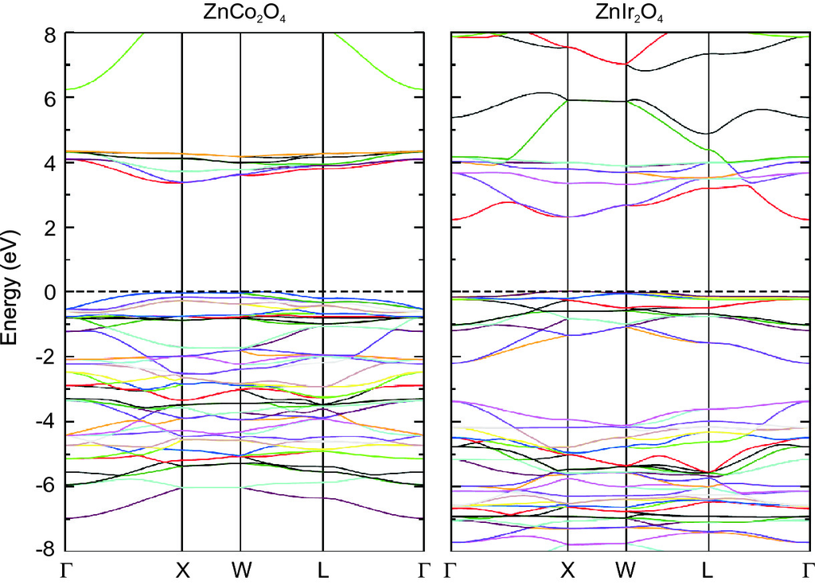

Fig. 6.16

Calculated band structures of ZnCo

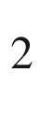

O

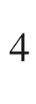

and ZnIr

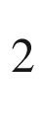

O

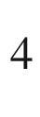

. Adapted from [470]

#### 6.3.10 Delafossites

In Fig. [6.17](#u116076_4_En_6_Chapter-Fig17), the theoretical band structures of the delafossites CuAlO



, CuGaO



, and CuInO

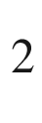

are shown. The maximum of the valence band is not at

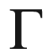

but near the F point. The direct band gap at

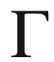

decreases for the sequence Al

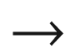

Ga

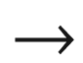

In, similar to the trend for AlAs, GaAs and InAs. The direct band gap at F and L, causing the optical absorption edge, increases, however (experimental values are 3.5, 3.6, and 3.9 eV).

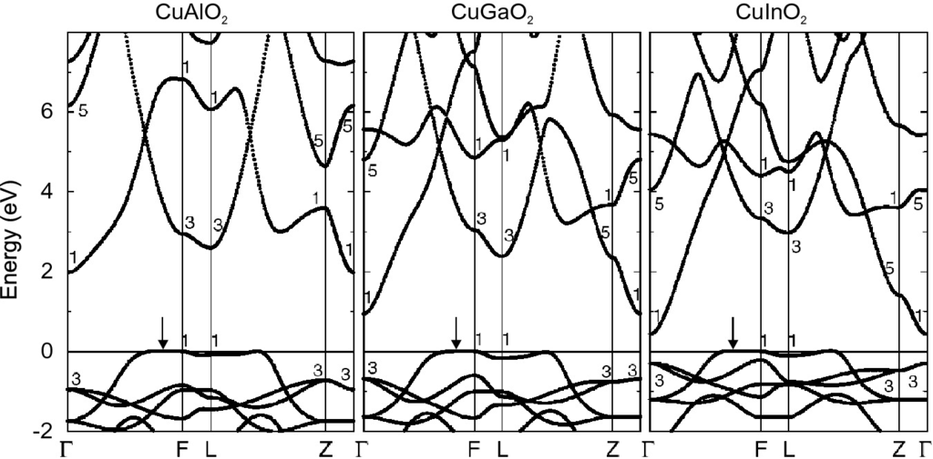

Fig. 6.17

Band structures of CuAlO

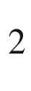

, CuGaO

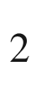

, and CuInO



, calculated with LDA (underestimating the absolute value of the band gaps). The *arrows* denote the maximum of the valence band that has been set to zero energy for each material. Adapted from [226]

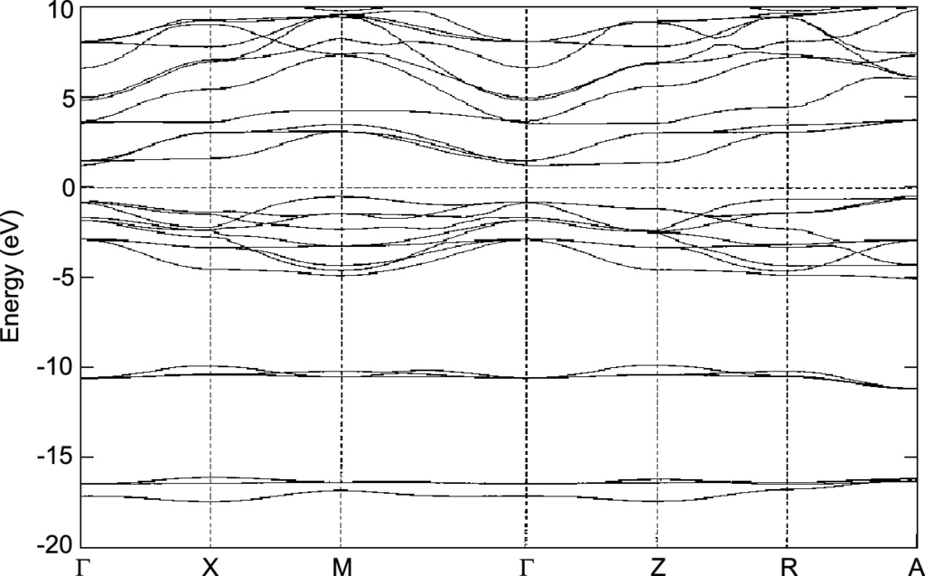

Fig. 6.18

Calculated energy band structure of BaTiO

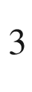

along the major symmetry directions. The Fermi level (

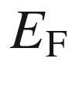

) is set at zero energy. Adapted from [475]

#### 6.3.11 Perovskites

The calculated band structure of BaTiO

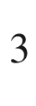

in the tetragonal phase is shown in Fig. [6.18](#u116076_4_En_6_Chapter-Fig18). The minimum of the conduction band is at the

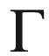

-point . The maximum of the valence band is not at the

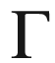

-point but at the M point. The band gap of the LDA[3](#u116076_4_En_6_Chapter-Fn3) calculation is too small (2.2 eV) compared to the experimental value

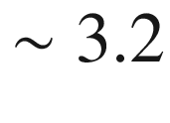

 eV.

The band structure of the halide perovskites has been calculated for hybrid organic-inorganic compounds like MAPbI



and FAPbI

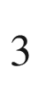

[476] and fully inorganic compounds APbI



(A = Li, Na, K, Rb, and Cs) [477]. Density of states and energy positions of (MA,FA,Cs)(Pb,Sn)(Cl,Br,I)



compounds are discussed in [478]. The trends are summarized in Fig. [6.19](#u116076_4_En_6_Chapter-Fig19). The band gap of halide perovskites can be varied across the visible range, e.g. within the CsPb(Cl,Br,I)

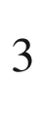

the system (Fig. [6.20](#u116076_4_En_6_Chapter-Fig20)).

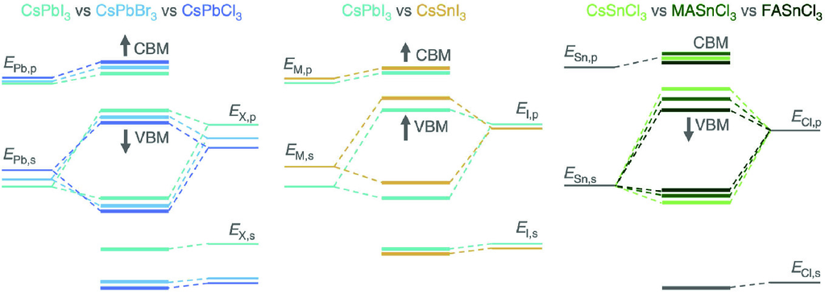

Fig. 6.19

Schematic energy levels in ABX



perovskites. Arrows indicate the shift of energy levels upon substitution of atoms or small organic molecules. Adapted from [478]

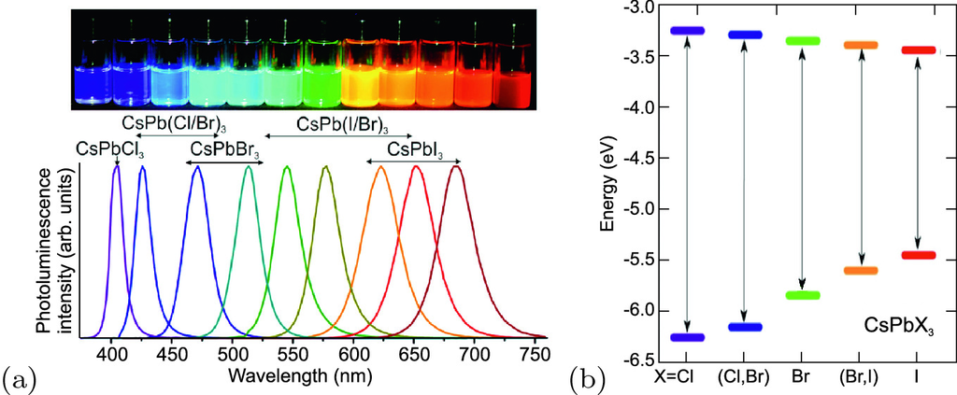

Fig. 6.20

**a** Photoluminescence of CsPbX

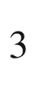

nanocrystals of halide perovskites with various anions (colloidal solutions in toluene under UV lamp (

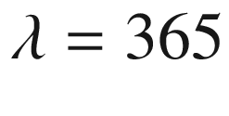

 nm)). Adapted from [479]. **b** Position of conduction and valence band edges of CsPbX



halide perovskites (relative to vacuum level at zero). Adapted from [480]

### 6.4 Systematics of Semiconductor Band Gaps

The trends with regard to the size of the band gap for elemental, III–V and II–VI semiconductors  can essentially be understood in terms of the bond strength and ionicity. In Fig. [6.21](#u116076_4_En_6_Chapter-Fig21), the band gaps of many important semiconductors are shown as a function of the lattice constant. For elemental semiconductors, the band gap decreases with reduced bond strength, i.e. lattice constant (C

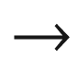

Si

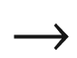

Ge). A similar trend exists both for the III–V and the II–VI semiconductors.

For the same lattice constant, the band gap increases with increasing ionicity, i.e. IV–IV

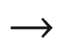

III–V

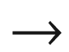

II–VI

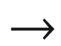

I–VII. A typical example is the sequence Ge



GaAs

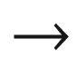

ZnSe

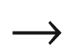

CuBr, for which all materials have almost the same lattice constant, and the band gaps increase 0.66 eV



1.42 eV



2.7 eV



2.91 eV.

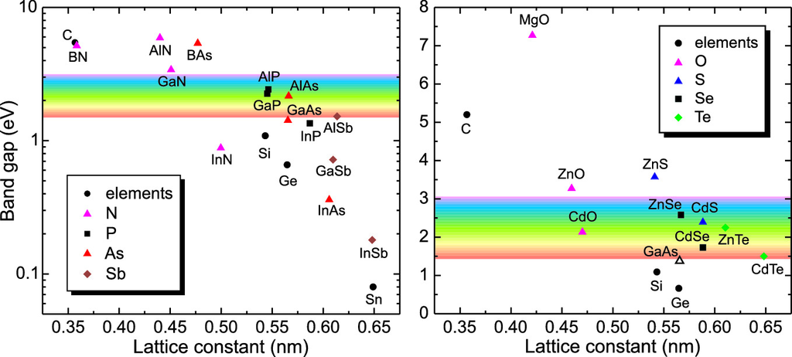

Fig. 6.21

Band gaps as a function of the lattice constant for various elemental, III–V and II–VI semiconductors. The lattice constant of wurtzite semiconductors has been recalculated for a cubic cell (

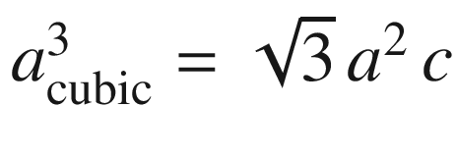

)

This behavior can be understood within the framework of a modified Kronig-Penney model [481] (Appendix F). Double potential wells (

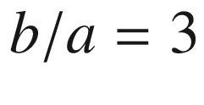

) are chosen to mimic the diatomic planes along the

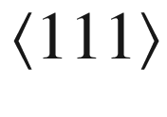

direction in the zincblende structure (Fig. [6.22](#u116076_4_En_6_Chapter-Fig22)a). The first investigation of such diatomic one-dimensional bandstructure was reported in [482]. Symmetric wells (depth

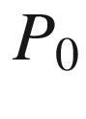

) are chosen to model covalent semiconductors and asymmetric wells with depths

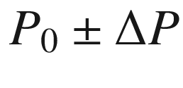

to model partially ionic semiconductors. Results are shown in Fig. [6.22](#u116076_4_En_6_Chapter-Fig22)a for

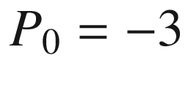

. With increasing asymmetry, i.e. increasing ionicity, the band gap increases, mostly due to a downward shift of the valence band. The case of III–V (II–VI) semiconductors is reached for

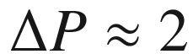

(4). The calculation of effective masses in [481] is incorrect and has been rectified in [483]; the effective mass increases monotonically with

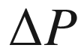

.

In Fig. [6.23](#u116076_4_En_6_Chapter-Fig23), the visual impression of 2" wafers of GaAs, GaP and GaN on white paper is shown. GaAs (and GaSb) is opaque since the band gap is below the visible spectral range. GaP has a band gap in the green and appears red, GaN has a band gap in the ultra-violet and thus appears transparent. As can be seen from Table [6.3](#u116076_4_En_6_Chapter-Tab3), the anion sequence Sb, As, P, and N leads to smaller lattice constant and higher ionicity. A notable deviation from this rule is InN whose band gap (0.7 eV) is much smaller than that of InP [484].

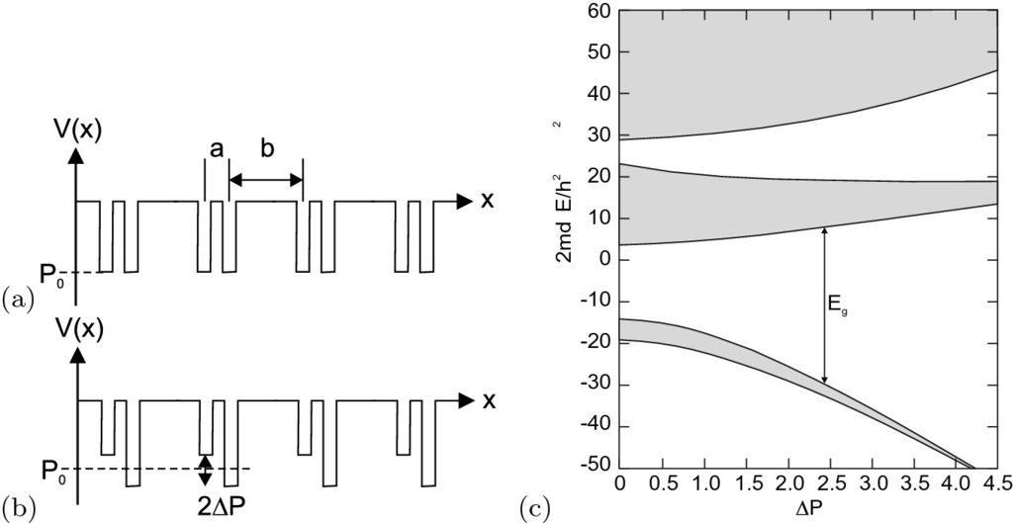

Fig. 6.22

Kronig-Penney model (along

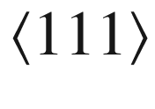

,

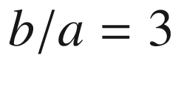

) for *a* **a** IV–IV semiconductor and **b** for a III–V (or II–VI) semiconductor, **c** resulting band structure (

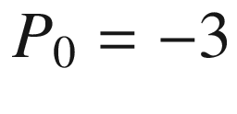

). *d* denotes the lattice constant (

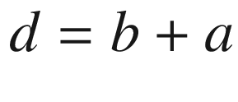

). Adapted from [481]

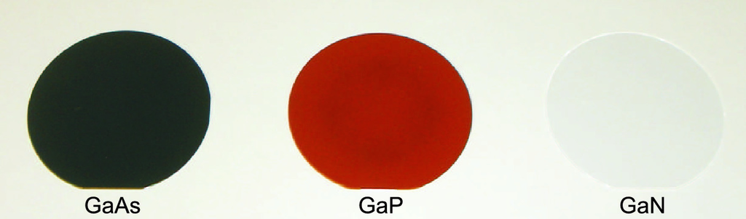

Fig. 6.23

Optical image of two inch wafers of GaAs (*left*), GaP (*center*) and ZnO (*right*). A GaN wafer would look like the ZnO wafer

Table 6.3

Comparison of band gap, lattice constant and ionicity of gallium–group V semiconductors for various anions. Lattice constant for GaN has been recalculated for a cubic cell

| Anion | $$E_{\mathrm {g}}$$  (eV) | $$a_0$$  (nm) | $$f_{\mathrm {i}}$$ |
| --- | --- | --- | --- |
| N | 3.4 | 0.45 | 0.50 |
| P | 2.26 | 0.545 | 0.33 |
| As | 1.42 | 0.565 | 0.31 |
| Sb | 0.72 | 0.61 | 0.26 |

### 6.5 Alloy Semiconductors

In alloy semiconductors [166], the size of the band gap and the character of the band gap will depend on the composition. The dependence of the band gap on the ternary composition is mostly nonlinear and can usually be expressed with a bowing parameter *b* that is mostly positive. For a compound A

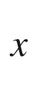

B

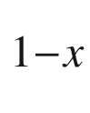

C the band gap is written as



(6.30)

Even on the virtual crystal approximation (VCA) level (Sect. [3.​7.​3](The_Physics_of_Semiconductors00001.docx#u116076_4_En_3_Chapter)) a nonzero bowing parameter *b* is predicted. However, a more thorough analysis shows that the bowing cannot be treated adequately within VCA and is due to the combined effects of volume deformation of the band structure with the alloy lattice constant, charge exchange in the alloy with respect to the binary end components, a structural contribution due to the relaxation of the cation–anion bond lengths in the alloy and a small contribution due to disorder [485]. The discussion of Sect. [6.12.3](#u116076_4_En_6_Chapter-Sec43) is related.

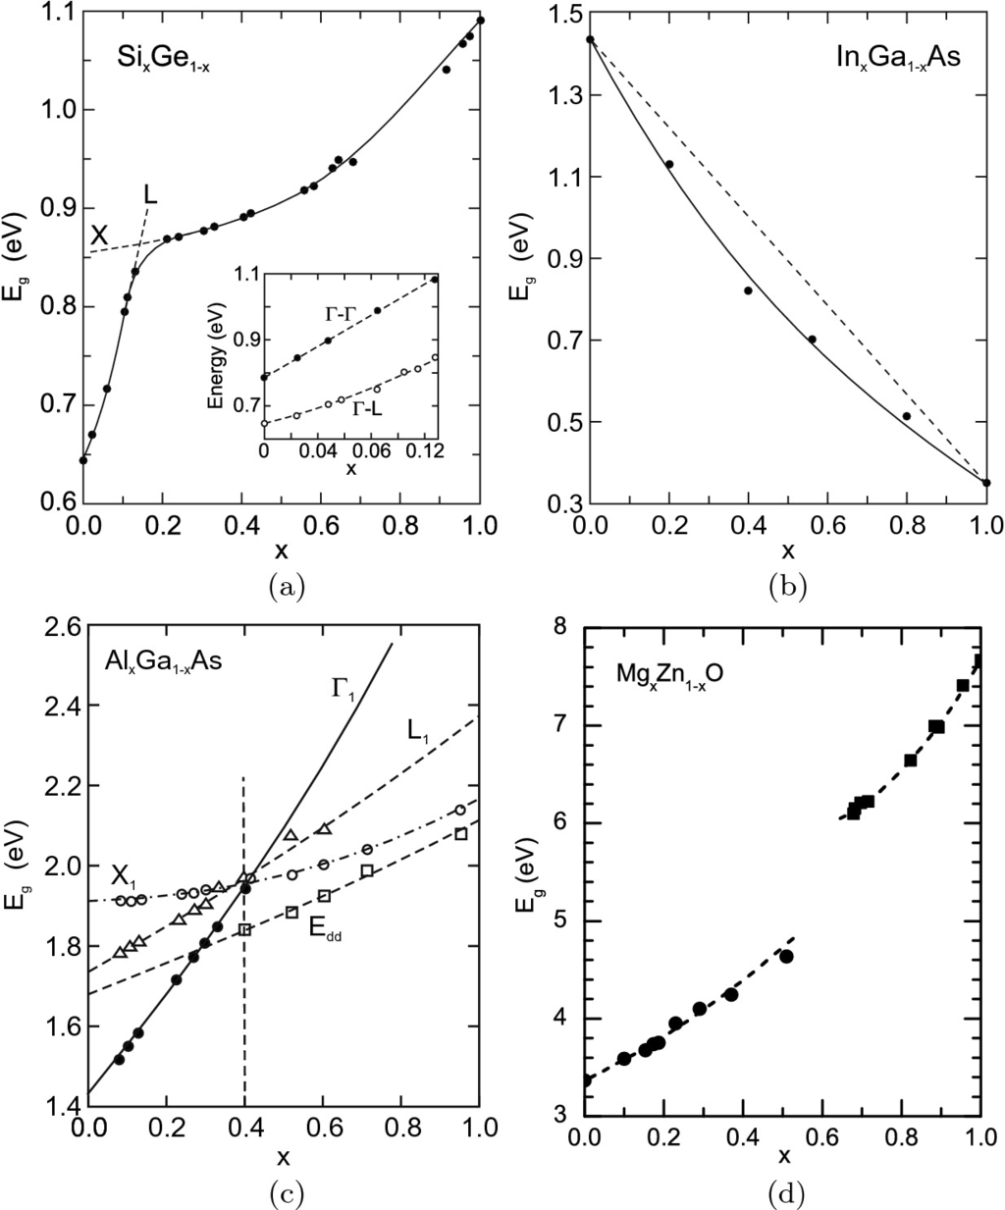

Fig. 6.24

**a** Band gap of Si



Ge

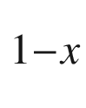

alloy (

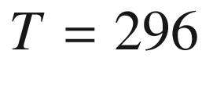

 K) with a change from the conduction-band minimum at L (Ge-rich) to X. The *inset* depicts the transition energy of the indirect (



–L) and direct (



–



) absorption edge for low Si content. Adapted from [489]. **b** Band gap (at room temperature) of In

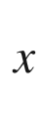

Ga

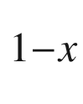

As. The *solid line* is an interpolation with bowing (

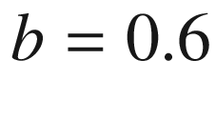

 eV) and the *dashed line* is the linear interpolation. Data from [486]. **c** Band gap (at room temperature) in the ternary system Al

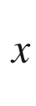

Ga



As. For

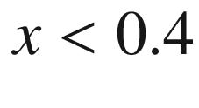

the alloy is a direct, for

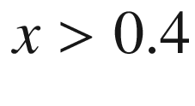

an indirect, semiconductor.

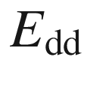

denotes the energy position of a deep donor (cf. Sect. [7.​7.​6](#u116076_4_En_7_Chapter)). Adapted from [490]. **d** Band gap (at room temperature) in the ternary system Mg



Zn

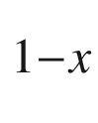

O. Data (from spectroscopic ellipsometry [491, 492]) are for hexagonal wurtzite phase (*circles*), and Mg-rich cubic rocksalt phase (*squares*). *Dashed lines* are fits to data with a different bowing parameter for each phase

The Si

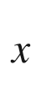

Ge

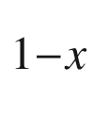

alloy has diamond structure for all concentrations and the position of the conduction-band minimum in



-space switches from L to X at about

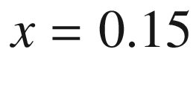

(Fig. [6.24](#u116076_4_En_6_Chapter-Fig24)a). However, for all concentrations the band structure is indirect. The In

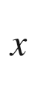

Ga



As alloy has zincblende structure for all compositions. The band gap is direct and decreases with a bowing parameter of

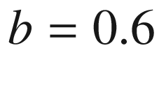

 eV [486] (Fig. [6.24](#u116076_4_En_6_Chapter-Fig24)b). This means that for

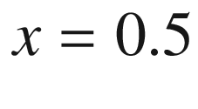

the band gap is 0.15 eV smaller than expected from a linear interpolation between GaAs and InAs, as reported by various authors [487].

If one binary end component has a direct band structure and the other is indirect, a transition occurs from direct to indirect at a certain composition. An example is Al

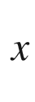

Ga

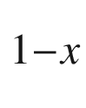

As where GaAs is direct and AlAs is indirect . For all concentrations the crystal has zincblende structure. In Fig. [6.24](#u116076_4_En_6_Chapter-Fig24)c, the



, L and X  conduction-band minima for ternary Al



Ga



As are shown. Up to an aluminum concentration of

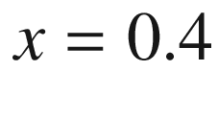

the band structure is direct. Above this value the band structure is indirect with the conduction-band minimum being at the X-point. The particularity of Al

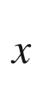

Ga

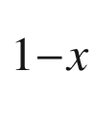

As is that its lattice constant is almost independent of *x*. For other alloys lattice match to GaAs or InP substrates is only obtained for specific compositions, as shown in Fig. [6.25](#u116076_4_En_6_Chapter-Fig25). The band gap bowing in the group-III–nitride system has been discussed in [488].

If the two binary end components have different crystal structure, a phase transition occurs at a certain composition (range). An example is Mg



Zn



O, where ZnO has wurtzite structure and MgO has rocksalt structure. The band gap is shown in Fig. [6.24](#u116076_4_En_6_Chapter-Fig24)d. In this case, each phase has its own bowing parameter.

All alloys of Fig. [6.24](#u116076_4_En_6_Chapter-Fig24)b–d have mixed cations. The band gap also varies upon anion substitution in a similar way as shown in Fig. [6.26](#u116076_4_En_6_Chapter-Fig26) for ternary alloys with the cation Zn and the chalcogenides S, Se, Te and O.

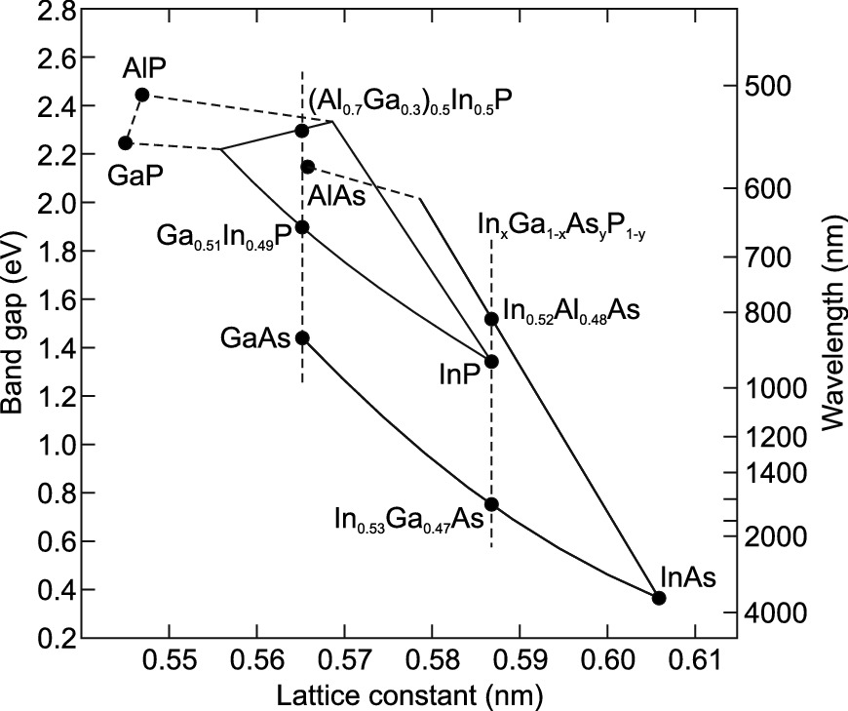

Fig. 6.25

Band gap versus lattice constant for Ga

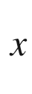

In

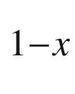

P and Al



In



P (lattice matched to GaAs) as well as for In



Al



As and In



Ga



As alloys (lattice matched to InP)

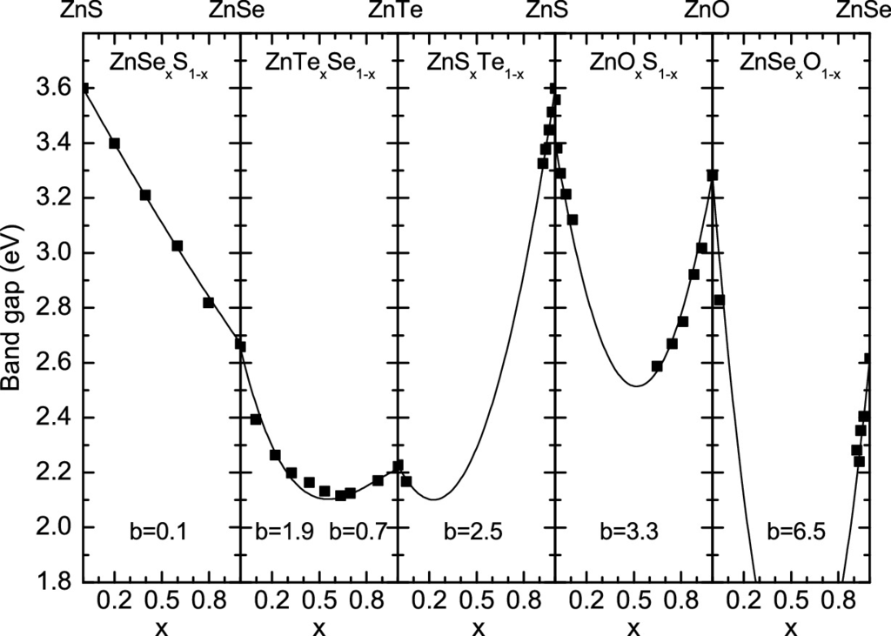

Fig. 6.26

Band gap of various Zn-based alloys with mixing in the anion sublattice. The *lines* are fits with ([6.30](#u116076_4_En_6_Chapter-Equ31)), the bowing parameter *b* is labeled. Data for Zn(S,Se,Te) from [493], for Zn(O,Se/Te) from [494]

### 6.6 Amorphous Semiconductors

Since the crystal lattice in an amorphous semiconductor is not periodic, the concept of

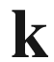

-space and the related concepts such as band structure

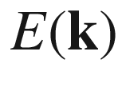

break down at least partially. The density of states, however, remains a meaningful and useful quantity (Sect. [6.13.2](#u116076_4_En_6_Chapter-Sec46)).

In a perfectly crystalline semiconductor the eigenenergies of the states in the bands are real. An amorphous semiconductor can be modeled using a spectrum of complex energies [495]. In Fig. [6.27](#u116076_4_En_6_Chapter-Fig27) the band structure of crystalline silicon is shown next to that calculated for amorphous silicon with

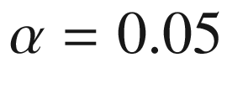

.

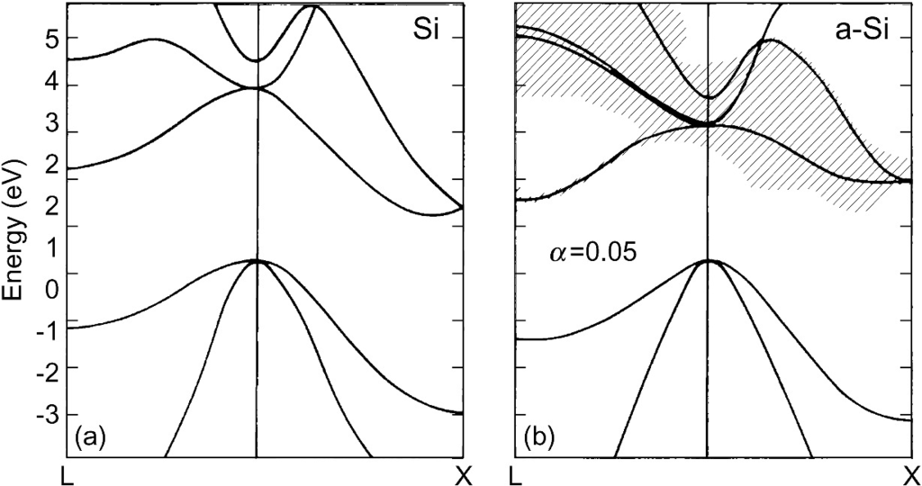

Fig. 6.27

**a** Calculated band structure of crystalline silicon. **b** Calculated band structure of amorphous silicon with

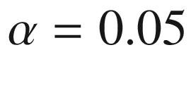

(cf. ([3.​7](The_Physics_of_Semiconductors00001.docx#u116076_4_En_3_Chapter))). The *solid lines* denote the real part of the energy, the *shaded areas* denote the regions with a width of twice the imaginary part of the energies centered around the real part. Adapted from [496]

### 6.7 Temperature Dependence of the Band Gap

The band gap of a semiconductor typically decreases with increasing temperature. A direct visual impression can be obtained from the *same* LED chain at room temperature and dipped into liquid nitrogen (Fig. [6.28](#u116076_4_En_6_Chapter-Fig28)). Experimental data of band gap versus temperature are shown in Fig. [6.29](#u116076_4_En_6_Chapter-Fig29) for bulk Si and ZnO.

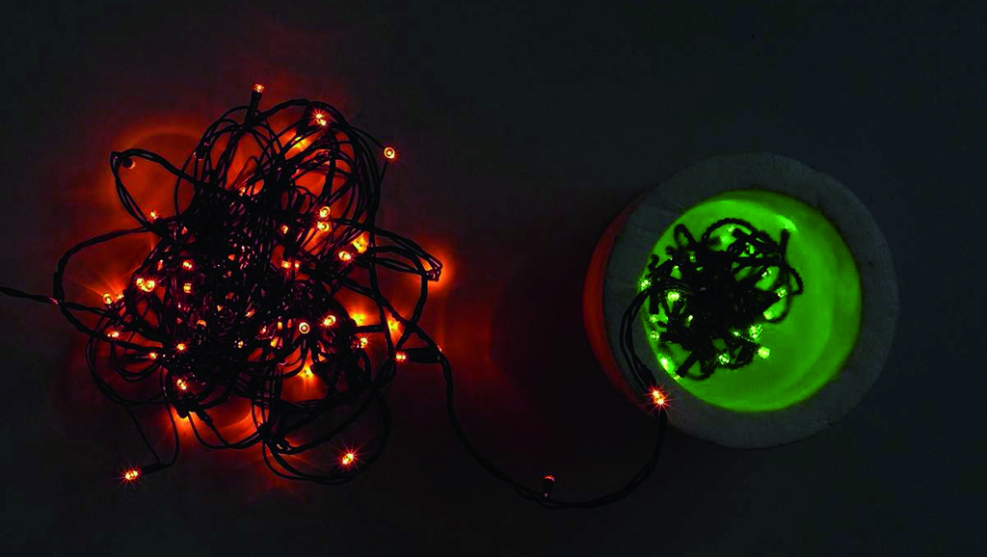

Fig. 6.28

LED chain with part at room temperature (left) and a part in a dewar filled with liquid nitrogen (right)

The reasons for the temperature variation of the band gap are the change of electron–phonon interaction and the expansion of the lattice. The temperature coefficient may be written as

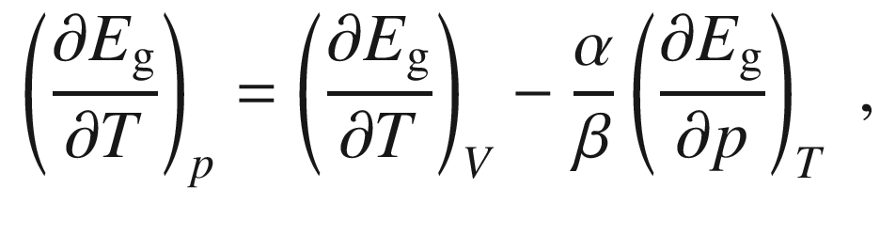

(6.31)

where

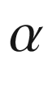

is the volume coefficient of thermal expansion and

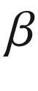

is the volume compressibility. A recommendable discussion of the thermodynamic role of the band gap as chemical potential for the mass action law ([7.​12](#u116076_4_En_7_Chapter)), entropy contributions and its temperature dependence can be found in [497].

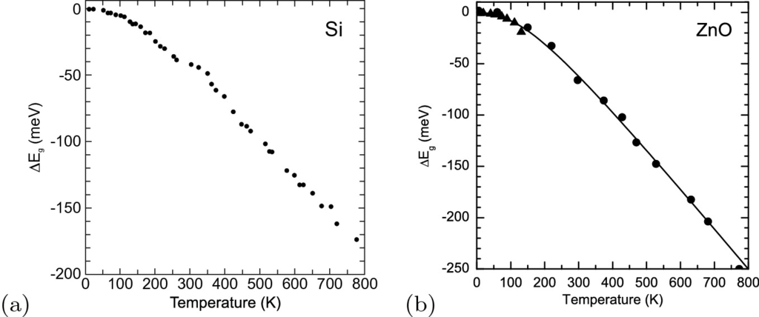

Fig. 6.29

Temperature dependence of the band gap of **a** Si (data from [498]) and **b** ZnO (experimental data from photoluminescence (*triangles*) and ellipsometry (*circles*)). The *solid lines* are fits with ([6.34](#u116076_4_En_6_Chapter-Equ35)) and the parameters given in Table [6.4](#u116076_4_En_6_Chapter-Tab4)

An anomaly is present for the lead salts (PbS, PbSe, PbTe) for which the temperature coefficient is positive (Fig. [6.30](#u116076_4_En_6_Chapter-Fig30)a). Theoretical calculations [499] show that both terms in ([6.31](#u116076_4_En_6_Chapter-Equ32)) are positive for the lead salts. The L

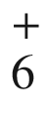

and L

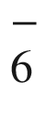

levels (see Fig. [6.12](#u116076_4_En_6_Chapter-Fig12)) shift as a function of temperature in such a way that their separation increases (Fig. [6.30](#u116076_4_En_6_Chapter-Fig30)b).

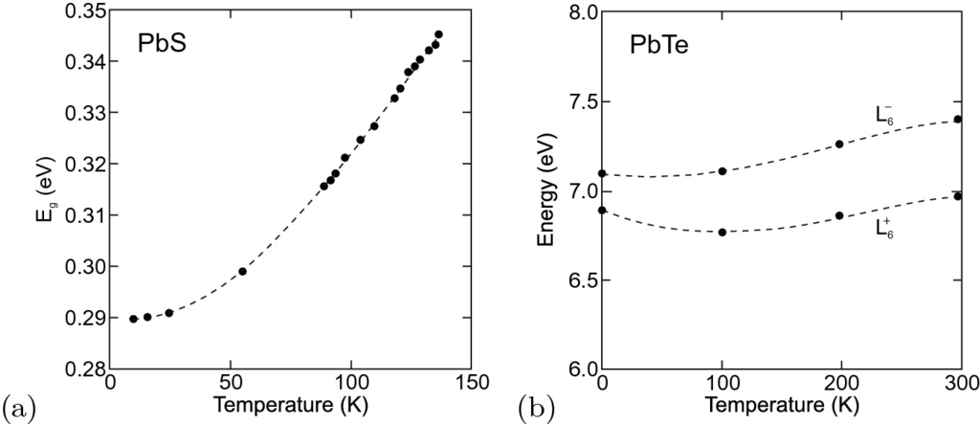

Fig. 6.30

**a** Band gap versus temperature for PbS. **b** Theoretical position of L



and L

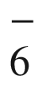

as a function of temperature for PbTe. Adapted from [468]

Also in copper and silver halides [500, 501] (Fig. [6.31](#u116076_4_En_6_Chapter-Fig31)a) and chalcopyrites [502] (Fig. [6.31](#u116076_4_En_6_Chapter-Fig31)b) the increase of band gap with increasing temperature has been found, sometimes only for a certain temperature range. This effect is attributed to the p-d electron hybridization in the valence band with Cu 3d electrons and to even stronger effect with Ag 4d electrons.

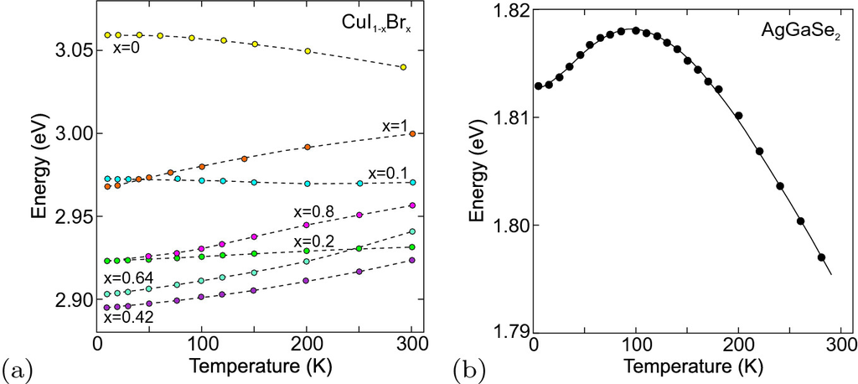

Fig. 6.31

**a** Band gap versus temperature for zincblende CuI



Br

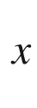

alloys with various compositions *x* (including binary CuI and CuBr) as labeled. *Dashed lines* are guide to the eye. Adapted from [500]. **b** Band gap vs. temperature for chalcopyrite AgGaSe



. *Solid line* is fit with two-oscillator Bose-Einstein model. Adapted from [502]

For many semiconductors the temperature dependence can be described with the empirical, three-parameter Varshni formula [503],

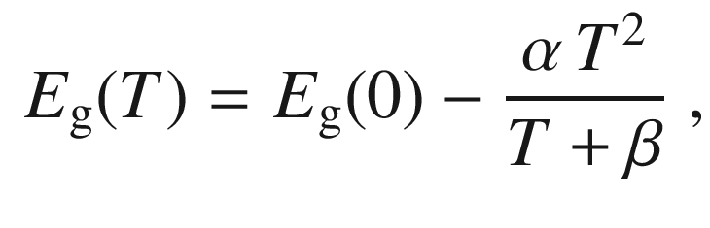

(6.32)

where

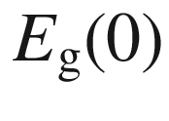

is the band gap at zero temperature. A more precise and physically motivated formula (based on a Bose-Einstein phonon model  [504]) has been given in [505]

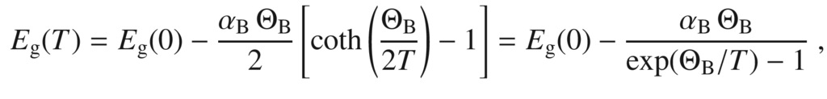

(6.33)

where

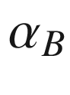

is a coupling constant and

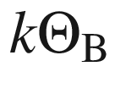

is a typical phonon energy; typical values are given in Table [6.4](#u116076_4_En_6_Chapter-Tab4). This model reaches a better description of the fairly flat dependence at low temperatures.Table 6.4

Parameters for the temperature dependence of the band gap according to [6.33](#u116076_4_En_6_Chapter-Equ34) (Si, GaAs: [505], GaN: [507], ZnO: [508]) and ([6.34](#u116076_4_En_6_Chapter-Equ35)) for various semiconductors

|  | $$\alpha $$ | $$\Theta $$ | $$\Delta $$ | $$\alpha _{\mathrm {B}}$$ | $$\Theta _{\mathrm {B}}$$ |
| --- | --- | --- | --- | --- | --- |
| (10  $$^{-4}$$   eV/K) | (K) |  | (10  $$^{-4}$$   eV/K) | (K) |
| Si | 3.23 | 446 | 0.51 | 2.56 | 296 |
| Ge | 4.13 | 253 | 0.49 |  |  |
| GaAs | 4.77 | 252 | 0.43 | 5.16 | 310 |
| GaN | 6.14 | 586 | 0.40 | 4.05 | 370 |
| InP | 3.96 | 274 | 0.48 |  |  |
| InAs | 2.82 | 147 | 0.68 |  |  |
| ZnSe | 5.00 | 218 | 0.36 |  |  |
| ZnO | 3.8 | 659 | 0.54 | 5.9 | 616 |

The more elaborate model of [506] takes into account a more variable phonon dispersion, including optical phonons, and proposes the four-parameter formula

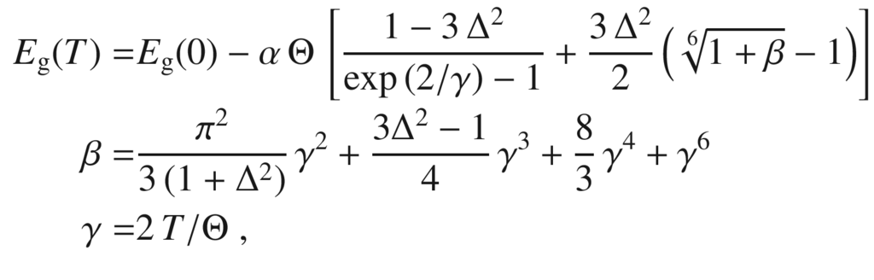

(6.34)

where

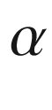

is the high-temperature limiting magnitude of the slope (of the order of several

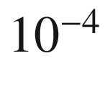

 eV/K),

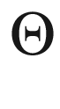

is an effective average phonon temperature and

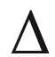

is related to the phonon dispersion.

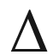

takes typically values between zero (Bose-Einstein model)  and 3/4 [506].

### 6.8 Isotope Dependence of the Band Gap

The band edge slightly depends on the isotope composition of semiconductor, as shown for GaAs in Fig. [6.32](#u116076_4_En_6_Chapter-Fig32). The effect is discussed in detail in [509].

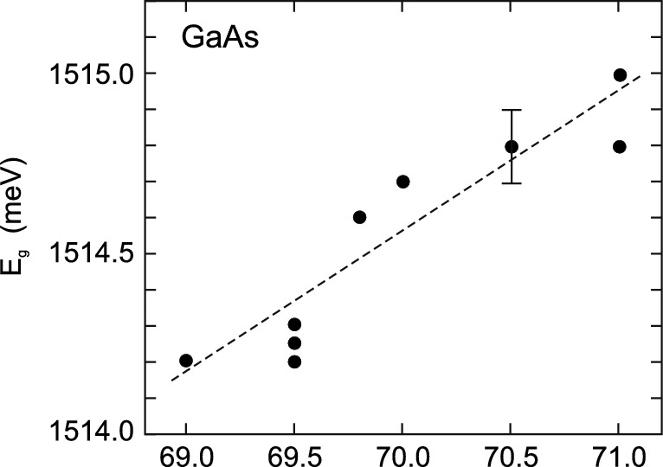

Fig. 6.32

Band gap of GaAs (at

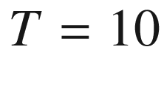

 K) as a function of the Ga isotope content. *Dashed line* is linear fit. Adapted from [509]

### 6.9 Electron Dispersion

#### 6.9.1 Equation of Electron Motion

The equation of motion for the electron in the band structure is no longer given by Netwon’s law

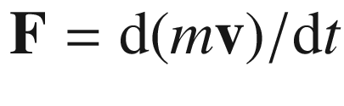

as in vacuum. Instead, the propagation of quantum-mechanical electron wave packets has to be considered. Their group velocity is given by (

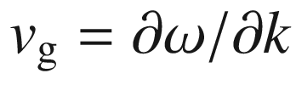

)

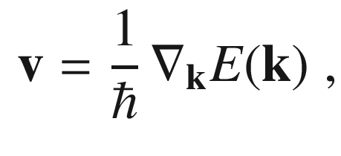

(6.35)

where

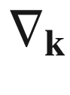

is the gradient with respect to



. Through the dispersion relation the influence of the crystal and its periodic potential on the motion enters the equation.

An electric field

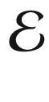

 acts on an electron during the time

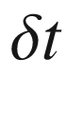

the work

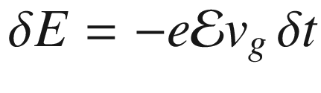

. This change in energy is related to a change in *k* via

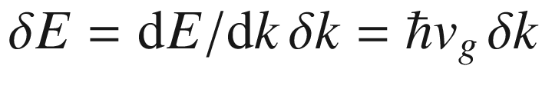

. Thus, we arrive at

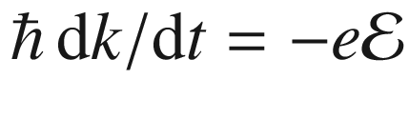

. For an external force we thus have

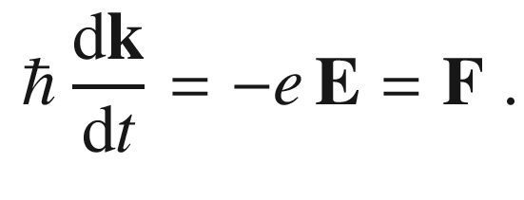

(6.36)

Thus, the crystal momentum

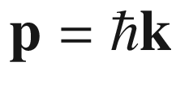

takes the role of the momentum. A more rigorous derivation can be found in [451].

In the presence of a magnetic field

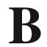

the equation of motion is

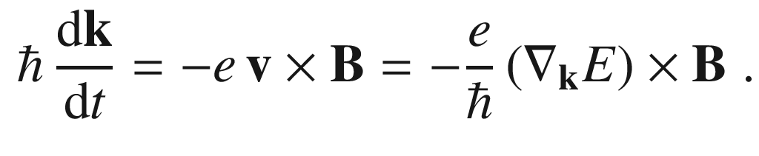

(6.37)

The motion in a magnetic field is thus perpendicular to the gradient of the energy, i.e. the energy of the electron does not change. It oscillates therefore on a surface of constant energy perpendicular to

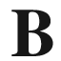

.

#### 6.9.2 Effective Mass of Electrons

From the free-electron dispersion

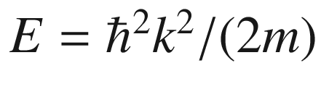

the mass of the particle is inversely proportional to the curvature of the dispersion relation, i.e.

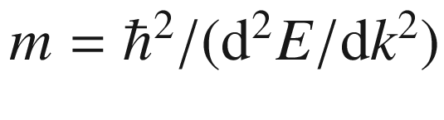

. This relation will now be generalized for arbitrary dispersion relations. The (inverse) tensor of the effective mass is defined as

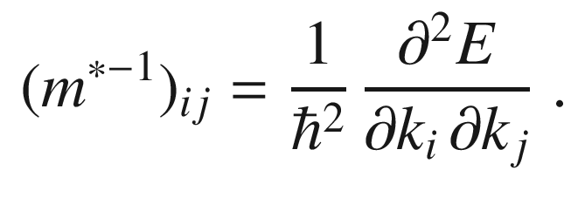

(6.38)

The equation

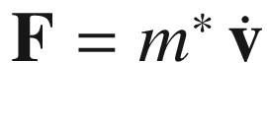

must be understood as a tensor equation, i.e. for the components of the force

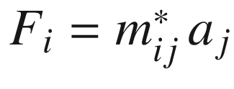

. Force and acceleration must no longer be collinear. In order to find the acceleration from the force, the inverse of the effective-mass tensor must be used,

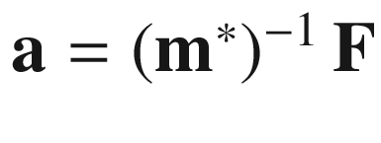

.

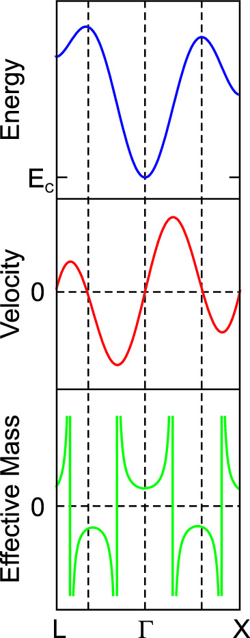

Fig. 6.33

Schematic diagram of the electron dispersion

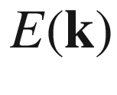

in a typical semiconductor (*blue*) and corresponding carrier velocity (

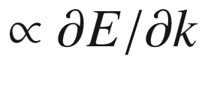

) (*red*) and effective mass (

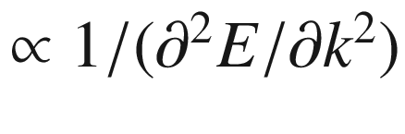

) (*green*)

In Fig. [6.33](#u116076_4_En_6_Chapter-Fig33) the energy dispersion of the (lowest) conduction band in a typical semiconductor, the related electron velocity and the effective mass are shown schematically.

In ([6.22](#u116076_4_En_6_Chapter-Equ23)) the ratio of the effective mass and the free-electron mass is of the order of

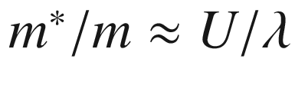

, the ratio of the free particle energy and the band gap. For typical semiconductors, the width of the (valence) band is of the order of 20 eV, and the gap is about 0.2–2 eV. Thus, the effective mass is expected to be 10–100 times smaller than the free-electron mass. Additionally, the relation

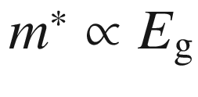

is roughly fulfilled (Fig. [6.34](#u116076_4_En_6_Chapter-Fig34)).

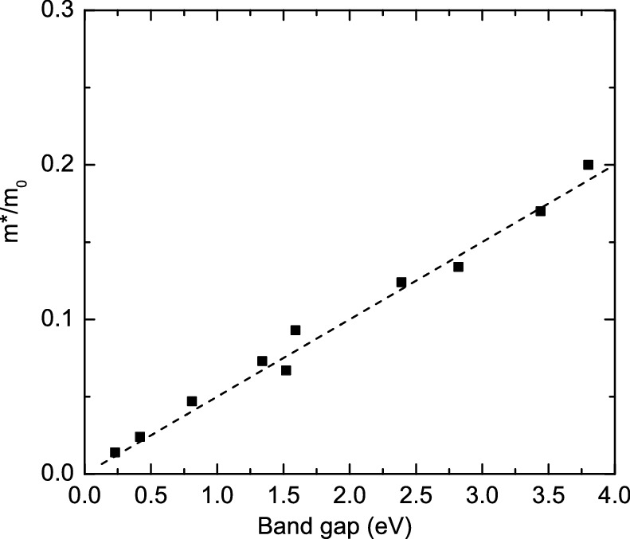

Fig. 6.34

Effective electron mass (in units of the free-electron mass

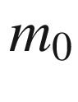

) as a function of the (low-temperature) band gap for several (direct band gap) semiconductors. The *dashed line* fulfills

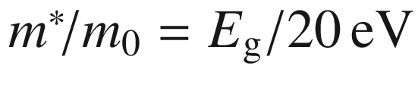

From so-called

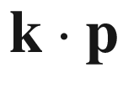

theory [510] (see Appendix H) the effective electron mass is predicted to be related to the momentum matrix element

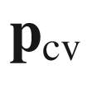

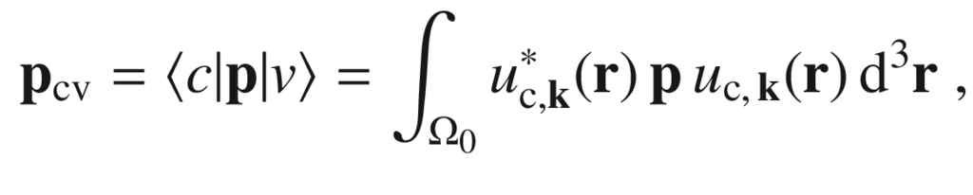

(6.39)

with

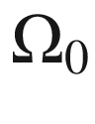

being the unit cell volume and the Bloch functions

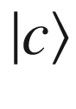

and

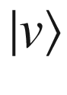

of the conduction and valence band, respectively, given as

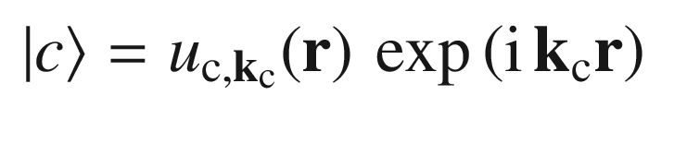

(6.40a)

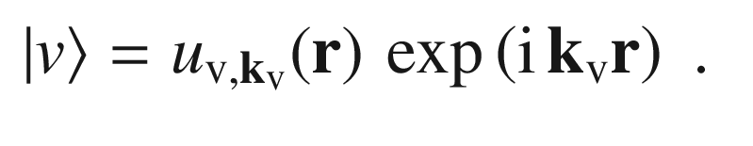

(6.40b)

Typically, the



-dependence of the matrix element is small and neglected. The momentum matrix element will also be important for optical transitions between the valence and conduction bands (Sect. [9.​6](The_Physics_of_Semiconductors00004.docx#u116076_4_En_9_Chapter)). Other related quantities that are often used are the energy parameter

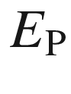

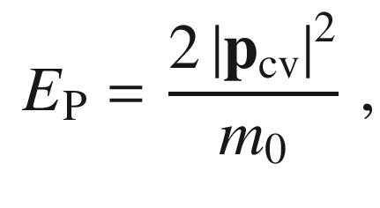

(6.41)

and the bulk momentum matrix element

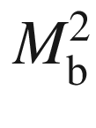

that is given by

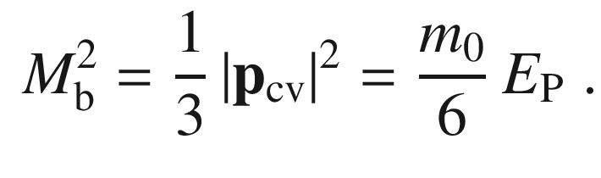

(6.42)

The electron mass is given by[4](#u116076_4_En_6_Chapter-Fn4)

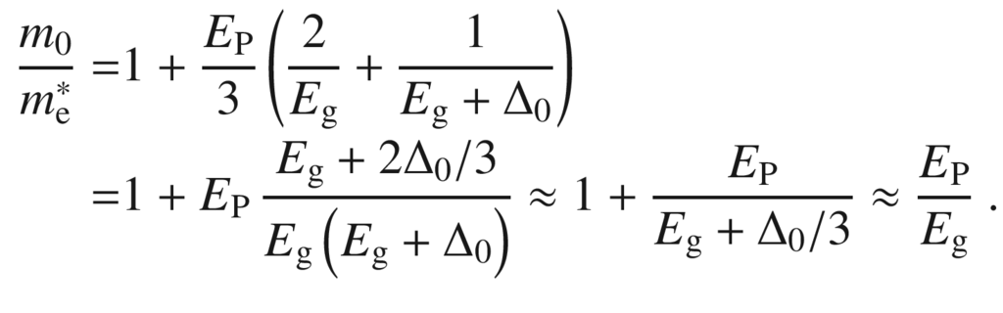

(6.43)

Comparison with the fit from Fig. [6.34](#u116076_4_En_6_Chapter-Fig34) yields that



is similar for all semiconductors [511] and of the order of 20 eV (InAs: 22.2 eV, GaAs: 25.7 eV, InP: 20.4 eV, ZnSe: 23 eV, CdS: 21 eV).

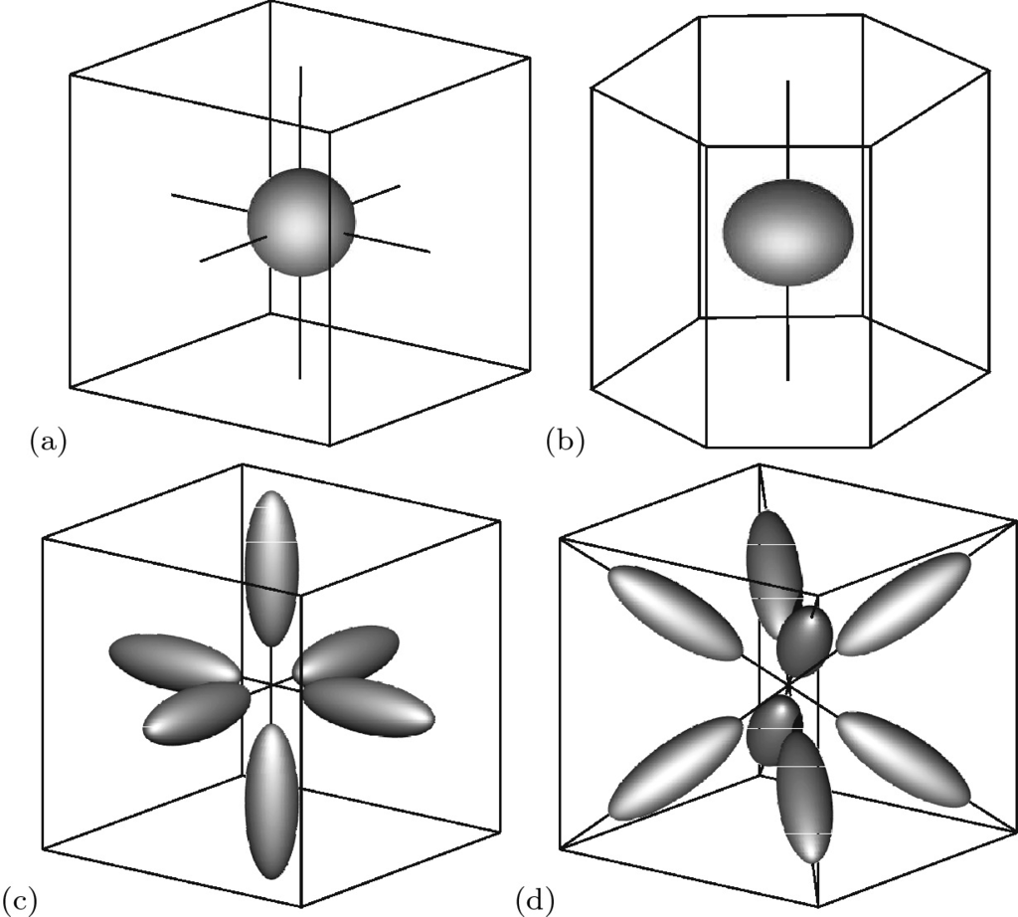

Fig. 6.35

Energy isosurfaces in



-space in the vicinity of the conduction-band minima for **a** GaAs with isotropic (spehrical) minimum at

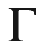

-point, **b** ZnO with anisotropic (ellipsoidal) minimum at



-point (anisotropy exaggerated), **c** silicon with six equivalent anisotropic minima (

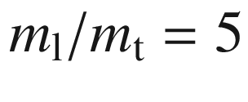

not to scale) along



and **d** germanium with eight equivalent anisotropic minima along

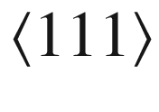

. The cube indicates the



directions for the cubic materials. For the wurtzite material (part **b**) the vertical direction is along [00.1]

In silicon there are six equivalent conduction-band minima. The surfaces of equal energy are schematically shown in Fig. [6.35](#u116076_4_En_6_Chapter-Fig35)c. The ellipsoids are extended along the



direction because the longitudinal mass (along the

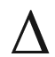

path) is larger than the transverse mass in the two perpendicular directions (Table [6.5](#u116076_4_En_6_Chapter-Tab5)). For example, the dispersion relation in the vicinity of one of the minima is given as (

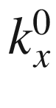

denotes the position of one of the conduction-band minima close to a X-point)

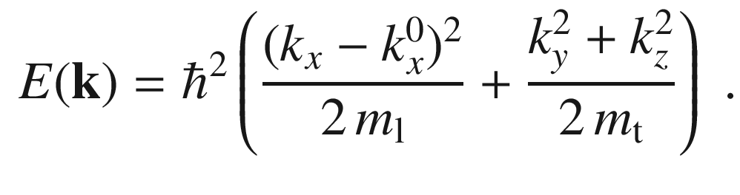

(6.44)

For germanium surfaces of constant energy around the eight conduction-band minima in the



directions are depicted in Fig. [6.35](#u116076_4_En_6_Chapter-Fig35)d. The longitudinal and the transverse masses are again different. For GaAs, the conduction-band dispersion around the



point is isotropic, thus the surface of constant energy is simply a sphere (Fig. [6.35](#u116076_4_En_6_Chapter-Fig35)a). In wurtzite semiconductors the conduction-band minimum is at the



-point. The mass along the *c*-axis is typically smaller than the mass within the (00.1) plane [512] (

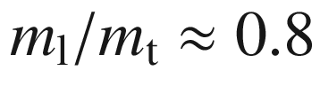

for ZnO [513]), see Fig. [6.35](#u116076_4_En_6_Chapter-Fig35)b. In [512] also an anisotropy within the (00.1) plane is predicted.Table 6.5

Longitudinal direction of effective mass ellipsoid, longitudinal and transverse effective electron mass in several semiconductors. For the density of states mass

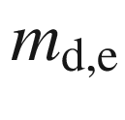

 see ([6.72](#u116076_4_En_6_Chapter-Equ79)). Mass values in units of the free electron mass

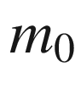

|  | Long. dir. | $$m_{\mathrm {l}}$$ | $$m_{\mathrm {t}}$$ | $$m_{\mathrm {l}}/m_{\mathrm {t}}$$ | $$m_{\mathrm {d,e}}$$ | Ref. |
| --- | --- | --- | --- | --- | --- | --- |
| C | $$\langle 100 \rangle $$ | 1.4 | 0.36 | 3.9 | 1.9 | [514] |
| Si | $$\langle 100 \rangle $$ | 0.98 | 0.19 | 5.16 | 1.08 | [515] |
| Ge | $$\langle 111 \rangle $$ | 1.59 | 0.082 | 19.4 | 0.88 | [515] |
| ZnO | [00.1] | 0.21 | 0.25 | 0.88 |  | [516] |
| CdS | [00.1] | 0.15 | 0.17 | 0.9 |  | [517] |

The directional dependence of the mass can be measured with cyclotron resonance experiments with varying direction of the magnetic field. In Fig. [6.36](#u116076_4_En_6_Chapter-Fig36), the field

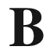

is in the (110) plane with different azimuthal directions. When the (static) magnetic field makes an angle

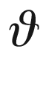

with the longitudinal axis of the energy surface, the effective mass is given as [518]

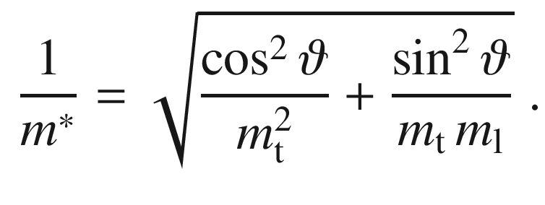

(6.45)

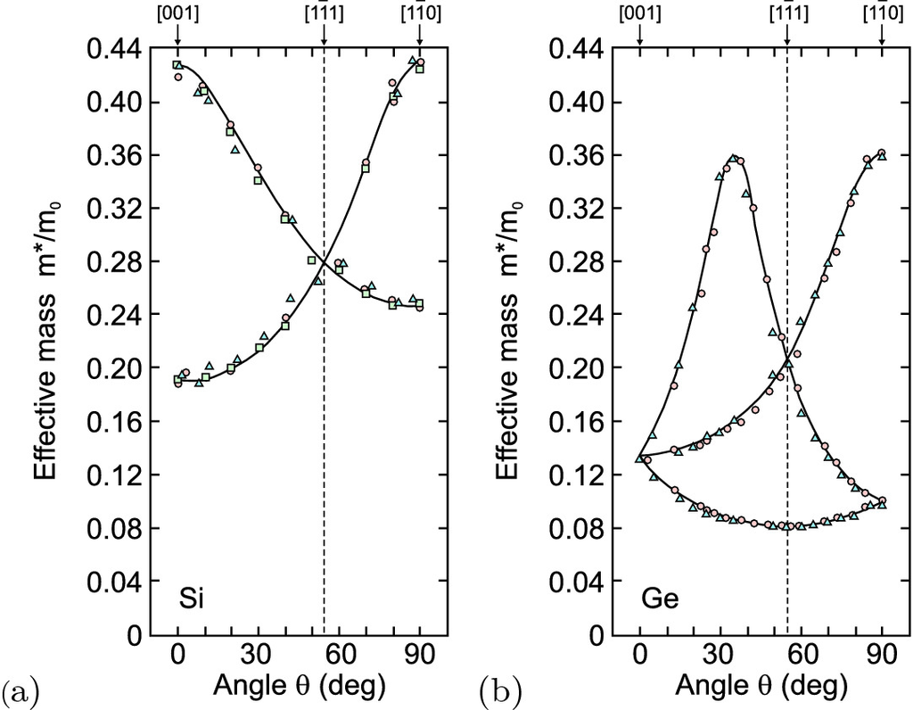

Fig. 6.36

Effective electron mass from cyclotron resonance experiments (at

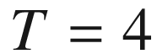

 K) on **a** Si and **b** Ge for the magnetic field in the (110) plane and various azimuthal directions

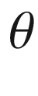

. Experimental data (*symbols*) and fits (*solid lines*) using ([6.45](#u116076_4_En_6_Chapter-Equ47)) with **a**

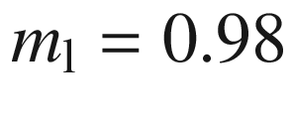

,

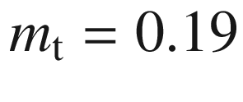

and **b**

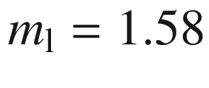

,

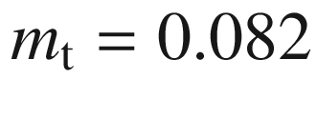

. Adapted from [515]

#### 6.9.3 Nonparabolicity of Electron Mass

The dispersion around the conduction-band minimum is only parabolic for small



. The further away the wavevector is from the extremum, the more the actual dispersion deviates from the ideal parabola (see, e.g., Fig. [6.10](#u116076_4_En_6_Chapter-Fig10)). This effect is termed *nonparabolicity*. Typically, the energy increases less quickly with *k* than in the parabolic model. This can be described in a so-called two-level model with the dispersion relation

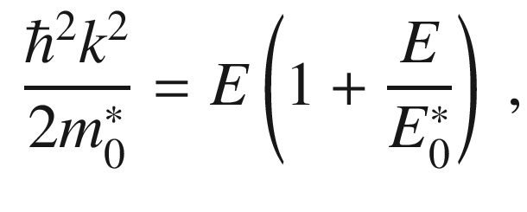

(6.46)

where

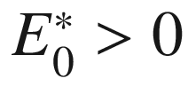

parameterizes the amount of nonparabolicity (a parabolic band corresponds to

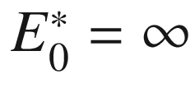

). The nonparabolic dispersion for GaAs is shown in Fig. [6.37](#u116076_4_En_6_Chapter-Fig37)a. The curvature is reduced for larger



and thus the effective mass is energy dependent and increases with the energy. Equation ([6.46](#u116076_4_En_6_Chapter-Equ48)) leads to the energy-dependent effective mass

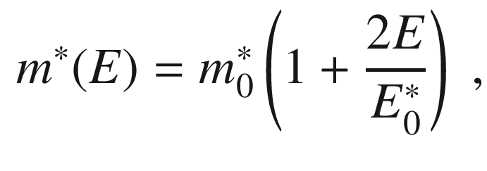

(6.47)

where

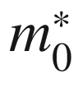

denotes here the effective mass at

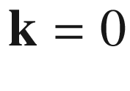

. Theory and experimental data for the effective electron mass of GaAs are shown in Fig. [6.37](#u116076_4_En_6_Chapter-Fig37)b.

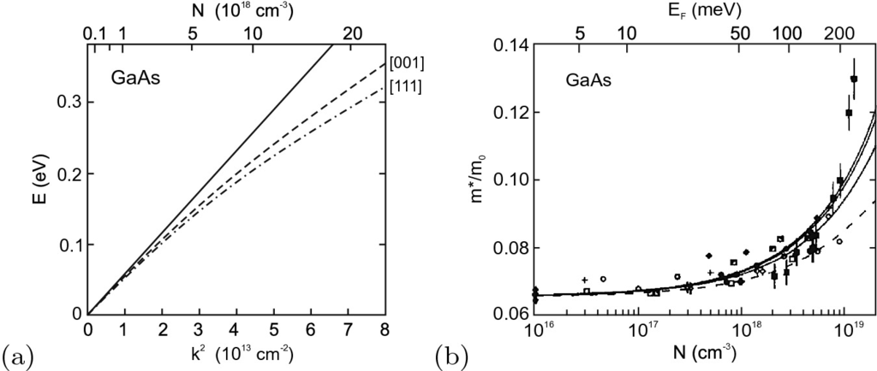

Fig. 6.37

**a** Dispersion relations for the conduction band of GaAs. The *solid line* is parabolic dispersion (constant effective mass). The *dashed* (*dash-dotted*) *line* denotes the dispersion for

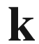

along [001] ([111]) from a five-level

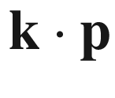

model (5LM). **b** Cyclotron resonance effective mass of electrons in GaAs as a function of the Fermi level (upper abscissa) and the corresponding electron concentration (lower abscissa). The *dashed line* is from a 2LM according to ([6.47](#u116076_4_En_6_Chapter-Equ49)) with

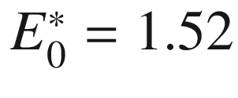

 eV. The *solid lines* are for a 5LM for the three principal directions of the magnetic field. The *symbols* represent experimental data from different sources. Data from [519]

### 6.10 Holes

#### 6.10.1 Hole Concept

Holes are missing electrons in an otherwise filled band. A Schrödinger-type wave-equation for holes (unoccupied electron states) was derived by Heisenberg [70] to interpret Hall effect data. The hole concept is useful to describe the properties of charge carriers at the top of the valence band. The hole is a new quasi-particle whose dispersion relation is schematically shown in Fig. [6.38](#u116076_4_En_6_Chapter-Fig38) in relation to the dispersion of electrons in the valence band.

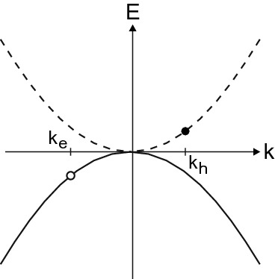

Fig. 6.38

Hole dispersion *dashed line* in relation to the electron dispersion in the valence band (*solid line*)

The wavevector of the hole (filled circle in Fig. [6.38](#u116076_4_En_6_Chapter-Fig38)) is related to that of the ‘missing’ electron (empty circle in Fig. [6.38](#u116076_4_En_6_Chapter-Fig38)) by

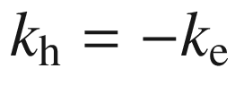

. The energy is

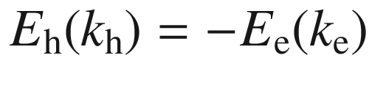

, assuming that

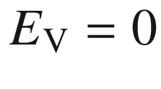

, otherwise

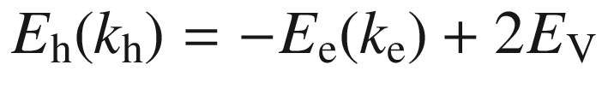

. The hole energy is larger for holes that are further away from the top of the valence band, i.e. the lower the energy state of the missing electron. The velocity of the hole,

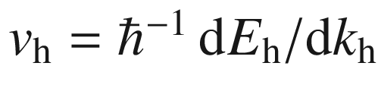

, is the same,

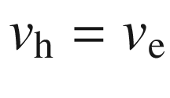

, and the charge is positive,

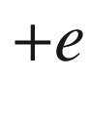

. The effective mass of the hole is positive at the top of the valence band,

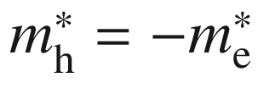

. Therefore, the drift velocities of an electron and hole are opposite to each other. The resulting current, however, is the same.

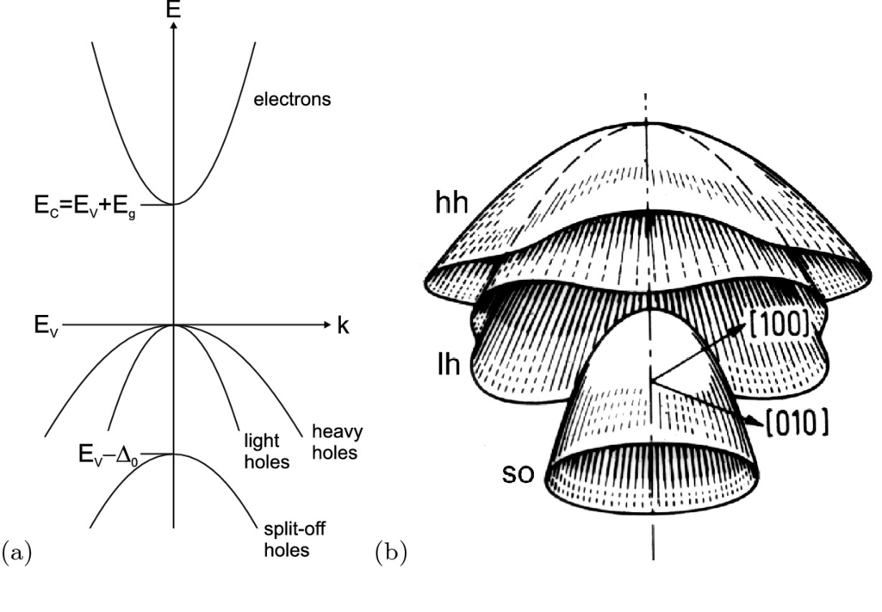

Fig. 6.39

**a** Simplified band structure with conduction band and three valence bands and (**b**) three-dimensional visualization (*E* versus

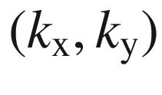

) of the valence bands of Ge (including warping). Part **b** from [521]

#### 6.10.2 Hole Dispersion Relation

The valence band at the



-point is 3-fold degenerate. The band developed from the atomic (bonding) p states; the coupling of the spin

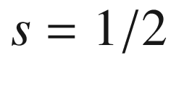

electrons with the orbital angular momentum

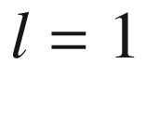

leads to a total angular momentum

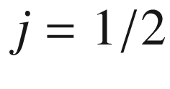

and

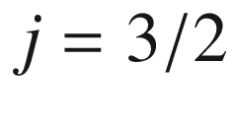

. The latter states are degenerate at



in zincblende bulk material and are called *heavy* holes (hh) for

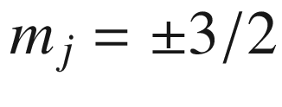

and *light* holes (lh) for

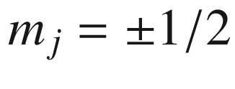

due to their different dispersion (Fig. [6.39](#u116076_4_En_6_Chapter-Fig39)a). The two (

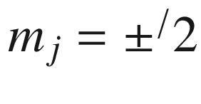

) states of the



state are split-off from these states by an energy

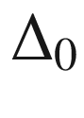

due to spin-orbit interaction and are called *split-off* (s-o) holes. The spin-orbit interaction increases with increasing atomic order number *Z* of the anion since the electrons are located preferentially there (Fig. [6.40](#u116076_4_En_6_Chapter-Fig40)). A detailed discussion of the spin-orbit splitting in zincblende semiconductors is given in [520].

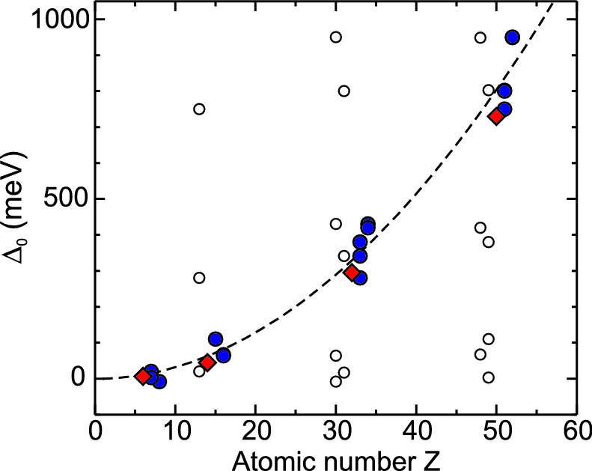

Fig. 6.40

Spin-orbit splitting

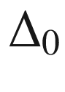

for elemental (*diamonds*) and various III–V and II–VI (*circles*) semiconductors. The data are plotted as *empty* (*filled*) *circles* as a function of the cation (anion) order number. Obviously,

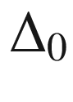

correlates with the anion *Z*. The *dashed line* is proportional to

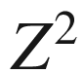

All three holes have different mass. In the vicinity of the



-point the dispersion for heavy and light holes can be described with (



:hh, −:lh)

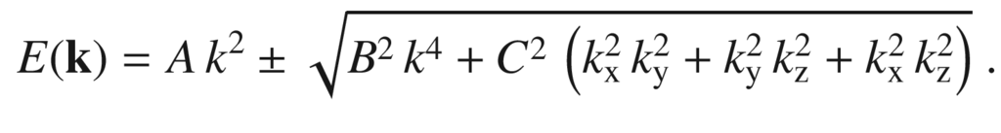

(6.48)

For heavy and light holes there is a dependence of the dispersion, i.e. the mass, in the (001) plane. This effect, sketched in Fig. [6.39](#u116076_4_En_6_Chapter-Fig39)b, is called *warping*. The warping at the GaAs valence-band edge is shown in Fig. [6.41](#u116076_4_En_6_Chapter-Fig41). Equation ([6.48](#u116076_4_En_6_Chapter-Equ50)) can also be expressed in terms of angular coordinates [522].

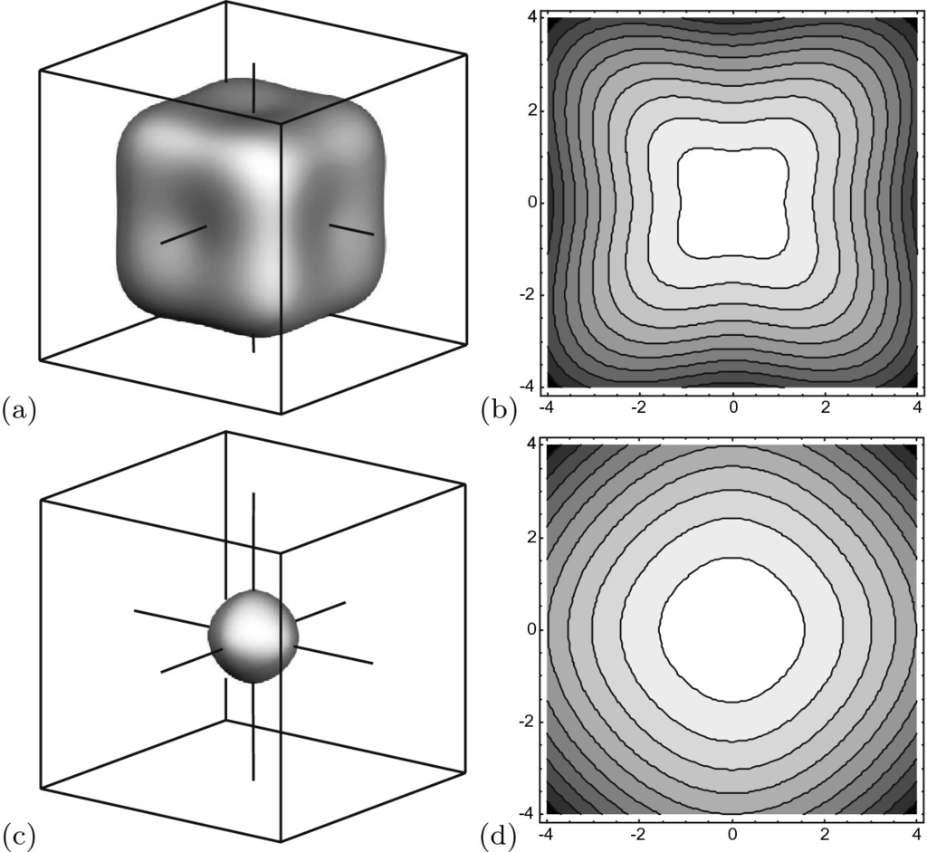

Fig. 6.41

Dispersion at the valence band edge of GaAs for **a**, **b** heavy holes and **c**,**d** light holes. **a**,**c** Constant energy surfaces and **b**,**d** isolines in the

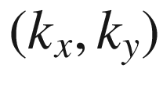

-plane (**b** and **d** have different energy scales)

Table 6.6

Valence-band parameters (for ([6.48](#u116076_4_En_6_Chapter-Equ50))) *A* and *B* in units of

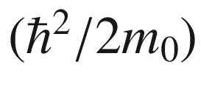

,

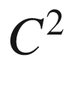

in units of

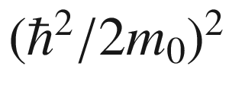

, and

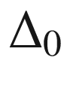

in eV. From [164, 523, 524]

| Material | *A* | *B* | $$C^2$$ | $$\Delta _0$$ |
| --- | --- | --- | --- | --- |
| C | $$-4.24$$ | $$-1.64$$ | 9.5 | 0.006 |
| Si | $$-4.28$$ | $$-0.68$$ | 24 | 0.044 |
| Ge | $$-13.38$$ | $$-8.5$$ | 173 | 0.295 |
| GaAs | $$-6.9$$ | $$-4.4$$ | 43 | 0.341 |
| InP | $$-5.15$$ | $$-1.9$$ | 21 | 0.11 |
| InAs | $$-20.4$$ | $$-16.6$$ | 167 | 0.38 |
| ZnSe | $$-2.75$$ | $$-1.0$$ | 7.5 | 0.43 |

The s-o holes have the dispersion

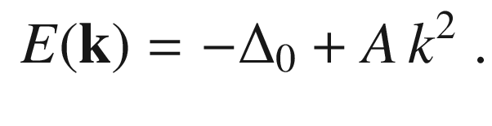

(6.49)

Values for *A*, *B*,

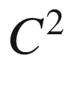

and



for a number of semiconductors are given in Table [6.6](#u116076_4_En_6_Chapter-Tab6). The valence-band structure is often described with the Luttinger parameters

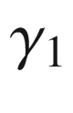

,

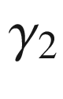

, and

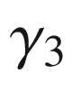

that can be represented through *A*, *B*, and *C* via

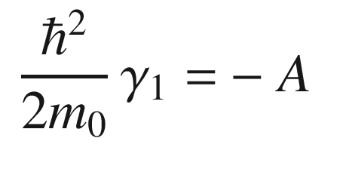

(6.50a)

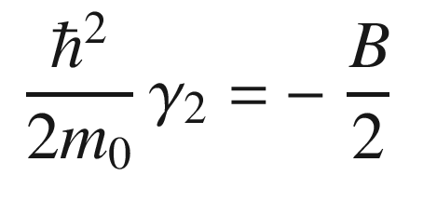

(6.50b)

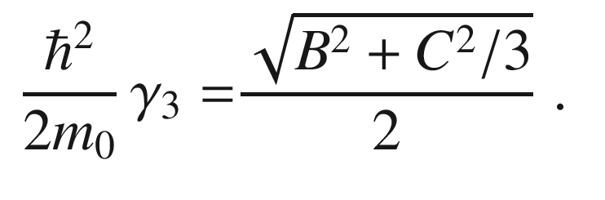

(6.50c)

The mass of holes in various directions can be derived from ([6.48](#u116076_4_En_6_Chapter-Equ50)). The mass along the [001] direction, i.e.

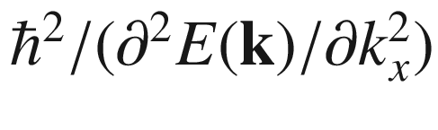

for

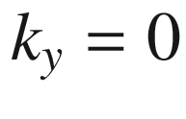

and

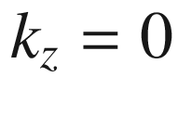

, is

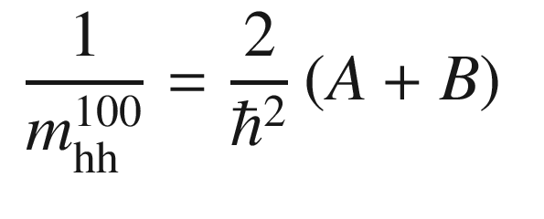

(6.51a)

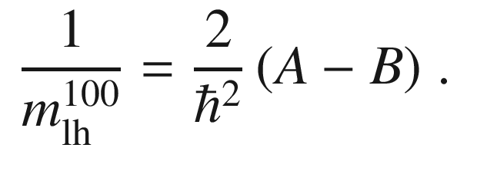

(6.51b)

The anisotropy of hole masses has been investigated with cyclotron resonance experiments (Fig. [6.42](#u116076_4_En_6_Chapter-Fig42)). For



being the angle between the magnetic field and the [001] direction, the effective heavy hole (upper sign) and light hole (lower sign) mass in cubic semiconductors is given by [515]

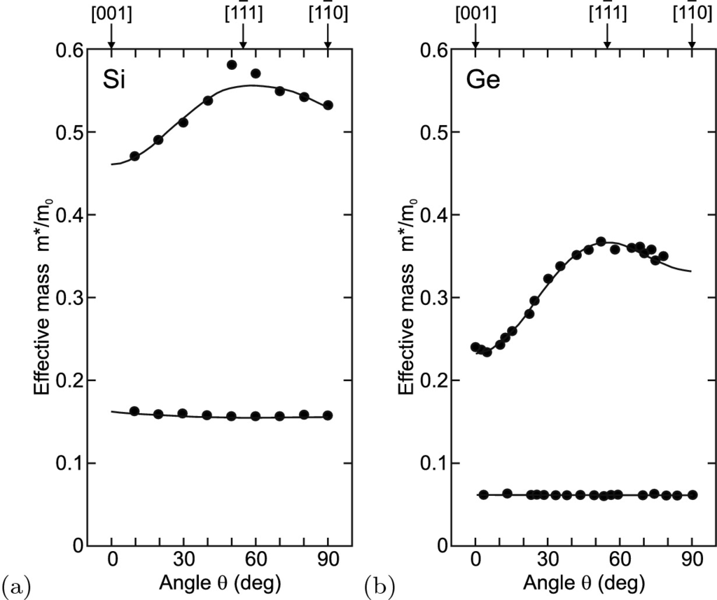

Fig. 6.42

Effective hole masses from cyclotron resonance experiments (

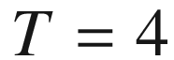

 K) for heavy and light holes in **a** Si and **b** Ge for the magnetic field in the (110) plane and various azimuthal directions

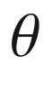

. Experimental data (*symbols*) and fits (*solid lines*) using ([6.52](#u116076_4_En_6_Chapter-Equ57)). Adapted from [515]

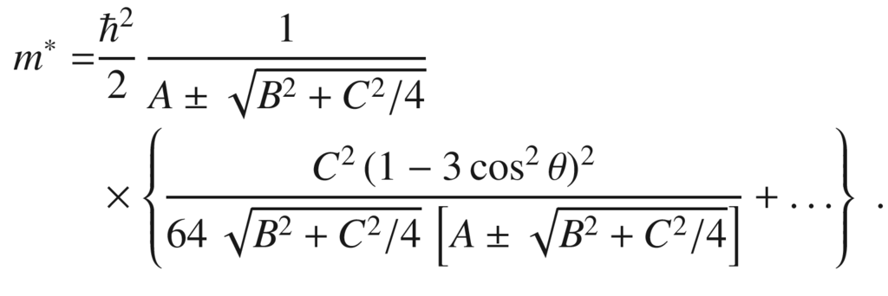

(6.52)

For

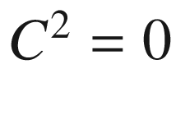

the hole bands are isotropic, as is obvious from ([6.48](#u116076_4_En_6_Chapter-Equ50)). In this case

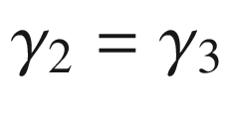

, the so-called spherical approximation. The average of the hole masses over all directions is

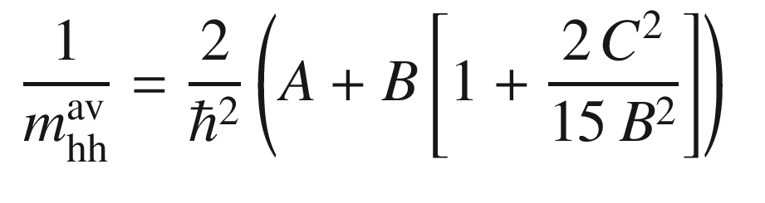

(6.53a)

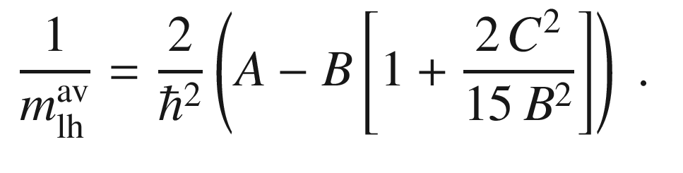

(6.53b)

Similar to the correlation of the electron mass with the band gap (Fig. [6.34](#u116076_4_En_6_Chapter-Fig34)), the Luttinger parameters are correlated with the band gap as shown in Fig. [6.43](#u116076_4_En_6_Chapter-Fig43). The parameters

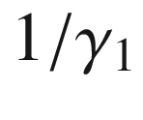

and

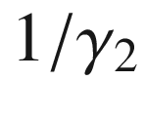

increase about linearly with

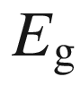

. The parameter

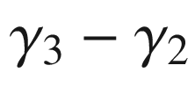

, which is responsible for the valence band warping, decreases with increasing band gap.

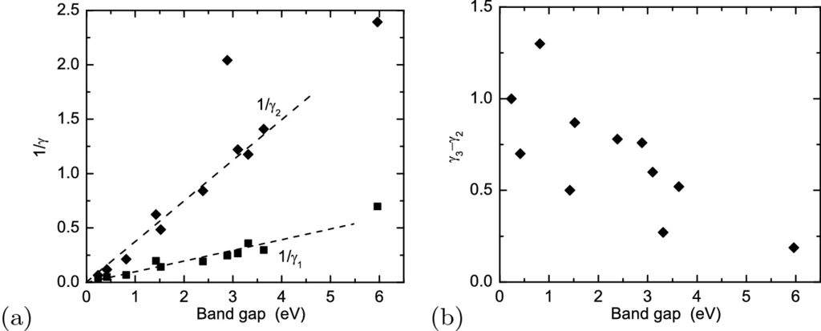

Fig. 6.43

Luttinger parameters for various III-V semiconductors versus their band gap. **a** Inverse values of

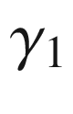

(*squares*) and

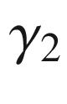

(*diamonds*). *Dashed lines* are guides to the eye. **b**

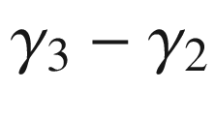

versus band gap

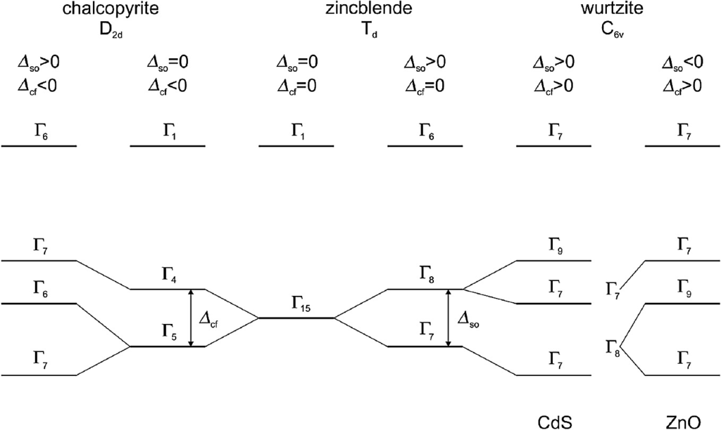

Fig. 6.44

Schematic band structure of zincblende and the valence-band splitting due to spin-orbit interaction

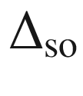

and crystal field splitting

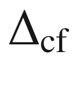

for chalcopyrites (typically

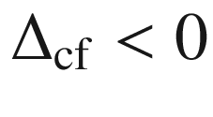

, see Fig. [6.45](#u116076_4_En_6_Chapter-Fig45)) and wurtzites. For the wurtzites the situation is schematically shown for CdS (

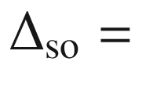

67 meV,

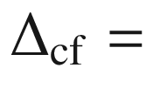

27 meV) (or GaN) and ZnO (

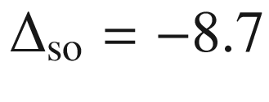

 meV,



41 meV)

#### 6.10.3 Valence-Band Fine Structure

In Fig. [6.44](#u116076_4_En_6_Chapter-Fig44), the schematic structure of the band edges for zincblende structure semiconductors is shown. The s-o holes in the zincblende structure are split-off due to the spin-orbit interaction

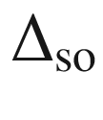

, the

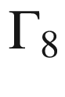

band is degenerate (heavy and light holes). Degeneracies for the holes are removed in the wurtzite and chalcopyrite structures by the additional crystal field splitting

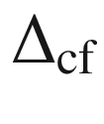

 due to the anisotropy between the *a*- and *c*-axes. Typically, e.g. for CdS, the topmost valence band in the wurtzite structure has

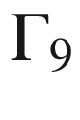

symmetry (allowed optical transitions only for

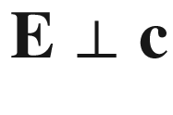

); an exception is ZnO for which the two upper bands are believed to be reversed. In the chalcopyrite structure optical transitions involving the

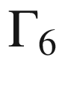

band are only allowed for

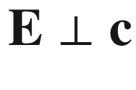

. The three hole bands are usually labeled *A*, *B*, and *C* from the top of the valence band.

The energy positions of the three bands (with respect to the position of the

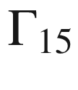

band) in the presence of spin-orbit interaction and crystal field splitting are given within the quasi-cubic approximation [525] by

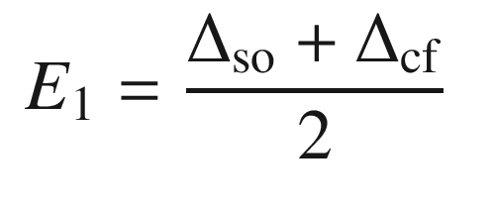

(6.54a)

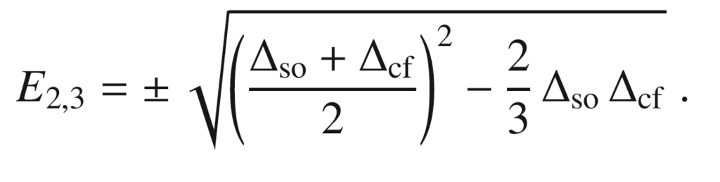

(6.54b)

In chalcopyrites the crystal field splitting is typically negative (Fig. [6.45](#u116076_4_En_6_Chapter-Fig45)). It is approximately linearly related to

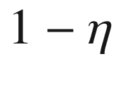

(for

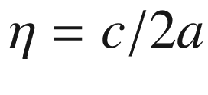

see Sect. [3.​4.​6](The_Physics_of_Semiconductors00001.docx#u116076_4_En_3_Chapter)).

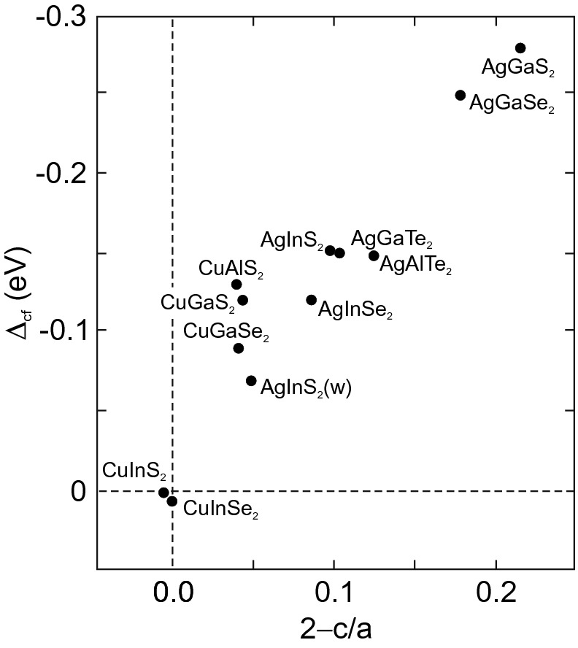

Fig. 6.45

Crystal field splitting

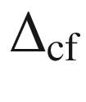

for various chalcopyrite compounds versus the tetragonal distortion

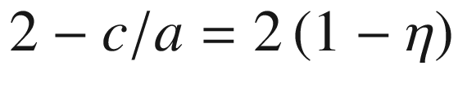

. *Dash-dotted line* represents

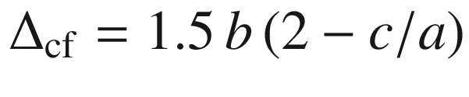

for

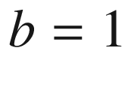

 eV. Data from [526]

### 6.11 Band Inversion

In certain compounds, typically mixing a semiconductor with a semimetal [527, 528], the band gap can shrink to zero (zero-gap semiconductor) and even become negative in the sense that the s-type

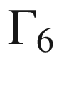

symmetry (conduction) band is inverted below the

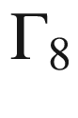

(p-type) valence-band edge. HgTe is a classical example for such material as shown in Fig. [6.46](#u116076_4_En_6_Chapter-Fig46), but similar effects are also present in other semiconductors, for example various chalcopyrites [529]. Remember that such band structures are topologically non-trivial (cf. Sect. [6.2.6](#u116076_4_En_6_Chapter-Sec13)).

For the zero-gap case, the dispersion of the two crossing bands is linear (like for graphene, cf. Sect. [13.​1.​2](The_Physics_of_Semiconductors00006.docx#u116076_4_En_13_Chapter)). The dielectric function of zero-gap semiconductors is discussed in [530].

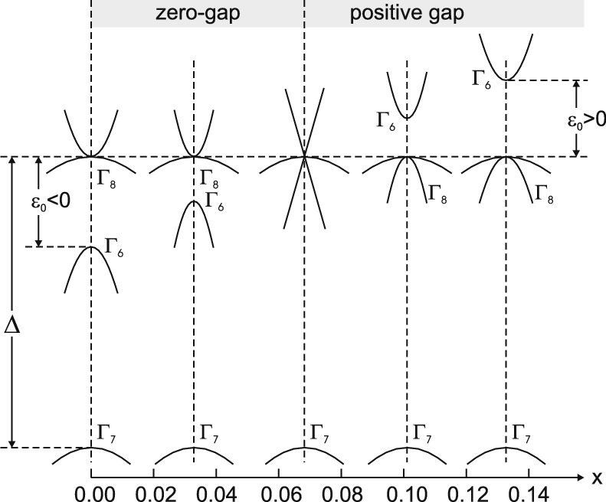

Fig. 6.46

Schematic band structure of zincblende with vanishing energy gap for the ternary compounds Mn



Hg



Te. Note the linear dispersion for the zero-gap case at

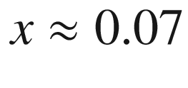

For the Cd

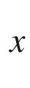

Hg



Te system, around the zero-gap concentration of

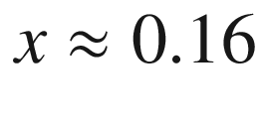

, the change from normal to inverted band structure will occur also as a function of temperature [531] as shown in Fig. [6.47](#u116076_4_En_6_Chapter-Fig47). Such effect had been described already 50 years ago for (Pb,Sn)Te at the L-point (cf. Sect. [6.3.6](#u116076_4_En_6_Chapter-Sec20)) in [532].

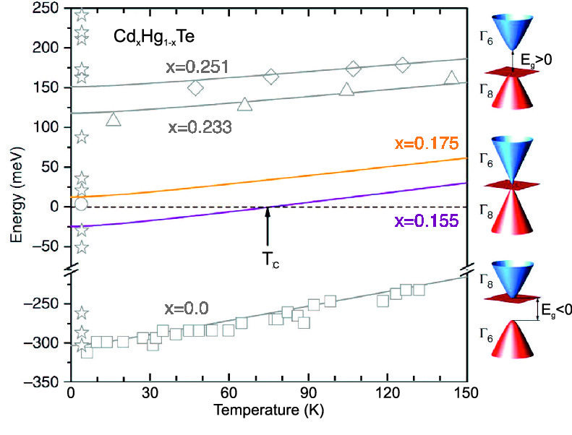

Fig. 6.47

Band gap of Cd



Hg



Te for various alloy compositions and temperatures. On the right, the schematic band structure of (Hg,Cd)Te with positive, zero and negative band gap is shown. Adapted from [531], reprinted under a Creative Commons Attribution (CC BY 4.0) licence

### 6.12 Strain Effects on the Band Structure

A mechanical strain (or equivalently stress) causes changes in the bond lengths. Accordingly, the band structure is affected. These effects have been exhaustively treated in [533, 534]. For small strain, typically

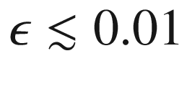

the shift of the band edges is linear with the strain, for large strain it becomes nonlinear [535]. Often homogeneous strain is assumed, the effect of inhomogeneous strain is discussed in [536].

#### 6.12.1 Strain Effect on Band Edges

In a direct-gap zincblende material the position of the conduction-band edge is only affected by the hydrostatic component of the strain

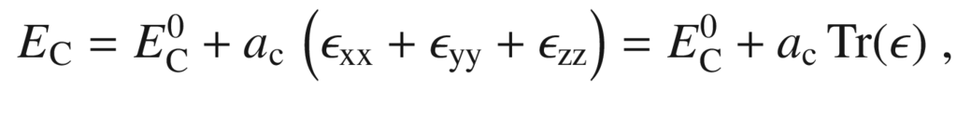

(6.55)

where

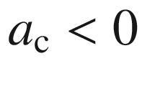

is the conduction-band hydrostatic deformation potential and

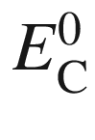

is the conduction-band edge of the unstrained material. Similarly, the valence-band edge is

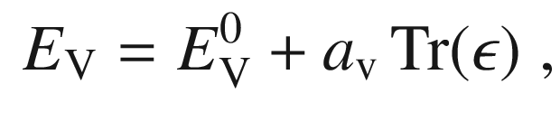

(6.56)

where

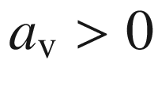

is the valence-band hydrostatic deformation potential. Therefore the band gap increases by

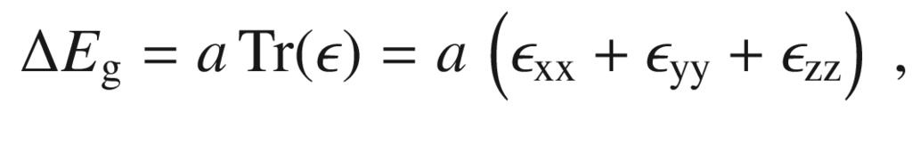

(6.57)

with

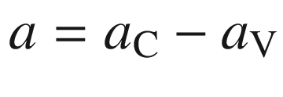

. Such linear behavior upon hydrostatic pressure has been found for many semiconductors and is shown in Fig. [6.48](#u116076_4_En_6_Chapter-Fig48)a for Ga

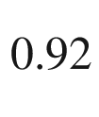

In

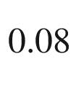

As. The anomaly for N-doping is discussed below in Sect. [6.12.3](#u116076_4_En_6_Chapter-Sec43). In Fig. [6.49](#u116076_4_En_6_Chapter-Fig49) the dependence of the direct and indirect gaps of GaAs is shown. The dependence of the direct gap on pressure is non-linear, that on the density is linear [537].

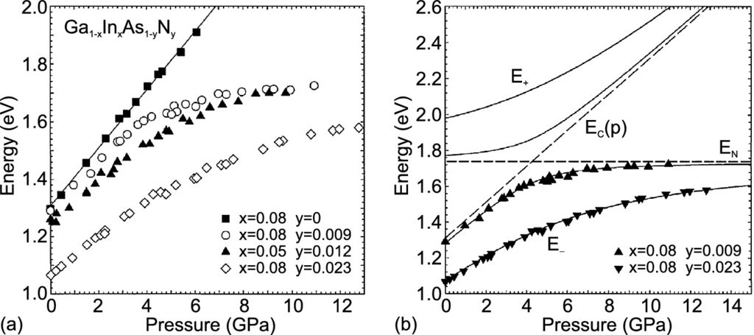

Fig. 6.48

**a** Dependence of the band gap of Ga

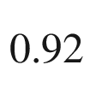

In

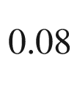

As alloy (*squares*) and nitrogen-doped (Ga,In)As on (compressive) hydrostatic pressure, determined by photomodulated transmission at

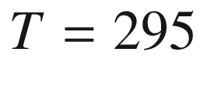

 K. **b** Pressure dependence of band gap for two (Ga,In)(As,N) samples together with model calculation ([6.62](#u116076_4_En_6_Chapter-Equ69)). The coupling parameter is

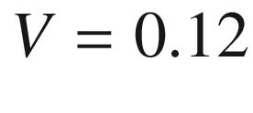

 eV (0.4 eV) for a nitrogen content of 0.9% (2.3%). Adapted from [538]

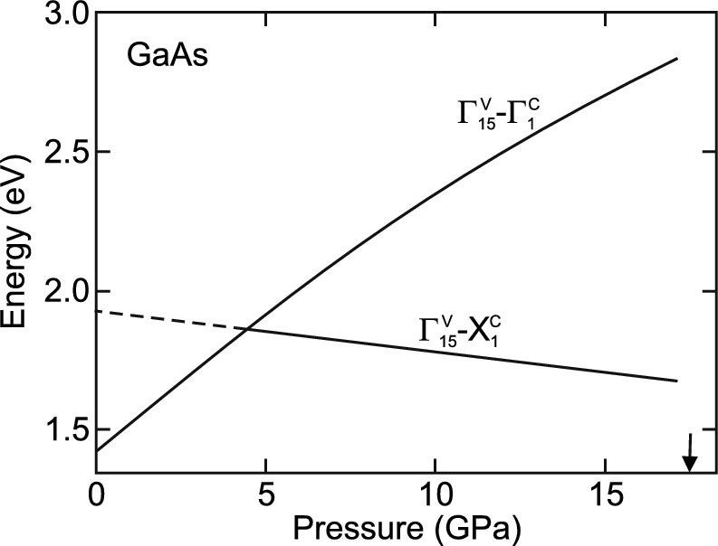

Fig. 6.49

Dependence of the direct

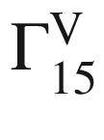

–

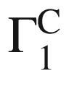

and indirect

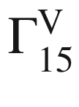

–

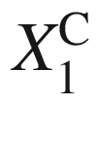

band gap of GaAs (

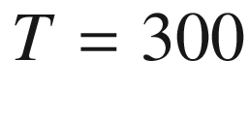

 K) on pressure. *Solid lines* are interpolations of experimental data, *dashed line* is extrapolation to

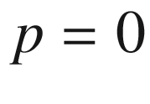

. The crossing of the direct and indirect band gap occurs at 4.2 GPa. The *arrow* denotes the pressure of the phase transition from zincblende to an orthorhomic structure around 17 GPa. Adapted from [537]

Biaxial and shear strains  affect the valence bands and lead to shifts and splitting of the heavy and light holes at the



-point:

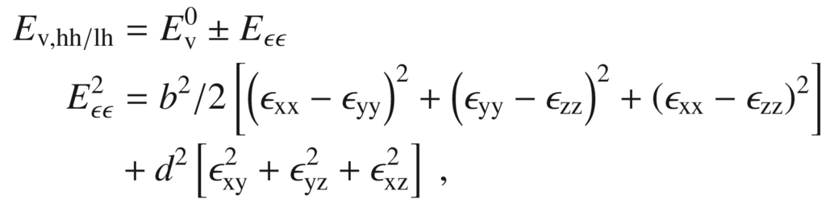

(6.58a)

where

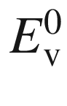

denotes the bulk valence-band edge. *b* and *d* are the optical deformation potentials. For compressive strain the heavy-hole band is above the light-hole band. For tensile strain there is strong mixing of the bands (Fig. [6.50](#u116076_4_En_6_Chapter-Fig50)). In Table [6.7](#u116076_4_En_6_Chapter-Tab7) the deformation potentials for some III–V semiconductors are listed. Typical values are in the eV regime.

In a wurtzite crystal, seven (or eight) deformation potentials are needed that are termed *a* (for the change of band gap with hydrostatic strain, again

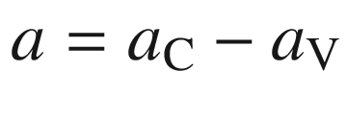

) and

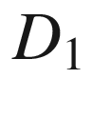

–

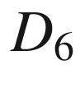

(for the valence band structure) [539, 540].

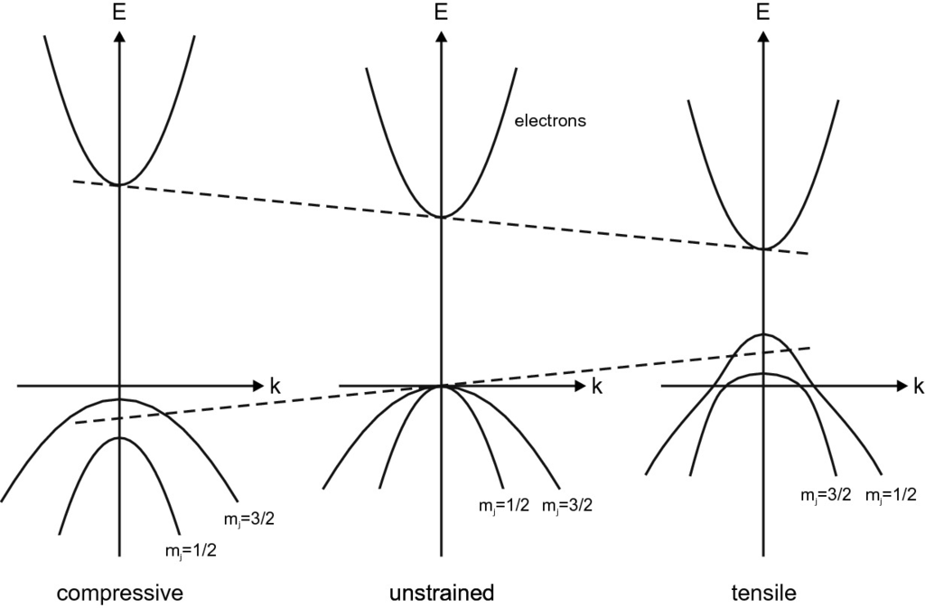

Fig. 6.50

Schematic band structure of GaAs in unstrained state (*center*) and under compressive and tensile biaxial strain as labeled. *Dashed lines* indicate shift of band edges due to hydrostatic part of strain

In Si and Ge, three deformation potentials, termed *a*, *b*, *d*, are needed for the valence band and two for each conduction band minimum,

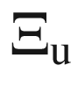

and

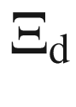

[541]. The energy position of the *i*-th conduction-band edge (with unit vector

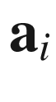

pointing to the valley) is

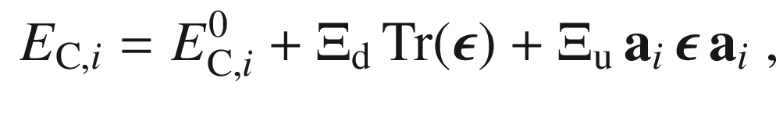

(6.59)

where

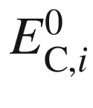

denotes the energy of the unstrained conduction-band edge. The deformation potentials for Si and Ge are given in Table [6.8](#u116076_4_En_6_Chapter-Tab8).Table 6.7

Deformation potentials for some III–V semiconductors. All values in eV

| Material | *a* | *b* | *d* |
| --- | --- | --- | --- |
| GaAs | $$-9.8$$ | $$-1.7$$ | $$-4.6$$ |
| InAs | $$-6.0$$ | $$-1.8$$ | $$-3.6$$ |

Table 6.8

Deformation potentials for silicon and germanium. All values in eV from [542]

| material | $$\Xi _{\mathrm {d}}^{(\Delta )}$$ | $$\Xi _{\mathrm {u}}^{(\Delta )}$$ | $$\Xi _{\mathrm {d}}^{(\mathrm {L})}$$ | $$\Xi _{\mathrm {u}}^{(\mathrm {L})}$$ | *a* | *b* | *d* |
| --- | --- | --- | --- | --- | --- | --- | --- |
| Si | 1.1 | 10.5 | $$-7.0$$ | 18.0 | 2.1 | $$-2.33$$ | $$-4.75$$ |
| Ge | 4.5 | 9.75 | $$-4.43$$ | 16.8 | 2.0 | $$-2.16$$ | $$-6.06$$ |

#### 6.12.2 Strain Effect on Effective Masses

In the presence of strain the band edges are shifted (cf. Sect. [6.12](#u116076_4_En_6_Chapter-Sec40)). Since the electron mass is related to the band gap, it is expected that the mass will also be effected. In the presence of hydrostatic strain

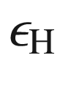

the electron mass is [543] (cf. to ([6.43](#u116076_4_En_6_Chapter-Equ45)) for

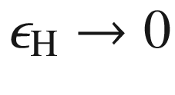

)

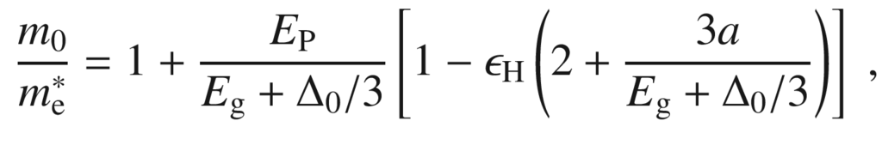

(6.60)

with *a* being the hydrostatic deformation potential and

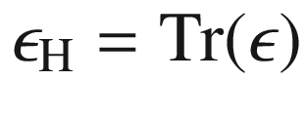

. In [543], formulas are also given for biaxial and shear strain and also for hole masses. Since the effective mass enters the mobility, the electrical conductivity depends on the stress state of the semiconductor (piezoresistivity, see Sect. [8.​3.​14](The_Physics_of_Semiconductors00004.docx#u116076_4_En_8_Chapter)).

#### 6.12.3 Interaction With a Localized Level

The normal dependence of the band gap on hydrostatic pressure is linear and given by ([6.57](#u116076_4_En_6_Chapter-Equ64)). (Ga,In)As containing nitrogen exhibits a remarkable deviation from this behavior as shown in Fig. [6.48](#u116076_4_En_6_Chapter-Fig48)a. This is due to the interaction of the continuum states of the conduction band with the electron level of the isoelectronic nitrogen impurity (Sect. [7.​7.​9](#u116076_4_En_7_Chapter))

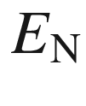

, being within the conduction band. For GaAs it is 0.2 eV above the conduction band edge

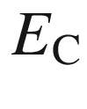

. This phenomenon has been investigated theoretically within microscopic detail [544]. Within a simple ‘band anticrossing’ two-level model, the coupling of the pressure-dependent conduction band edge

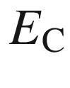

and the nitrogen level can be obtained from the Eigenwert equation

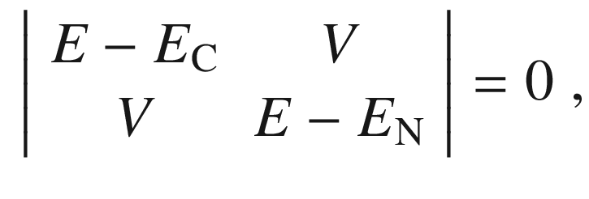

(6.61)

*V* being the coupling constant. The determinant vanishes for

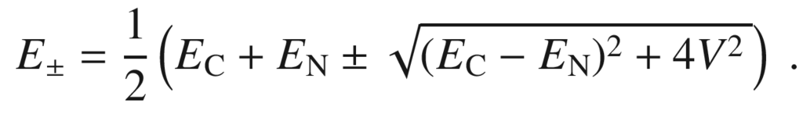

(6.62)

Here the weak pressure dependence of

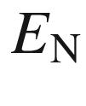

is neglected for simplicity. This model can explain the pressure dependence of the band gap of (Ga,In)As:N fairly well [538] (Fig. [6.48](#u116076_4_En_6_Chapter-Fig48)b). The coupling parameter *V* is in the order of a few 0.1 eV for small nitrogen content. In photomodulated reflection also the

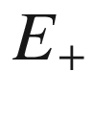

levels can be observed [545]. The anti-crossing model can also model the dependence of the GaAs

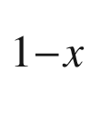

N



bandgap on the nitrogen concentration [545] (Fig. [6.51](#u116076_4_En_6_Chapter-Fig51)).

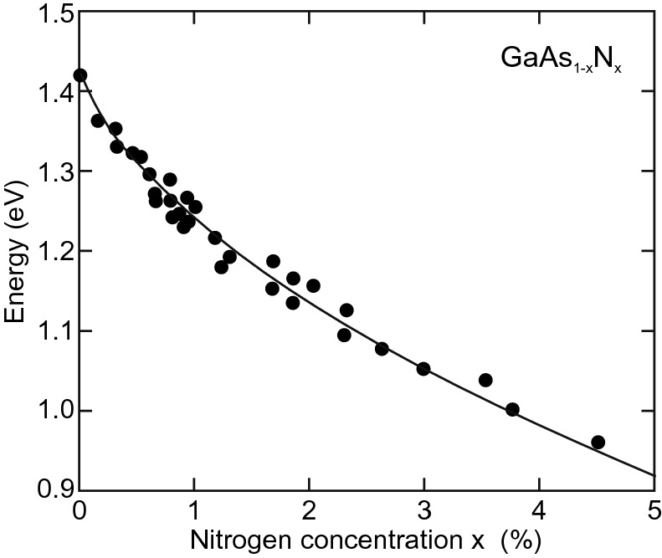

Fig. 6.51

Bandgap of GaAs



N



, experimental data from various sources (*symbols*) and model (*curve*) according to ([6.62](#u116076_4_En_6_Chapter-Equ69)) with

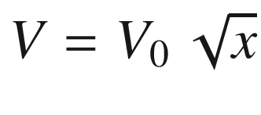

for

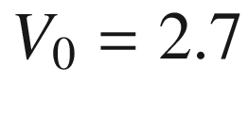

 eV. Adapted from [545]

### 6.13 Density of States

#### 6.13.1 General Band Structure

The dispersion relation yields how the energy of a (quasi-) particle depends on the



vector. Now we want to know how many states are at a given energy. This quantity is called the *density of states* (DOS) and is written as *D*(*E*). It is defined in an infinitesimal sense such that the number of states between *E* and

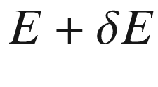

is

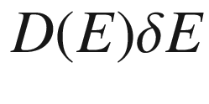

. In the vicinity of the extrema of the band structure many states are at the same energy such that the density of states is high.

The dispersion relation of a band will be given as

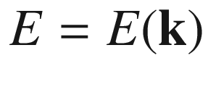

. If several bands overlap, the densities of state of all bands need to be summed up. The density of states at the energy

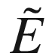

for the given band is

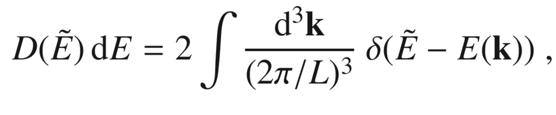

(6.63)

where, according to ([5.​5](The_Physics_of_Semiconductors00002.docx#u116076_4_En_5_Chapter)),

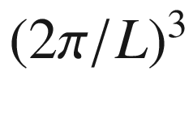

is the



-space volume for one state. The factor 2 is for spin degeneracy. The integral runs over the entire



-space and selects only those states that are at

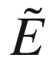

. The volume integral can be converted to a surface integral over the isoenergy surface

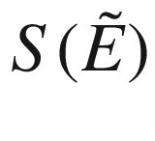

with

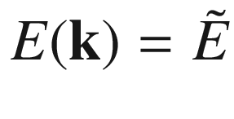

. The volume element

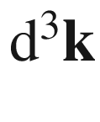

is written as

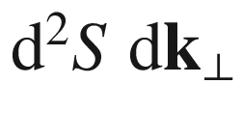

. The vector

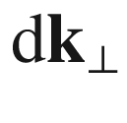

is perpendicular to

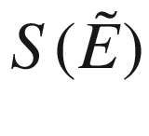

and proportional to

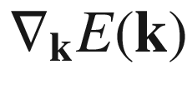

, i.e.

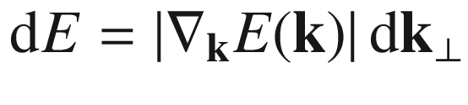

.

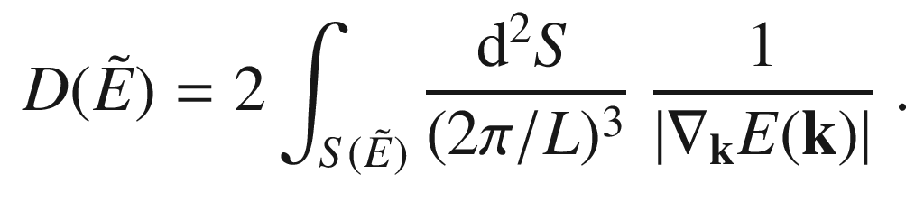

(6.64)

In this equation, the dispersion relation is explicitly contained. At band extrema the gradient diverges, however, in three dimensions the singularities are integrable and the density of states takes a finite value. The corresponding peak is named a van-Hove singularity. The concept of the density of states is valid for all possible dispersion relations, e.g. for electrons, phonons or photons.

The density of states for the silicon band structure (see Fig. [6.9](#u116076_4_En_6_Chapter-Fig9)a) is shown in Fig. [6.52](#u116076_4_En_6_Chapter-Fig52).

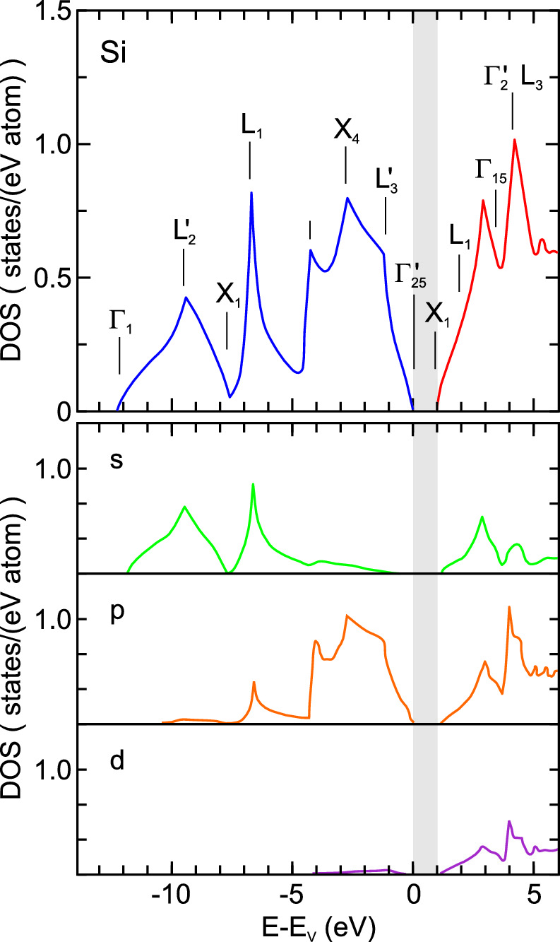

Fig. 6.52

Density of states in the silicon valence- (*blue*) and conduction-band (*red*) as obtained from theoretical calculation using empirical pseudopotentials. *Grey* regions denotes the band gap. Critical points (cf. Fig. [6.9](#u116076_4_En_6_Chapter-Fig9)a) are labeled. In the lower three graphs, the DOS is decomposed into contributions from different angular momentum states (s (*green*), p (*orange*) and d (*purple*)). *Top part* adapted from [546], *bottom part* adapted from [175]

#### 6.13.2 Amorphous Semiconductors

If disorder is introduced, the density of states is modified as shown in Fig. [6.53](#u116076_4_En_6_Chapter-Fig53) for amorphous germanium using a calculation with complex eigenenergies. The defects, as compared to the perfect lattice, introduced states in the band gap and generally wash out the sharp features from the crystalline DOS.

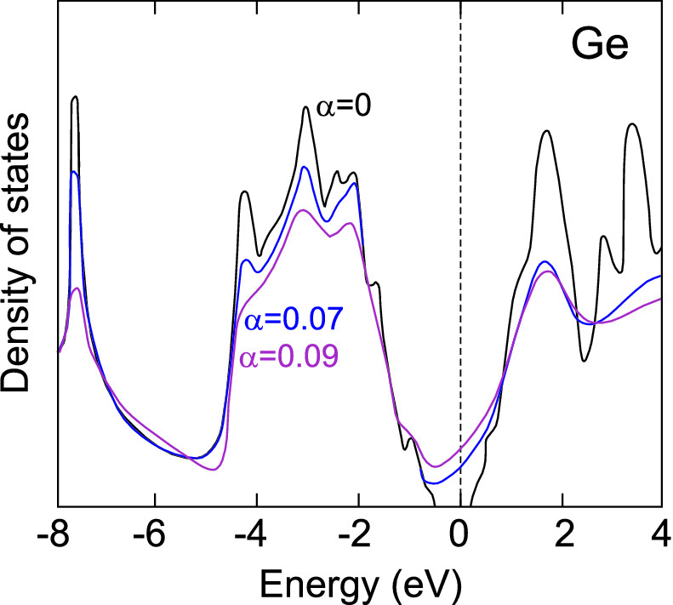

Fig. 6.53

Theoretical calculation for the density of states of amorphous Ge models as obtained for various degrees of disorder



([3.​7](The_Physics_of_Semiconductors00001.docx#u116076_4_En_3_Chapter)).

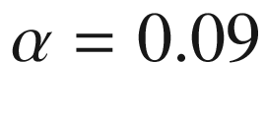

corresponds to a mean short-range order distance of about 2.4 lattice constants (cmp. Fig. [3.​14](The_Physics_of_Semiconductors00002.docx#u116076_4_En_3_Chapter-Fig14)b). Adapted from [204]

Several models exist for the defect level distributions within the band gap. The first model was the Mott model which has band tails at the valence and conduction band edges [547]. In the Cohen-Fritzsche-Ovshinsky (CFO) model [548], the band tails are more severe and overlap; the Fermi energy lies at the minimum of the density of states. In the Davis–Mott model [549] deep states were added in the gap and eventually the Marshall-Owen model [550] assumes band tails and donor- and acceptor-like deep states. The four models are schematically shown in Fig. [6.54](#u116076_4_En_6_Chapter-Fig54). These model densities of states allow also the interpretation of carrier transport in amorphous semiconductors, taking into account localized and delocalized states (see Sect. [8.​9](The_Physics_of_Semiconductors00004.docx#u116076_4_En_8_Chapter)).

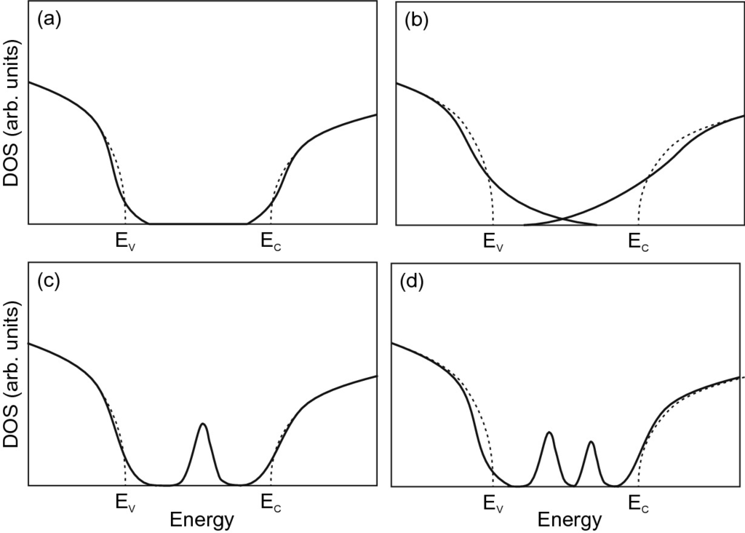

Fig. 6.54

Model density of states in amorphous semiconductors (*solid lines*) according to Mott [547], Cohen-Fritzsche-Ovshinsky [548], Davis–Mott [549] and Marshall–Owen [550]. *Dashed lines* represent the DOS of the same material without disorder

The density of states for an amorphous semiconductor is best calculated from atomistic models, possibly averaging over many configurations. The typical features, compared to the clear band gap of a similar ordered material, are band tails due to disorder (cmp. Sect. [5.​2.​9](The_Physics_of_Semiconductors00002.docx#u116076_4_En_5_Chapter)) and deep levels within the gap due to specific atomic arrangements not present in ordered bulk. The most investigated system is amorphous silicon; in Fig. [6.55](#u116076_4_En_6_Chapter-Fig55) a numerical calculation of the density of states is shown together with charge distribution of four states at selected energies [551]. The further the states are in the band tail, the stronger their localization is. The two most right states shown in Fig. [6.55](#u116076_4_En_6_Chapter-Fig55) are not conducting.

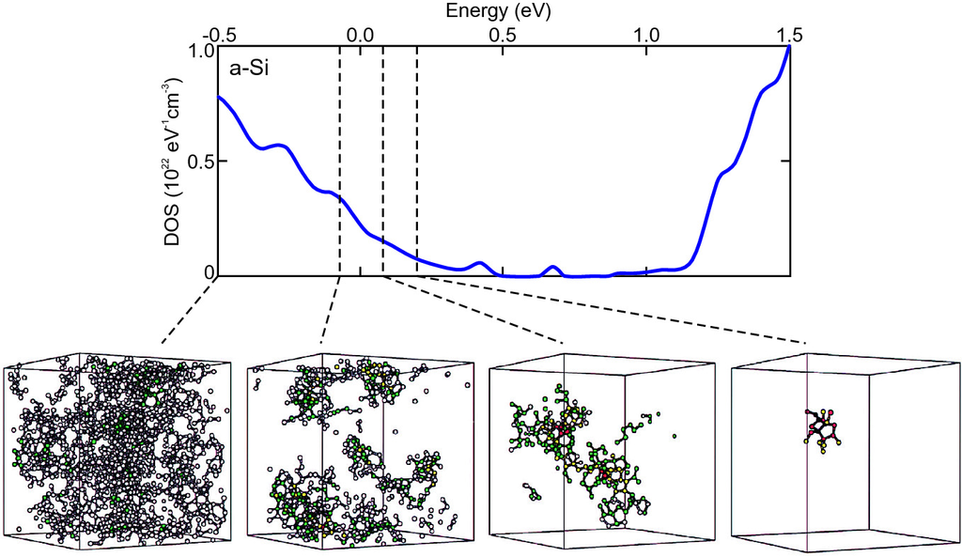

Fig. 6.55

Theoretical calculation of the density of electronic states of amorphous silicon. The charge distribution in four selected states at the indicated energies is shown, from right to left with decreasing localization. Adapted from [551]

As another example, simulations of ZnSnO

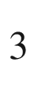

are shown in Fig. [6.56](#u116076_4_En_6_Chapter-Fig56). The band tail between 0 and 0.5 eV is due to disorder of oxygen 2p orbitals [552]. At 0.9 eV a level due to under-coordinated oxygen appears. Deep levels are due to metal-metal bonds. Band tails due to chemically disordered oxygen have been experimentally observed for amorphous GIZO [553].

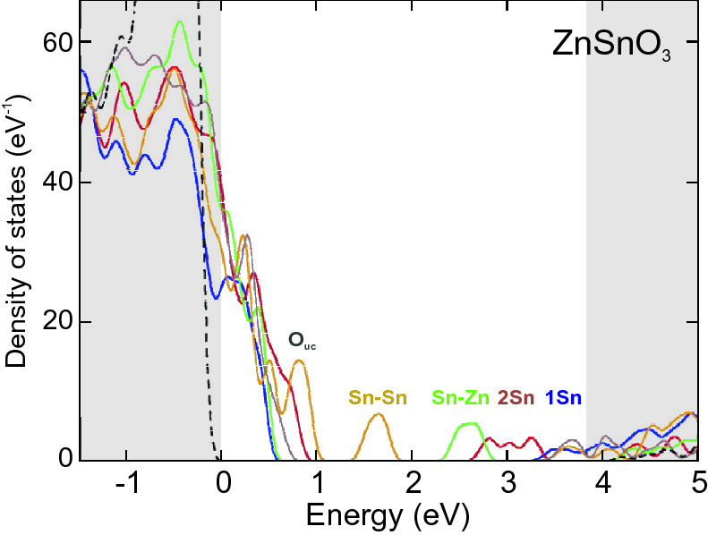

Fig. 6.56

Theoretical calculation for the density of states of crystalline (*dashed lines*, conduction and valence bands indicated by *greay areas*) and amorphous ZnSnO

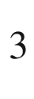

with different configurations (*solid lines*). States due to under-coordinated oxygen (

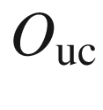

) and metal-metal bonds are labelled. Adapted from [552]

#### 6.13.3 Free-Electron Gas

In *M* dimensions, the energy states of a free-electron gas are given as

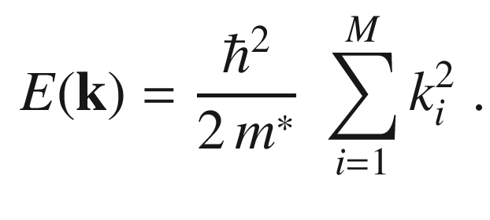

(6.65)

The

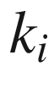

can take the values

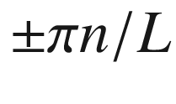

(in the first Brillouin zone) with

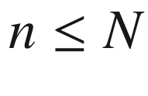

, *N* being the number of unit cells in one dimension. These values are equidistant in



-space. Each *M*-dimensional



-point takes a volume of

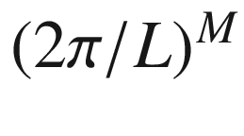

. The number of states

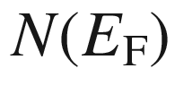

up to the energy

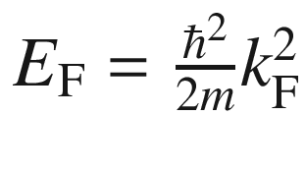

(later used as Fermi energy

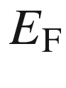

and Fermi vector

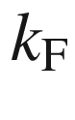

) is

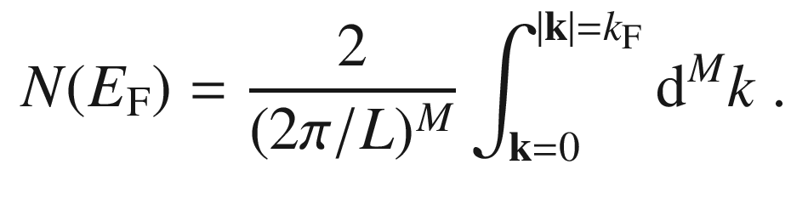

(6.66)

The factor 2 is for spin degeneracy, the integration runs over *M* dimensions. The density of states is the derivative

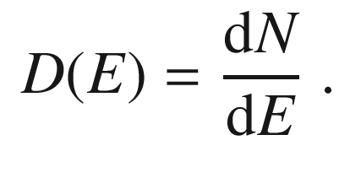

(6.67)

In the following, the density of states for

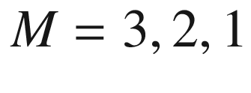

and zero dimensions is derived. A visualization is given in Fig. [14.​1](The_Physics_of_Semiconductors00006.docx#u116076_4_En_14_Chapter-Fig1).

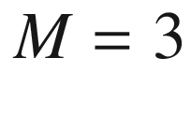

##### 6.13.3.1

This case relates to bulk material in which electrons are free to move in all three dimensions. Performing the integral ([6.66](#u116076_4_En_6_Chapter-Equ73)) for

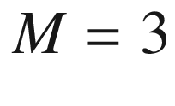

yields for an isotropic mass,

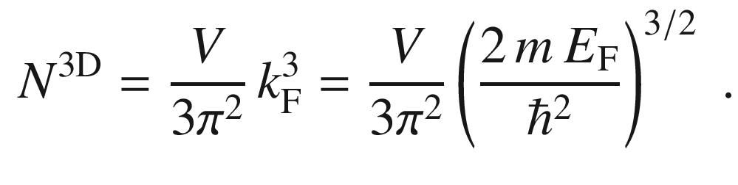

(6.68)

Therefore,

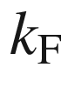

and

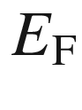

are given by

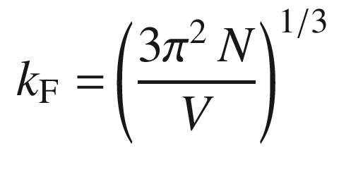

(6.69)

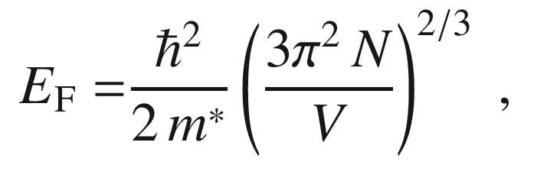

(6.70)

and the density of states in three dimensions is

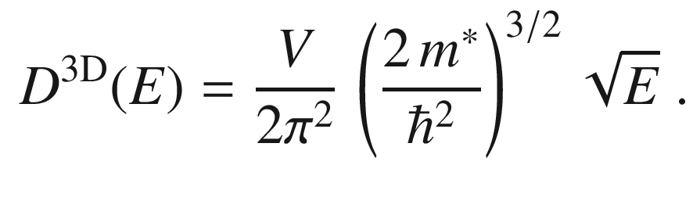

(6.71)

Mostly the density of states is used as density of states per volume, then the factor *V* in ([6.71](#u116076_4_En_6_Chapter-Equ78)) is omitted.

If a conduction-band minimum is degenerate, a factor

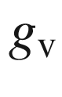

(valley degeneracy) must be included in the density of states, i.e.

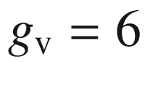

for Si and

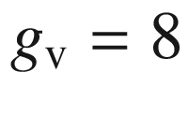

for Ge (

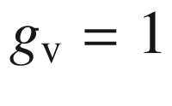

for GaAs). This factor is typically included in the mass used in ([6.71](#u116076_4_En_6_Chapter-Equ78)) that then becomes the density of states mass

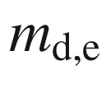

. If the conduction-band minimum has cylindrical symmetry in

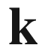

-space, such as for Si and Ge, the mass that has to be used is

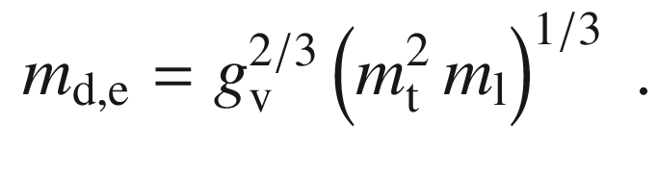

(6.72)

In the case of a degeneracy of the valence band, the states of several bands need to be summed. In bulk material, typically the heavy and light hole bands are degenerate at the



-point. If the split-off band is not populated because of insufficient temperature, the valence-band edge density of states is expressed by the density of states hole mass

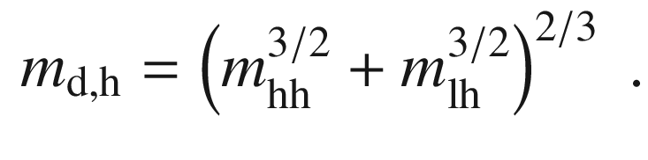

(6.73)

The density of states (per volume) at the conduction and valence band edges are thus given by

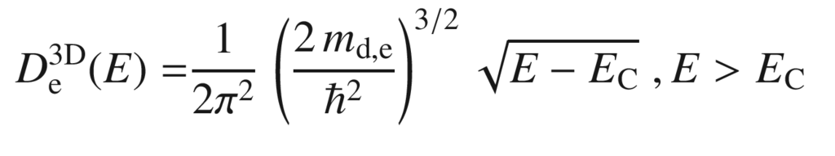

(6.74)

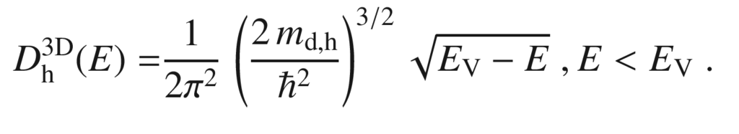

(6.75)

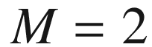

##### 6.13.3.2

This case is important for thin layers in which the electron motion is confined in one direction and free in a plane. Such structures are called quantum wells (see Sect. [12.​3.​2](The_Physics_of_Semiconductors00005.docx#u116076_4_En_12_Chapter)). We find for the 2D density of states (for each subband over which it is not summed here, including spin degeneracy)

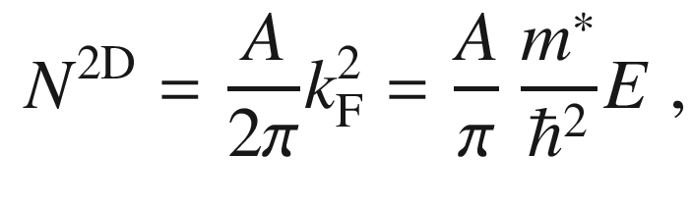

(6.76)

where *A* is the area of the layer. The density of states is thus constant and given by

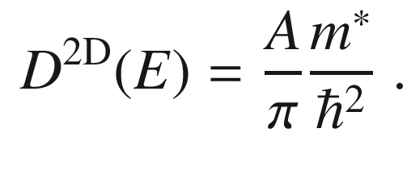

(6.77)

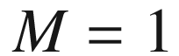

##### 6.13.3.3

The case

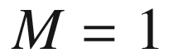

describes a quantum wire in which the electron motion is confined in two dimensions and free in only one dimension. For this case, we find for a wire of length *L*

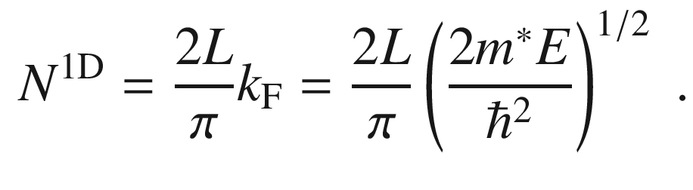

(6.78)

The density of states becomes singular at

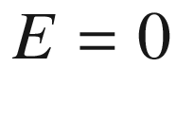

and is given by (for one subband)

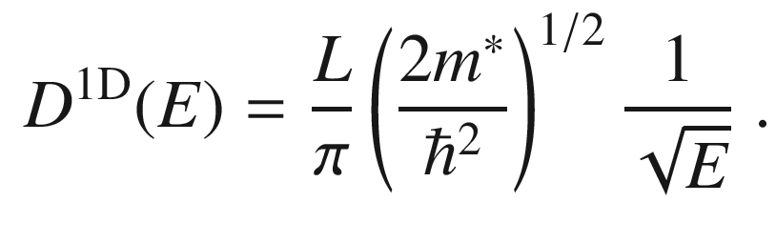

(6.79)

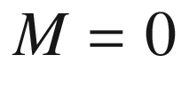

##### 6.13.3.4

In this case electrons have no degrees of freedom, as, e.g., in a quantum dot (Sect. [14.​4](The_Physics_of_Semiconductors00006.docx#u116076_4_En_14_Chapter)), and each state has a

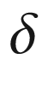

-like density of states at each of the quantized levels.

Footnotes

[1](#u116076_4_En_6_Chapter-Fn1_source)

In this book the form of the potential will never be explicitly given.

[2](#u116076_4_En_6_Chapter-Fn2_source)

Due to the local density approximation (LDA) the absolute values of the band gaps are too small by about 1 eV.

[3](#u116076_4_En_6_Chapter-Fn3_source)

local density approximation.

[4](#u116076_4_En_6_Chapter-Fn4_source)

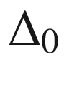

is the spin-orbit splitting discussed in Sect. [6.10.2](#u116076_4_En_6_Chapter-Sec37).

© Springer Nature Switzerland AG 2021

M. Grundmann

The Physics of Semiconductors

Graduate Texts in Physics

<https://doi.org/10.1007/978-3-030-51569-0_7>

## 7. Electronic Defect States

Marius Grundmann[1](#u116076_4_En_7_Chapter-Aff11)

(1)

Felix Bloch Institute for Solid State Physics, Universität Leipzig, Leipzig, Germany

Marius Grundmann

Email:

[grundmann@physik.uni-leipzig.de](mailto:grundmann@physik.uni-leipzig.de)

*Über Halbleiter sollte man nicht arbeiten, das ist eine Schweinerei, wer weiß ob es überhaupt Halbleiter gibt.*

*One should not work on semiconductors. They are a mess. Who knows whether semiconductors even exist.*

*W. Pauli, 1931*[554]

## Abstract

After the carrier statistics for intrinsic conduction and general doping principles, donors and acceptors, compensation and high doping effects are treated in detail. The concept of quasi-Fermi levels is introduced. Finally for deep levels and their thermodynamics general remarks and several examples are given.

### 7.1 Introduction

One cm

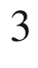

of a semiconductor contains about

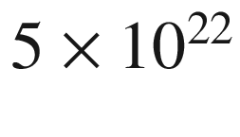

atoms. It is practically impossible to achieve perfect purity. Typical low concentrations of impurity atoms are in the

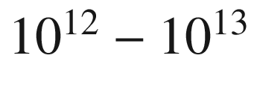

 cm

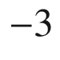

regime. Such a concentration corresponds to a purity of

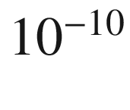

, corresponding to about one alien in the world’s human population. In the beginning of semiconductor research the semiconductors were so impure that the actual semiconducting properties could only be used inefficiently. Nowadays, thanks to large improvements in high-purity chemistry, the most common semiconductors, in particular silicon, can be made so pure that the residual impurity concentration plays no role in the physical properties. However, the most important technological step for semiconductors is *doping*, the controlled incorporation of impurities, in order to manage the semiconductor’s conductivity. Typical impurity concentrations used in doping are

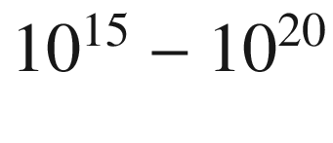

 cm

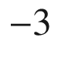

. A milestone in the understanding of doping and the spreading of semiconductor technology was the 1950 textbook by Shockley [555].

### 7.2 Carrier Concentration

Generally, the density of electrons in the conduction band is given by

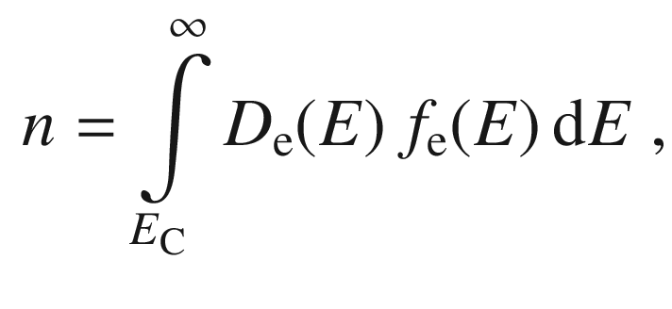

(7.1)

and accordingly the density of holes in the valence band is

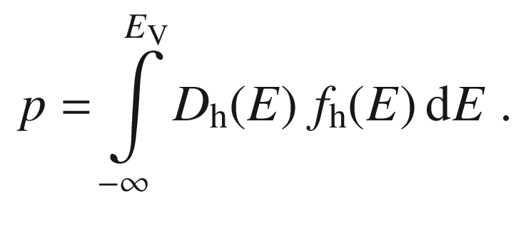

(7.2)

The energy of the top of the valence band is denoted by

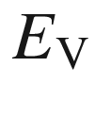

, the bottom of the conduction band as

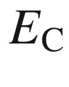

. We assume here parabolic band edges, i.e. effective masses

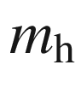

and

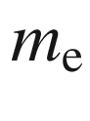

for holes and electrons, respectively. The density of states (per volume) in the conduction band

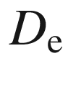

and valence bands

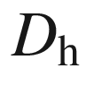

is given by ([6.​74](#u116076_4_En_6_Chapter)) and ([6.​75](#u116076_4_En_6_Chapter)).

The statistical distribution function for electrons is denoted by

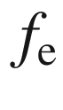

is given in thermodynamical equilibrium by the Fermi-Dirac distribution, (E.22),

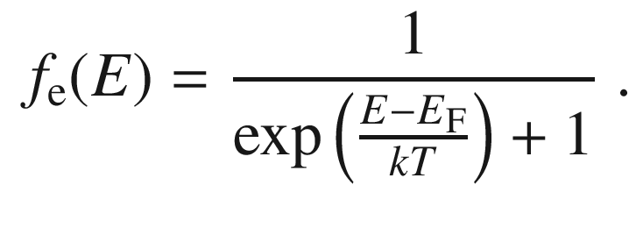

(7.3)

The distribution function for holes is

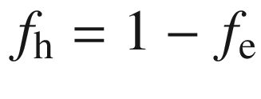

,

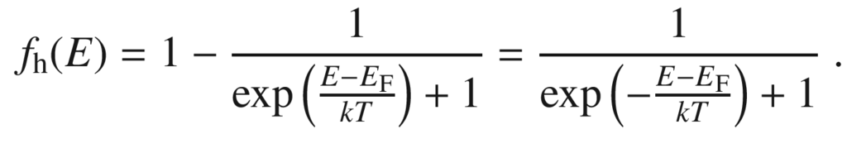

(7.4)

If several hole bands (hh, lh, so) are considered, the same distribution is valid for all hole bands in thermal equilibrium.

If the Boltzmann distribution (E.23) is a good approximation, the carrier distribution is called *nondegenerate*. If the Fermi-Dirac distribution needs to be invoked, the carrier ensemble is called *degenerate*. If the Fermi level is within the band, the ensemble is highly degenerate.

If the Boltzmann approximation (E.23) cannot be applied, i.e. at high temperatures or for very small band gaps, the integral over *Df* cannot be analytically evaluated. In this case the Fermi integral is needed that is defined[1](The_Physics_of_Semiconductors00004.docx#u116076_4_En_7_Chapter-Fn1) as

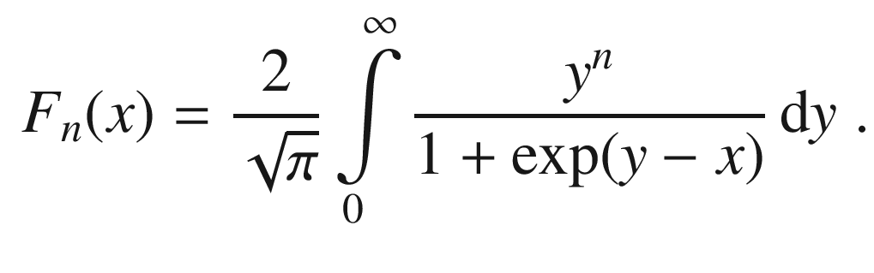

(7.5)

In the present case of bulk materials

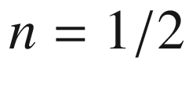

. For large negative argument, i.e.

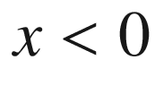

and

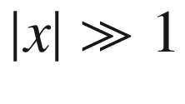

,

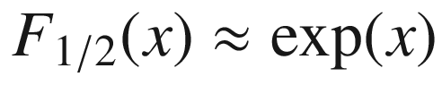

, which is the Boltzmann approximation.

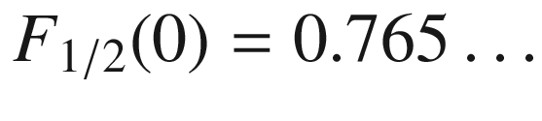

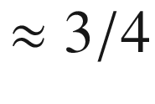

. For large argument, i.e.

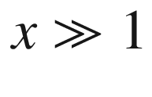

,

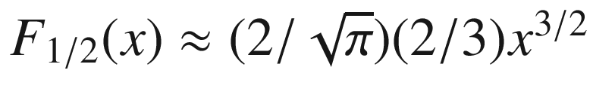

. Such fairly simple approximations are plotted in Fig. [7.1](#u116076_4_En_7_Chapter-Fig1) in comparison with the Fermi integral. For computations, analytical [556–559] or numerical approximations [560, 561] are used.

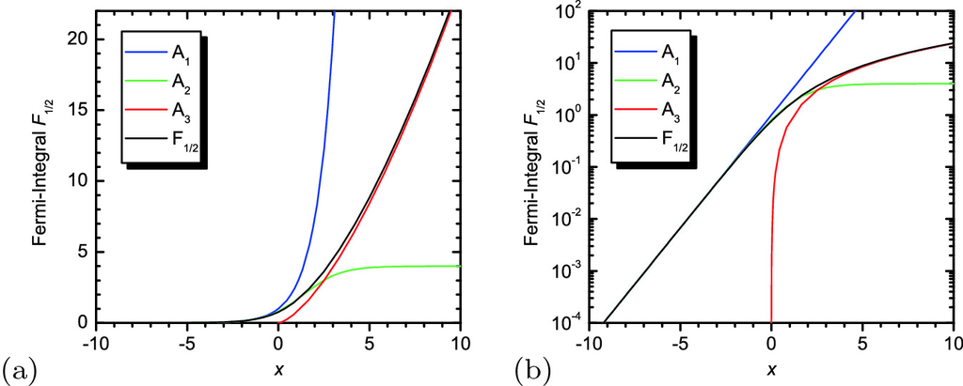

Fig. 7.1

Fermi integral

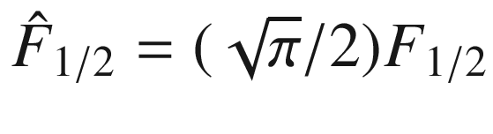

with approximations in three regions of the argument:

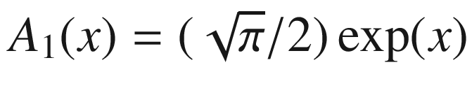

for

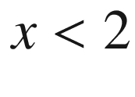

,

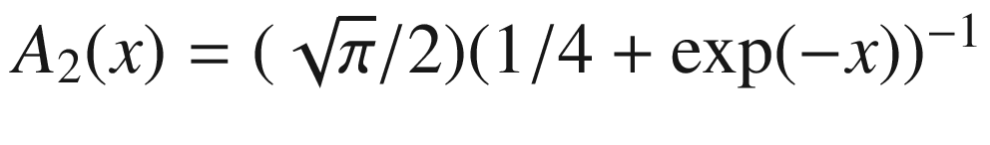

for

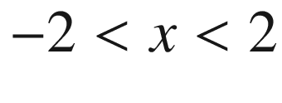

,

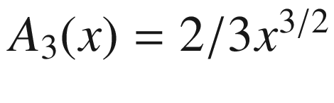

for

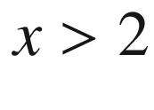

. **a** linear, **b** semilogarithmic plot

The derivative of the Fermi integral is given by

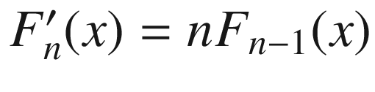

,

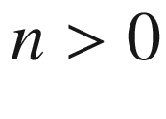

. For

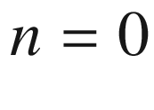

, i.e. a two-dimensional system, the integral can be executed explicitly,

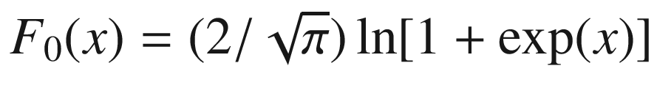

.

With the Fermi integral

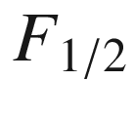

([7.10](#u116076_4_En_7_Chapter-Equ10)) and ([7.11](#u116076_4_En_7_Chapter-Equ11)) the free-carrier densities can be written as

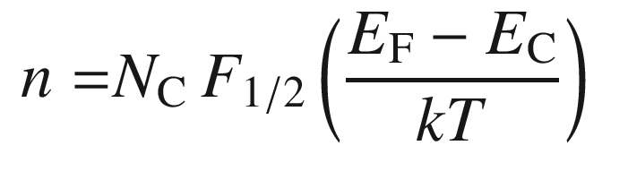

(7.6)

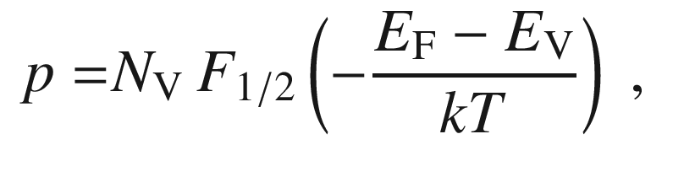

(7.7)

with

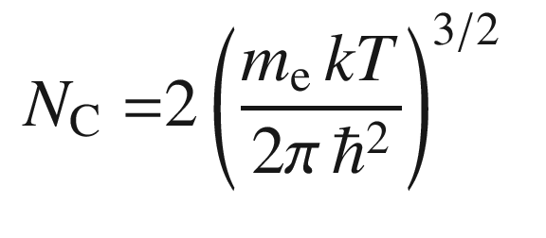

(7.8)

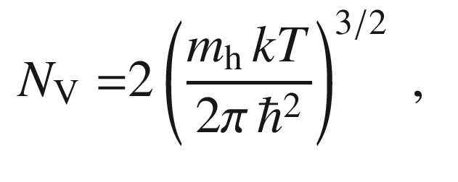

(7.9)

where

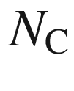

(

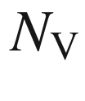

) is called the conduction-band (valence-band)  edge density of states. The masses in ([7.8](#u116076_4_En_7_Chapter-Equ8)) and ([7.9](#u116076_4_En_7_Chapter-Equ9)) are the density of states masses given in ([6.​72](#u116076_4_En_6_Chapter)) and ([6.​73](#u116076_4_En_6_Chapter)). Values of

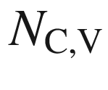

for Si, Ge and GaAs are given in Table [7.1](#u116076_4_En_7_Chapter-Tab1).Table 7.1

Band gap, intrinsic carrier concentration, conduction band and valence-band edge density of states at

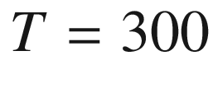

 K for various semiconductors

|  | $$E_{\mathrm {g}}$$   (eV) | $$n_{\mathrm {i}}$$   (cm  $$^{-3}$$  ) | $$N_{\mathrm {C}}$$   (cm  $$^{-3}$$  ) | $$N_{\mathrm {V}}$$   (cm  $$^{-3}$$  ) |
| --- | --- | --- | --- | --- |
| InSb | 0.18 | $$1.6 \times 10^{16}$$ |  |  |
| InAs | 0.36 | $$8.6 \times 10^{14}$$ |  |  |
| Ge | 0.67 | $$2.4 \times 10^{13}$$ | $$1.04 \times 10^{19}$$ | $$6.0 \times 10^{18}$$ |
| Si | 1.124 | $$1.0 \times 10^{10}$$ | $$7.28 \times 10^{19}$$ | $$1.05 \times 10^{19}$$ |
| GaAs | 1.43 | $$1.8 \times 10^{6}$$ | $$4.35 \times 10^{17}$$ | $$5.33 \times 10^{18}$$ |
| GaP | 2.26 | $$2.7 \times 10^{0}$$ |  |  |
| GaN | 3.3 | $${\ll }1$$ |  |  |

Now, we assume that the Boltzmann approximation (E.23) can be used, i.e. the probability that a band state is populated is

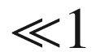

. Then, the integral ([7.1](#u116076_4_En_7_Chapter-Equ1)) can be executed analytically and the concentration *n* of electrons in the conduction band is given as

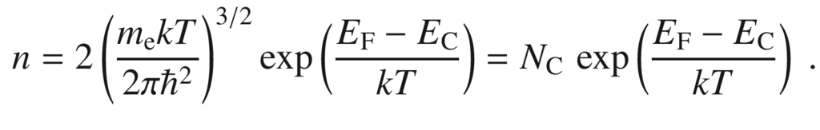

(7.10)

For the Boltzmann approximation and a parabolic valence band, the density of holes is given by

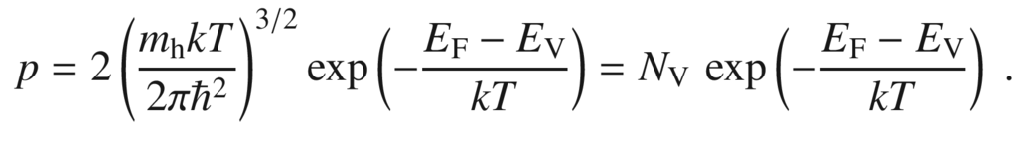

(7.11)

Within the Boltzmann approximation, the product of the electron and hole density is

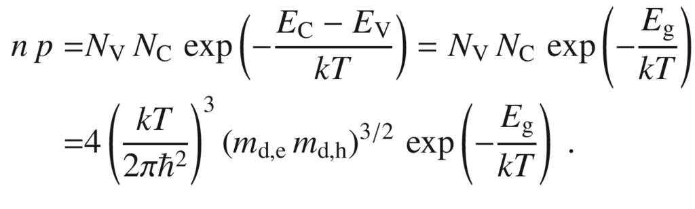

(7.12)

Thus, the product

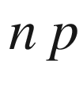

is *independent* of the position of the Fermi level, as long as the Boltzmann approximation is fulfilled. This is the case when the Fermi level lies within the band gap and it is sufficiently far away from the band edges, fulfilling about

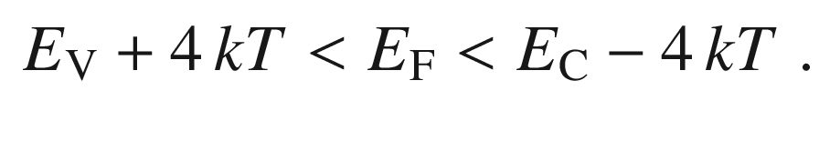

(7.13)

The relation ([7.12](#u116076_4_En_7_Chapter-Equ12)) is called the mass-action law.

In Fig. [7.2](#u116076_4_En_7_Chapter-Fig2), the product *np* is shown for silicon over a wide range of Fermi energies. If

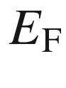

is within the band gap, *np* is essentially constant. If the Fermi level is in the valence or conduction band, *np* decreases exponentially.

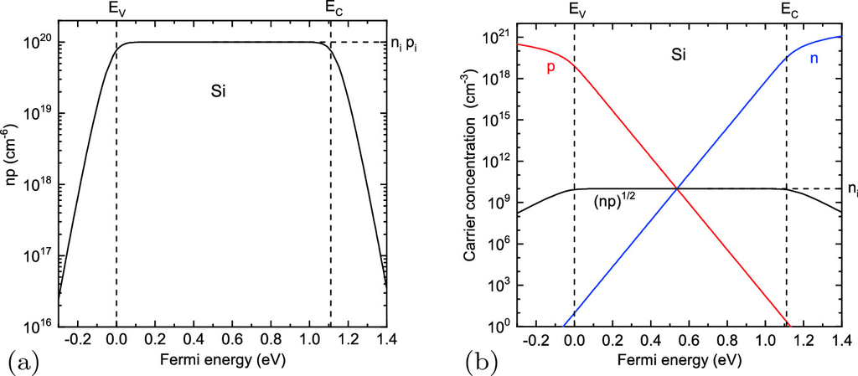

Fig. 7.2

**a** *np* for silicon at

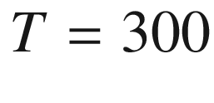

 K as a function of the position of the Fermi level. The valence-band edge

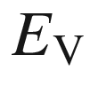

is chosen as

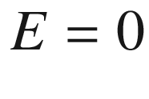

. *np* is constant for the range of Fermi energies given by ([7.13](#u116076_4_En_7_Chapter-Equ13)) (

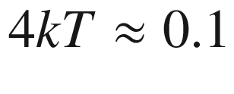

 eV). **b** *n*, *p* and

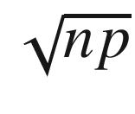

as a function of the Fermi level

### 7.3 Intrinsic Conduction

First, we consider the conductivity of the intrinsic, i.e. an ideally pure, semiconductor. At

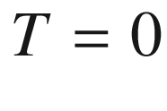

all electrons are in the valence band, the conduction band is empty and thus the conductivity is zero (a completely filled band cannot conduct current). Only at finite temperatures the electrons have a finite probability to be in a conduction-band state and to contribute to the conductivity. Due to neutrality, the electron and hole concentrations in the intrinsic semiconductors are the same, i.e. each electron in the conduction band comes from the valence band,

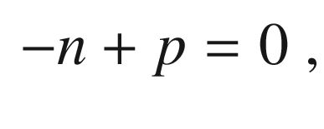

(7.14)

or

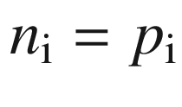

. Therefore

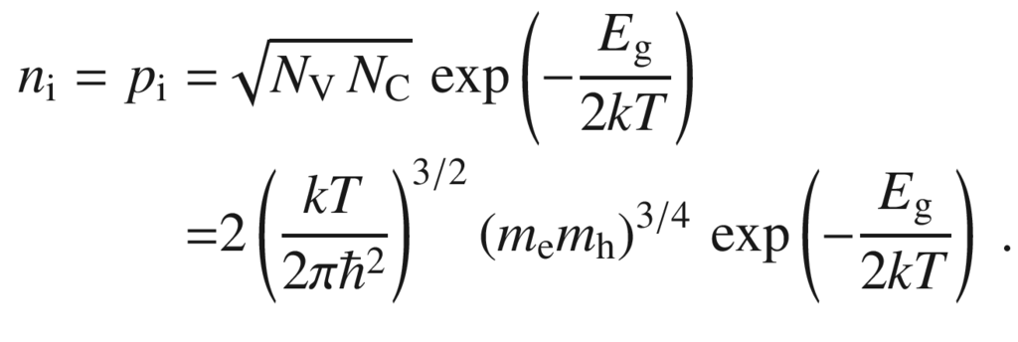

(7.15)

The mass-action law

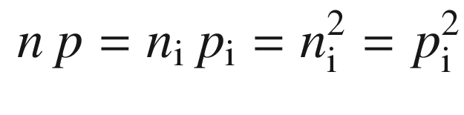

(7.16)

will be essential also for light and moderately doped semiconductors. The intrinsic carrier concentration is exponentially dependent on the band gap. Thus, in thermodynamic equilibrium intrinsic wide-gap semiconductors have much smaller electron concentrations than intrinsic small-gap semiconductors (see Table [7.1](#u116076_4_En_7_Chapter-Tab1)). The intrinsic carrier concentration of Si (in cm

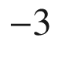

) has been determined to be (within 1%, *T* in K)

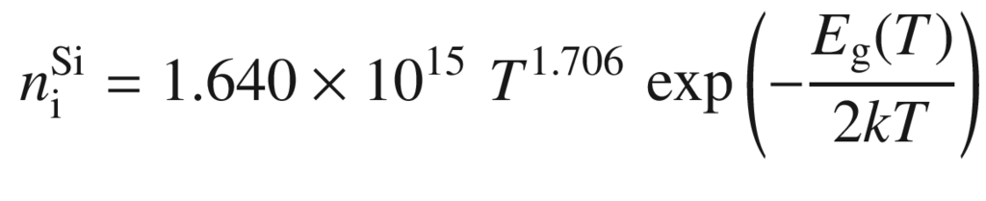

(7.17)

for temperatures between 77 and 400 K [562, 563] (Fig. [7.3](#u116076_4_En_7_Chapter-Fig3)).

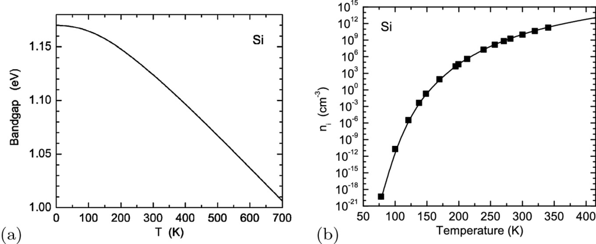

Fig. 7.3

**a** Band gap of silicon versus temperature. **b** Intrinsic carrier concentration of silicon versus temperature. *Solid line* is ([7.17](#u116076_4_En_7_Chapter-Equ17)) using

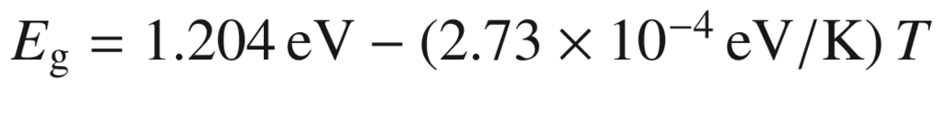

[564], *symbols* are experimental data from [565]

As we will see later in Part II, many semiconductor devices rely on regions of low conductivity (depletion layers) in which the carrier concentration is small. Since the carrier concentration cannot be smaller than the intrinsic concentration (

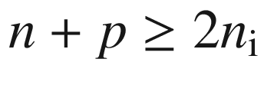

), an increase of temperature leads to increasing ohmic conduction in the depletion layers and thus to a reduction or failure of device performance. The small band gap of Ge leads to degradation of bipolar device performance already shortly above room temperature. For silicon, intrinsic conduction limits operation typically to temperatures below about 300

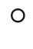

C. For higher temperatures, as required for devices in harsh environments, such as close to motors or turbines, other semiconductors with wider band gaps need to be used, such as GaN, SiC or even diamond.

From the neutrality condition for the intrinsic semiconductor ([7.14](#u116076_4_En_7_Chapter-Equ14)) and ([7.10](#u116076_4_En_7_Chapter-Equ10)) and ([7.11](#u116076_4_En_7_Chapter-Equ11)), the Fermi level of the intrinsic semiconductor can be determined as

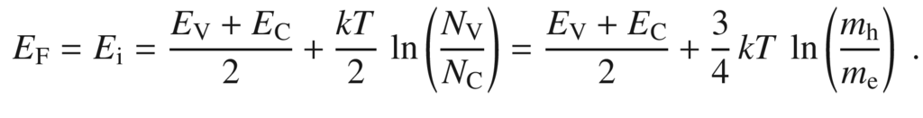

(7.18)

Since the hole mass is perhaps a factor of ten larger than the electron mass, the second term has the order of *kT*. Thus, for typical semiconductors where

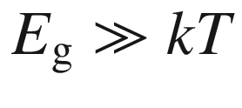

, the  intrinsic Fermi level, denoted by

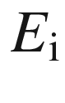

, is close to the middle of the band gap, i.e.

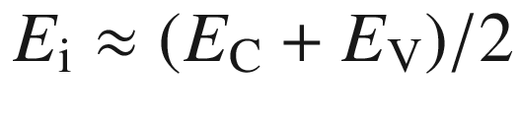

.

The situation for an intrinsic semiconductor is schematically shown in Fig. [7.4](#u116076_4_En_7_Chapter-Fig4)b. In the following we will consider doping which can shift the Fermi level away from

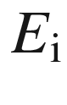

. Within the Boltzmann approximation (also

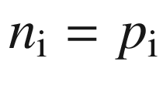

),

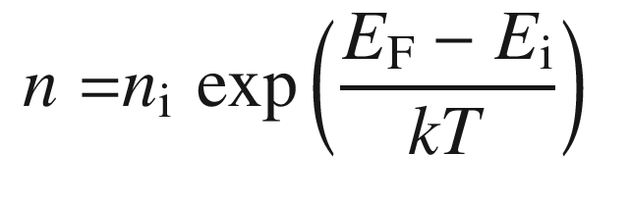

(7.19)

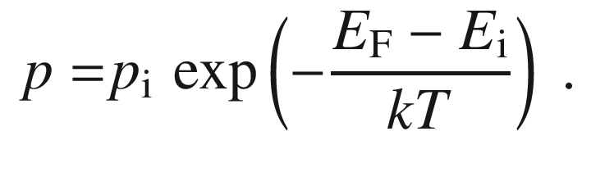

(7.20)

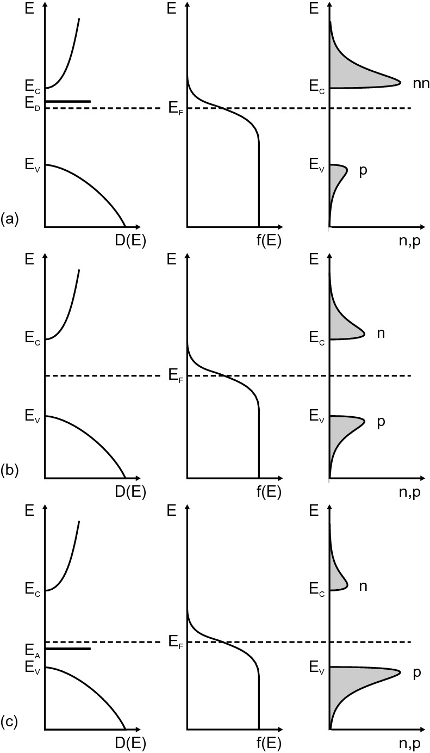

Fig. 7.4

Density of states (*left column*), Fermi distribution (*center column*) and carrier concentration (*right column*) for **a** n-type, **b** intrinsic and **c** p-type semiconductors in thermal equilibrium

### 7.4 Doping

#### 7.4.1 Concept

The modification of the conductivity of a semiconductor using point defects is termed *doping*. In 1930 electrical conduction of semiconductors was attributed solely to impurities [566, 567]. However ‘chemically pure’ substances become conductive upon deviation from stoichiometry, e.g. historically found for changes in the anion concentration and conductivity in CuI [38] (p-type) and ZnO [80] (n-type). The modification of CuI by exposure to different partial pressure of iodine in organic solutions with different iodine concentration [41] and subsequently various concentrations of copper vacancies [568] can be considered the first doping of a semiconductor (1909).

The electronic levels of a defect or an impurity can exist within the forbidden gap of the bulk host material. These levels can lie close to the band edges or in the vicinity of the middle of the band gap. In a simplified approach, the first stem from *shallow* defects (Sect. [7.5](#u116076_4_En_7_Chapter-Sec7)), the latter from *deep* defects (Sect. [7.7](The_Physics_of_Semiconductors00004.docx#u116076_4_En_7_Chapter-Sec16)).

#### 7.4.2 Doping Principles

In [569] various doping principles are formulated. Essentially, the amount of impurities that lead to electrically active dopants is limited by the increasingly probable formation of compensating defects. In the case of donors, these are electron killers, e.g. n-type doping of Si:As is limited by the formation of V

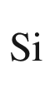

[570]. In the case of acceptors, the compensating defects are hole killers. The so-called n-type *pinning energy*

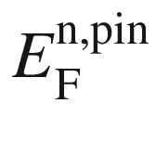

is the Fermi level at which such killer defect (e.g. a cation vacancy) forms. When the Fermi level reaches the pinning energy, no further progress in n-type doping can be made, since the spontaneously generated electron killers will negate the introduced (impurity) donors. As a tendency, materials with low lying conduction band, i.e. large electron affinity (difference between vacuum level and conduction band) can be doped n-type. Similarly, p-type doping by acceptors, shifting the Fermi level towards the valence band, will meet at some point

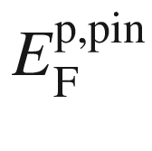

, called p-type pinning energy, when native hole killers, such as anion vacancies or cation interstitials form spontaneously. At this point, further p-type doping is no longer possible. p-type doping is facilitated by materials whose valance band maximum is close to the vacuum level [569].

A comparison of the wide gap materials ZnO, NiO and MgO is depicted in Fig. [7.5](#u116076_4_En_7_Chapter-Fig5). The position of the pinning levels is marked on a common energy scale. From the position of

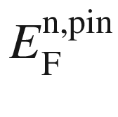

it can be understood, that ZnO can be highly n-doped while NiO and MgO cannot [571]. From

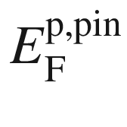

, NiO can be doped p-type, while MgO cannot be doped at all.

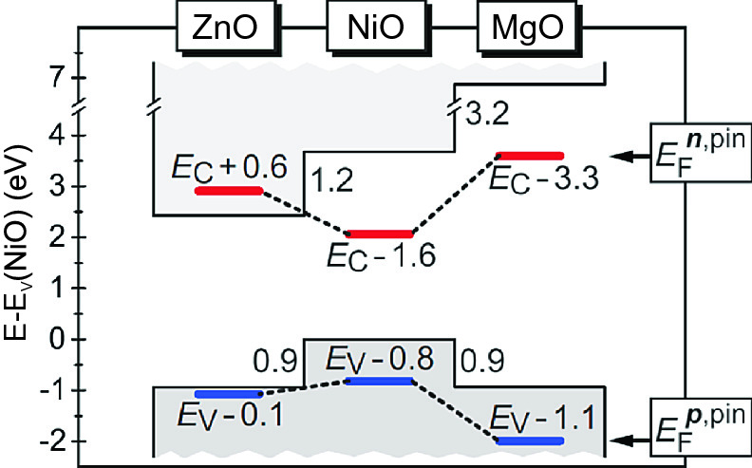

Fig. 7.5

Comparison of ZnO, NiO and MgO on a common energy scale, comparing conduction band and valence band edges and n-type (*red*) and p-type (*blue*) pinning energies (determined for metal-rich and oxygen-rich conditions, respectively).

Adapted from [571]

For dopability, generally, it is also important that the ionized charges from impurities are free and thus contribute to the free charge carrier density and do not form localized states, e.g. due to polaronic effects (Sect. [8.​7](The_Physics_of_Semiconductors00004.docx#u116076_4_En_8_Chapter)).

### 7.5 Shallow Defects

In Fig. [7.6](#u116076_4_En_7_Chapter-Fig6), the positions of the energy levels of a variety of impurities are shown for Ge, Si and GaAs. An impurity for which the long-range Coulomb part of the ion-core potential determines the energetic level is termed a *shallow* impurity. The extension of the wavefunction is given by the Bohr radius. This situation is in contrast to a *deep* level where the short-range part of the potential determines the energy level. The extension of the wavefunction is then of the order of the lattice constant. A view on the history of the science of shallow impurity states is given in [572, 573].

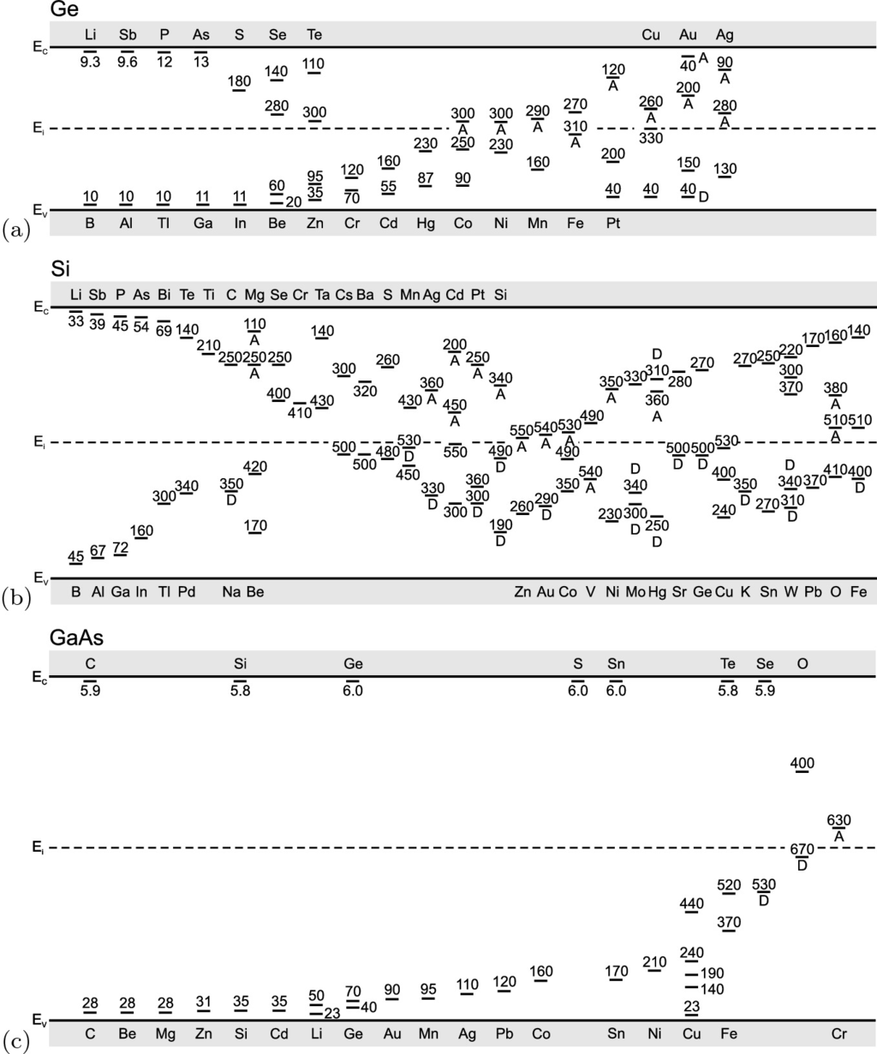

Fig. 7.6

Energetic position (ionization energy labeled in meV) of various impurities (A: acceptor, D: donor) in **a** Ge, **b** Si and **c** GaAs. Based on [574]

We will consider first a group-IV semiconductor, Si, and (impurities) dopants from the groups III and V of the periodic system. When these are incorporated on a lattice site (with tetrahedral bonds), there is one electron too few (group III, e.g. B) or one electron too many (group V, e.g. As). The first case is called an *acceptor*, the latter a *donor*. The doping of III–V semiconductors is detailed in [575].

#### 7.5.1 Donors

Silicon doped with arsenic is denoted as Si:As. The situation is schematically shown in Fig. [7.7](#u116076_4_En_7_Chapter-Fig7). The arsenic atom has, after satisfying the tetrahedral bonds, an extra electron. This electron is bound to the arsenic atom via the Coulomb interaction since the ion core is positively charged compared to the silicon cores. If the electron is ionized, a fixed positive charge remains at the As site.

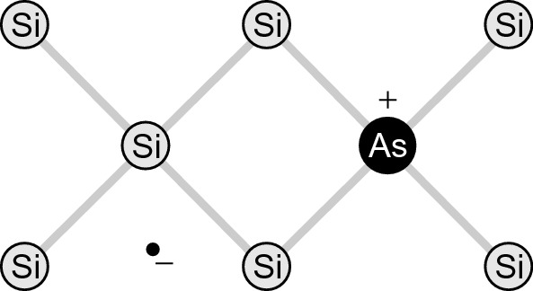

Fig. 7.7

Arsenic impurity in silicon. Arsenic donates one electron, and a fixed positive charge remains

Without being in the silicon matrix, an arsenic atom has an ionization energy of 9.81 eV. However, in the solid the Coulomb interaction is screened by the dielectric constant of the material, typically

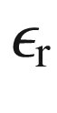

is of the order of 10 for typical semiconductors. Additionally, the mass is renormalized (effective mass) by the periodic potential to a value that is smaller than the free electron mass. Within effective-mass theory (Appendix I) the hydrogen problem is scaled with the (isotropic) effective mass

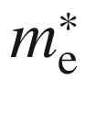

and the dielectric constant

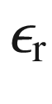

, the binding energy (ionization energy)

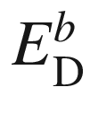

of the electron to the shallow donor is (relative to the continuum given by the conduction-band edge

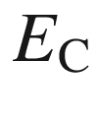

)

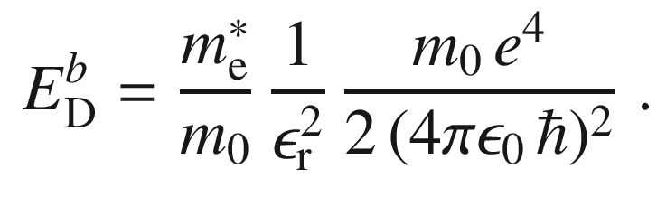

(7.21)

The scaling with

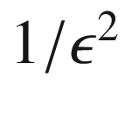

has been pointed out first in [576].

The absolute energy position of the level is

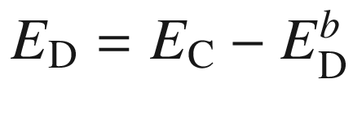

. The first factor in the right side of ([7.21](#u116076_4_En_7_Chapter-Equ21)) is the ratio of effective and free-electron mass, typically 1/10, the second factor is typically 1/100. The third factor is the ionization energy of the hydrogen atom, i.e. the Rydberg energy of 13.6 eV. Thus, the binding energy in the solid is drastically reduced by a factor of about

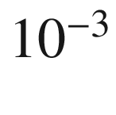

to the 10 meV regime. The excited states of the hydrogen-like spectrum can also be investigated experimentally (Sect. [9.​8](The_Physics_of_Semiconductors00004.docx#u116076_4_En_9_Chapter)).

The extension of the wavefunction of the electron bound to the fixed ion is given by the Bohr radius

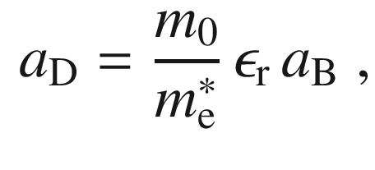

(7.22)

where

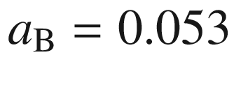

 nm denotes the hydrogen Bohr radius. For GaAs

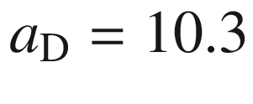

 nm. A similar value has been determined for InP [577]. For semiconductors with a nonisotropic band minimum, such as Si, Ge or GaP, an ‘elliptically deformed’ hydrogen problem with the masses

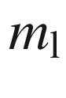

and

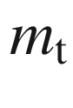

has to be treated [578].

An impurity that fulfills ([7.21](#u116076_4_En_7_Chapter-Equ21)) is called an *effective-mass* impurity. For GaAs, the effective-mass donor has a binding energy of 5.715 meV, which is closely fulfilled for several chemical species (Table [7.3](#u116076_4_En_7_Chapter-Tab3)). In GaP, experimental values deviate considerably from the effective-mass donor (59 meV). For silicon, considering the anisotropic tensor of the effective masses, the result for the effective-mass donor binding energy is 29 meV [578]. Some experimentally observed values are summarized in Table [7.2](#u116076_4_En_7_Chapter-Tab2). Deviations from the effective-mass theory are due to modification of the potential in the immediate vicinity of the impurity atom and breakdown of the effective-mass formalism.

Different impurities can have quite similar binding energies. They can be distinguished, e.g., by electron spin resonance (ESR). At low temperatures the electron is localized on the impurity and the hyperfine interaction with the nucleus can be resolved in ESR. In Fig. [7.8](#u116076_4_En_7_Chapter-Fig8) data are shown for As and P in germanium. The multiplets distinguish the nuclear spins

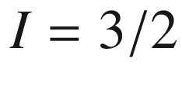

for arsenic (

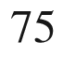

As) and

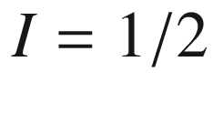

for phosphorus (

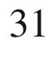

P) [579].

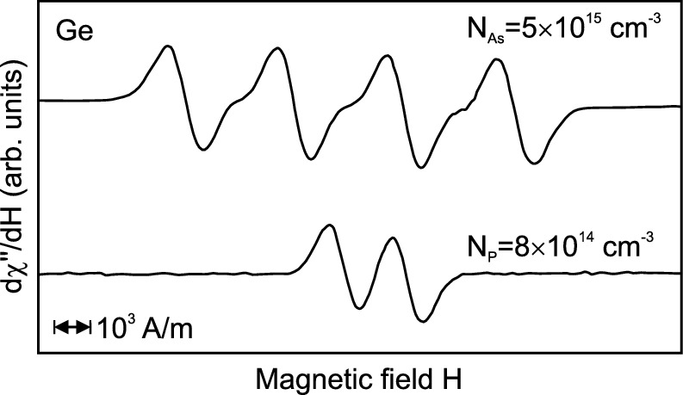

Fig. 7.8

Electron spin resonance signal from As and P in Ge with the magnetic field

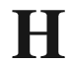

parallel to [100],

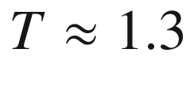

 K.

Adapted from [579]

Table 7.2

Binding energies

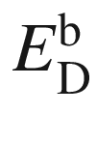

of Li and group-V donors in elemental semiconductors. Data for carbon from [580]. All values in meV

|  | Li | N | P | As | Sb |
| --- | --- | --- | --- | --- | --- |
| C |  | 1700 | $${\approx }500$$ |  |  |
| Si | 33 |  | 45 | 49 | 39 |
| Ge | 9.3 |  | 12.0 | 12.7 | 9.6 |

Table 7.3

Binding energies



of donors in GaAs (data from [581]), GaP (data from [582]) and GaN (low concentration limits, data from [583, 584]). All values in meV

|  | V site | | III site | |
| --- | --- | --- | --- | --- |
| GaAs | S | 5.854 | C | 5.913 |
| Se | 5.816 | Si | 5.801 |
| Te | 5.786 | Ge | 5.937 |
| GaP | O | 897 | Si | 85 |
| S | 107 | Ge | 204 |
| Se | 105 | Sn | 72 |
| Te | 93 |  |  |
| GaN | O | 39 | Si | 22 |
|  |  | Ge | 19 |

The donors are typically distributed statistically (randomly) in the solid. Otherwise their distribution is called clustered. The concentration of donors is labeled

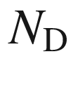

and usually given in cm

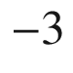

.

The concentration of donors populated with an electron (neutral donors) is denoted by

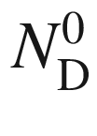

, the concentration of ionized donors (positively charged) is

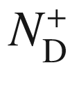

. Other conventions in the literature label the concentrations

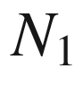

and

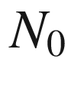

, respectively:

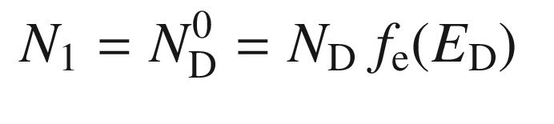

(7.23a)

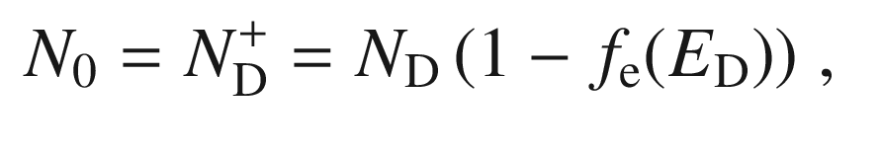

(7.23b)

with

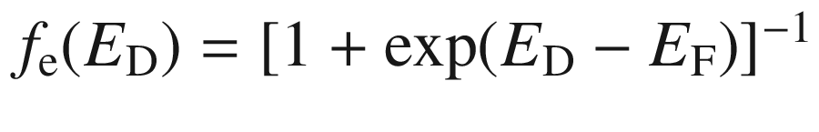

. For the sum of these quantities the condition

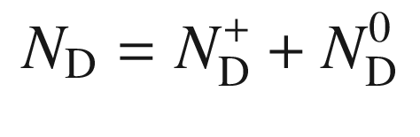

(7.24)

holds.

The ratio of the two concentrations is first given as (caveat: this formula will be modified below)

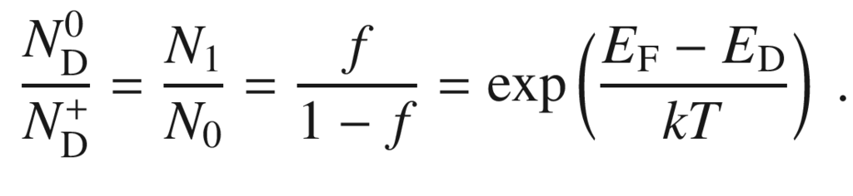

(7.25)

Now, the degeneracy of the states has to be considered. The donor charged with one electron has a 2-fold degeneracy

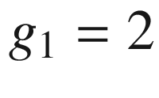

since the electron can take the spin up and down states. The degeneracy of the ionized (empty) donor is

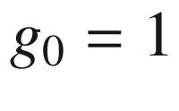

. Additionally, we assume here that the donor cannot be charged with a second electron (cmp. Sect. [7.7.2](The_Physics_of_Semiconductors00004.docx#u116076_4_En_7_Chapter-Sec18)). Due to Coulomb interaction, the energy level of the possible

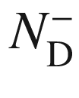

state is in the conduction band. Otherwise, a multiply charged center would be present. We also do not consider excited states of

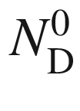

that might be in the band gap as well. In the following, we will continue with

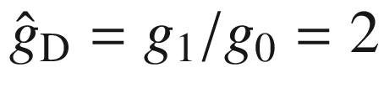

as suggested in [585].[2](The_Physics_of_Semiconductors00004.docx#u116076_4_En_7_Chapter-Fn2) We note that the definition of the degeneracy factor for donors (and acceptors, see ([7.38](#u116076_4_En_7_Chapter-Equ40))) is not consistent in the literature as summarized in [586]. Considering now the degeneracy, ([7.25](#u116076_4_En_7_Chapter-Equ26)) is modified to

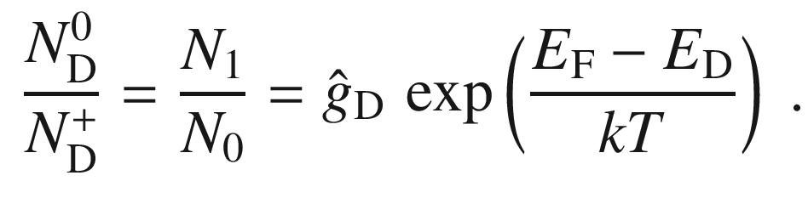

(7.26)

This can be understood from thermodynamics (cf. Sect. [4.​2.​2](The_Physics_of_Semiconductors00002.docx#u116076_4_En_4_Chapter)), a rate analysis or simply the limit

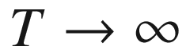

.

The probabilities

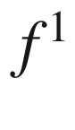

and

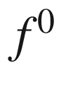

for a populated or empty donor,  respectively, are

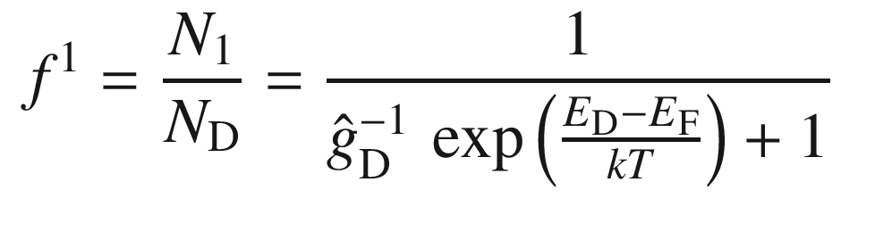

(7.27a)

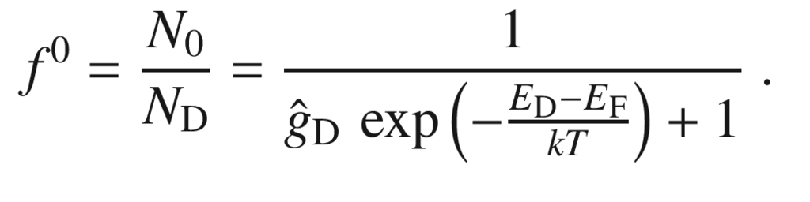

(7.27b)

First, we assume that no carriers in the conduction band stem from the valence band (no intrinsic conduction). This will be the case at sufficiently low temperatures when

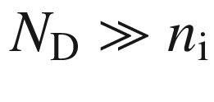

. Then the number of electrons in the conduction band is equal to the number of ionized donors, i.e.

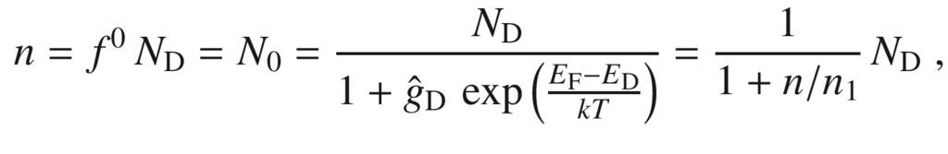

with

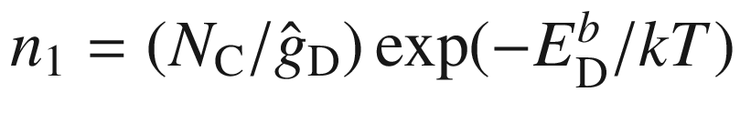

. The neutrality condition (its general from is given in equation ([7.40](#u116076_4_En_7_Chapter-Equ42))) is

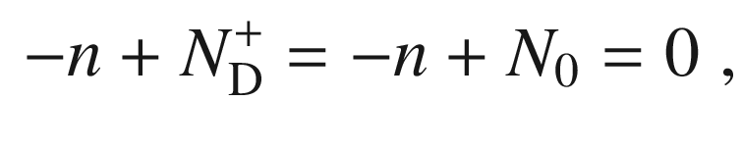

(7.28)

leading to the equation (*n* is given by ([7.10](#u116076_4_En_7_Chapter-Equ10)))

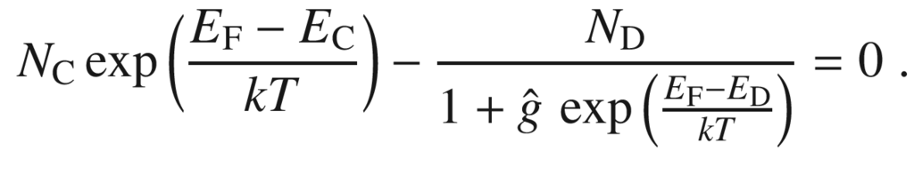

(7.29)

Solving this equation will yield the Fermi level (as a function of temperature *T*, doping level

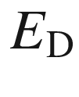

and doping concentration

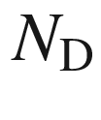

).[3](The_Physics_of_Semiconductors00004.docx#u116076_4_En_7_Chapter-Fn3) The solution is

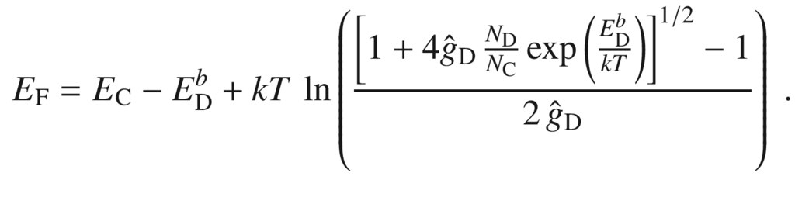

(7.30)

For

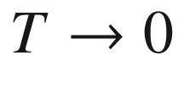

the Fermi level is, as expected, in the center between the populated and unpopulated states, i.e. at

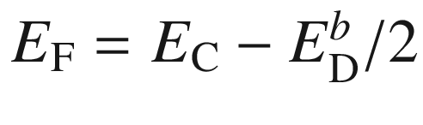

. In Fig. [7.9](#u116076_4_En_7_Chapter-Fig9)a the position of the Fermi is shown for a donor with 45 meV binding energy in Si. For low temperatures the solution can be approximated as (dashed curve in Fig. [7.9](#u116076_4_En_7_Chapter-Fig9)b)

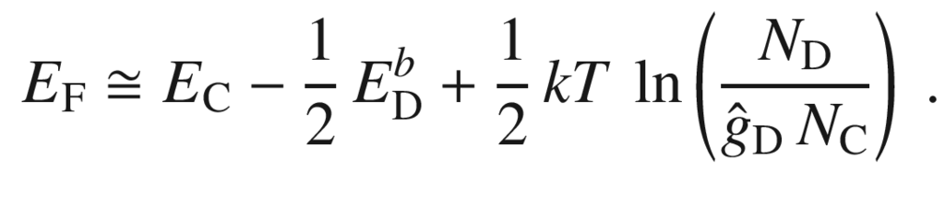

(7.31)

The freeze-out of carriers in n-type silicon has been discussed in detail in [587], taking into account the effects of the fine structure of the donor states. We note that the fairly high donor binding energy in silicon leads to freeze-out of carriers at about 40 K and is thus limiting for the low-temperature performance of devices. Ge has smaller donor ionization energies and subsequently a lower freeze-out temperature of 20 K. For n-type GaAs, conductivity is preserved down to even lower temperatures.

We note that the freeze-out of carriers involves the recombination of free electrons with the ionized donors. This aspect is considered in Sect. [10.​9](The_Physics_of_Semiconductors00005.docx#u116076_4_En_10_Chapter). Microscopically this process is equal to the emission of a (far infrared) photon [588, 589]. Similarly the release of an electron from the donor is due to the absorption of a photon.

For higher temperatures, when the electron density saturates towards

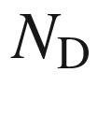

, the approximate solution is (dash-dotted curve in Fig. [7.9](#u116076_4_En_7_Chapter-Fig9)a)

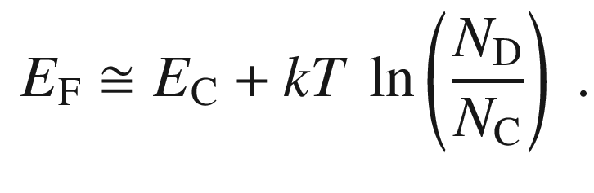

(7.32)

The electron density *n* is given (still in the Boltzmann approximation) by

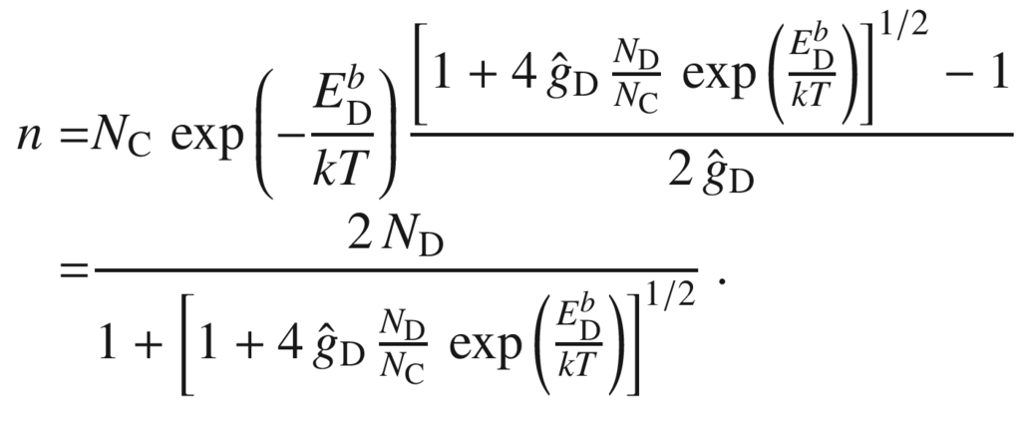

(7.33)

The theoretical electron density as a function of temperature is shown in Fig. [7.9](#u116076_4_En_7_Chapter-Fig9)b. It fits very well to experimental data for arsenic doped germanium [594] as shown in Fig. [7.10](#u116076_4_En_7_Chapter-Fig10) (Arrhenius plot,

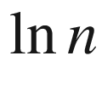

vs. 1/*T*).

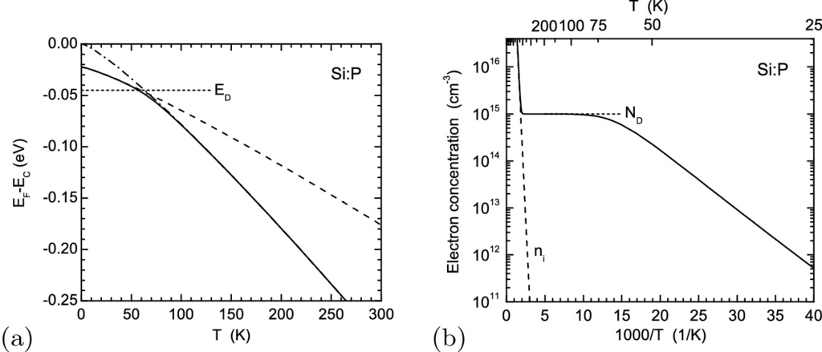

Fig. 7.9

**a** Position of the Fermi level in Si:P (

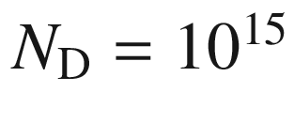

 cm

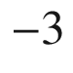

,

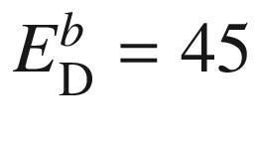

 meV, no acceptors) as a function of temperature *without* consideration of intrinsic carriers. Zero energy refers to the (temperature-dependent, Table [6.​4](#u116076_4_En_6_Chapter-Tab4)) conduction-band edge

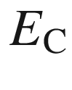

with approximative solutions for low (*dashed line*, ([7.31](#u116076_4_En_7_Chapter-Equ33))) and high (*dash-dotted line*, ([7.32](#u116076_4_En_7_Chapter-Equ34))) temperatures. **b** Corresponding density of conduction-band electrons as a function of temperature

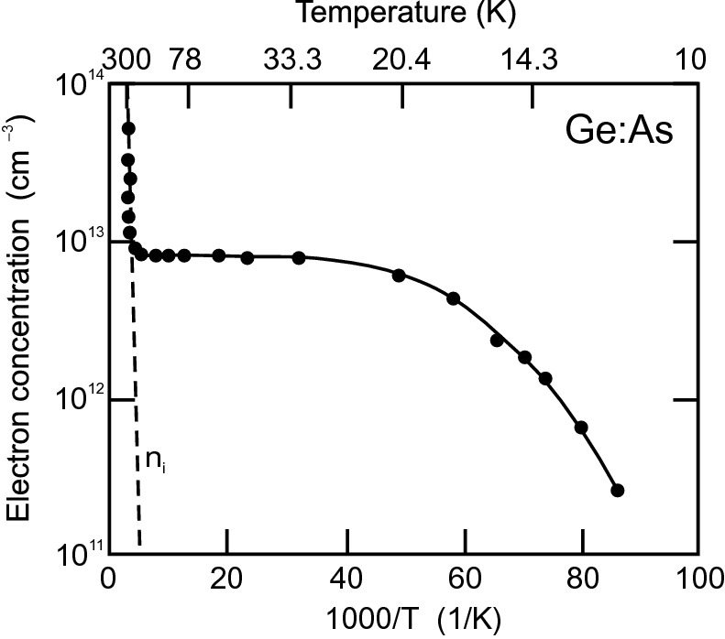

Fig. 7.10

Electron concentration as a function of temperature for a Ge:As sample with

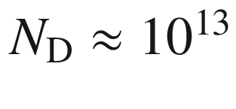

 cm

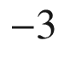

. *Solid line* is fit to the data with a donor binding energy of 12.7 meV.

Adapted from [594]

For low temperatures, the solution ([7.34](#u116076_4_En_7_Chapter-Equ36)) is close to

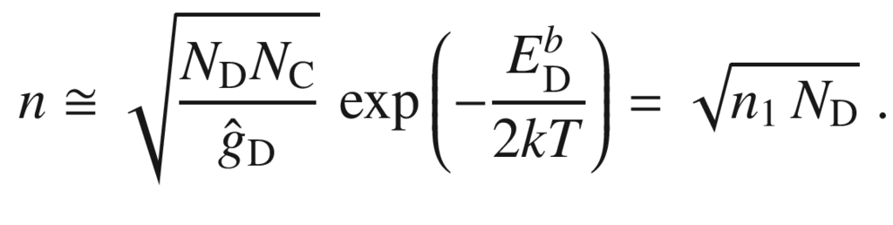

(7.34)

For high temperatures,

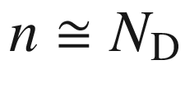

. This regime is called *exhaustion* or *saturation* since all possible electrons have been ionized from their donors. We note that even in this case

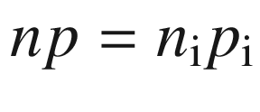

holds, however,

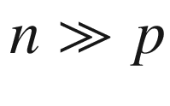

.

While the characteristic energy for the ionization of electrons from donors is



, at high enough temperatures electrons are transferred also from the valence band into the conduction band. Thus, in order to make the above consideration valid for all temperatures, the intrinsic conduction also has to be considered. The neutrality condition (still in the absence of any acceptors) is

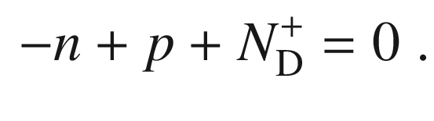

(7.35)

Using ([7.10](#u116076_4_En_7_Chapter-Equ10)) and

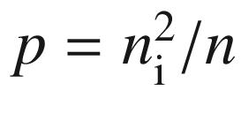

, the equation reads:

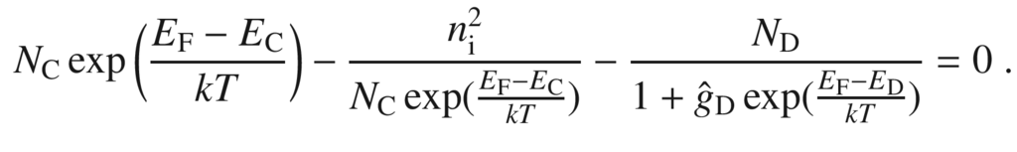

(7.36)

The solution can be given analytically but is more complicated[4](The_Physics_of_Semiconductors00004.docx#u116076_4_En_7_Chapter-Fn4). The temperature-dependent position of the Fermi level is shown in Fig. [7.11](#u116076_4_En_7_Chapter-Fig11).

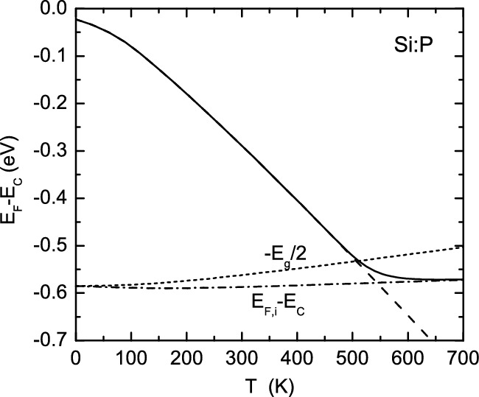

Fig. 7.11

Position of the Fermi level in Si:P (

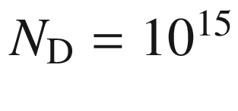

 cm

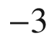

,

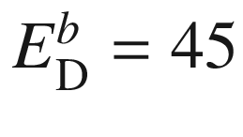

 meV, no acceptors) as a function of temperature. The temperature dependence of the band gap (as given in Table [6.​4](#u116076_4_En_6_Chapter-Tab4)) has been taken into account. Zero energy refers to the conduction-band edge for all temperatures. The *dotted curve* shows

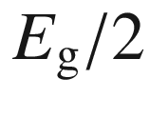

. The *dashed* (*dash-dotted*) *line* shows the low- (high-) temperature limit according to ([7.31](#u116076_4_En_7_Chapter-Equ33)) and ([7.18](#u116076_4_En_7_Chapter-Equ18)), respectively. The corresponding electron concentration as a function of temperature is shown in Fig. [7.9](#u116076_4_En_7_Chapter-Fig9)b

The three important regimes are the intrinsic conduction at high temperatures when

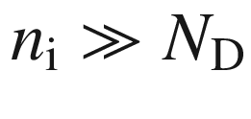

, the exhaustion at intermediate temperatures when

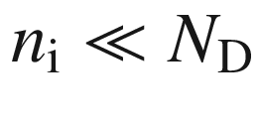

and

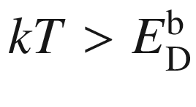

, and finally the freeze-out regime for

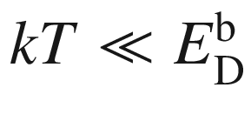

at low temperatures when the electrons condense back into the donors. The three regimes can be seen in the experimental data on carrier density of electrons in n-Ge (Fig. [7.10](#u116076_4_En_7_Chapter-Fig10)) and of holes in p-Ge (Fig. [7.15](#u116076_4_En_7_Chapter-Fig15)).

A similar plot as in Fig. [7.11](#u116076_4_En_7_Chapter-Fig11) is shown in Fig. [7.12](#u116076_4_En_7_Chapter-Fig12) but for different doping levels. With increasing temperature, the Fermi level shifts from close to the band edge towards the band center. At higher doping, this shift begins at higher temperatures.

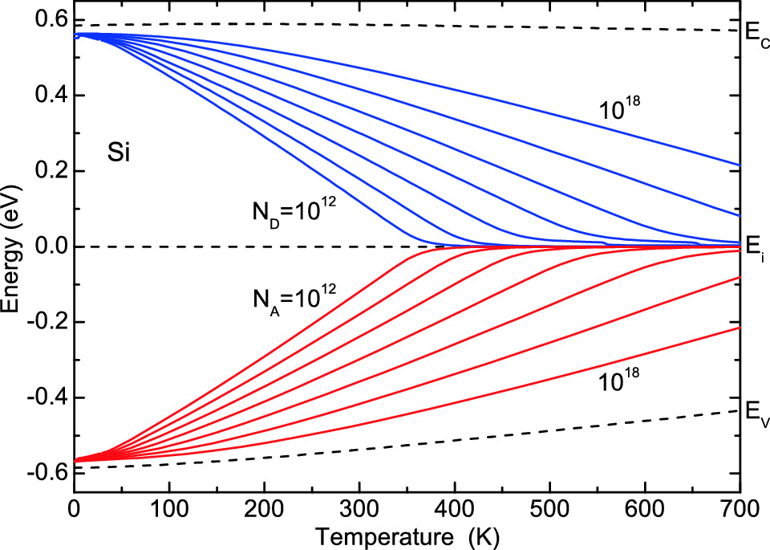

Fig. 7.12

Fermi level in silicon as a function of temperature for various doping levels (n-type (*blue lines*) and p-type (*red lines*)) of

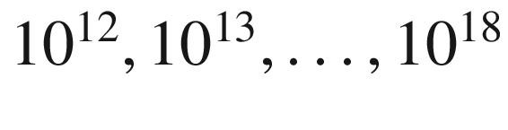

 cm

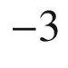

. The intrinsic Fermi level is chosen as zero energy for all temperatures. The (temperature-dependent) conduction and valence band edges are shown as *dashed lines*

The electronic states of individual donors can be directly visualized by scanning tunneling microscopy (STM) as shown in Fig. [7.13](#u116076_4_En_7_Chapter-Fig13) for Si:P. For small negative bias, tunneling occurs through the charged dopant that is located within the first three monolayers. At high negative bias the large contribution from the filled valence band masks the effect of the donor. This image, however, shows that the contrast attributed to the dopant atom is not due to surface defects or absorbates.

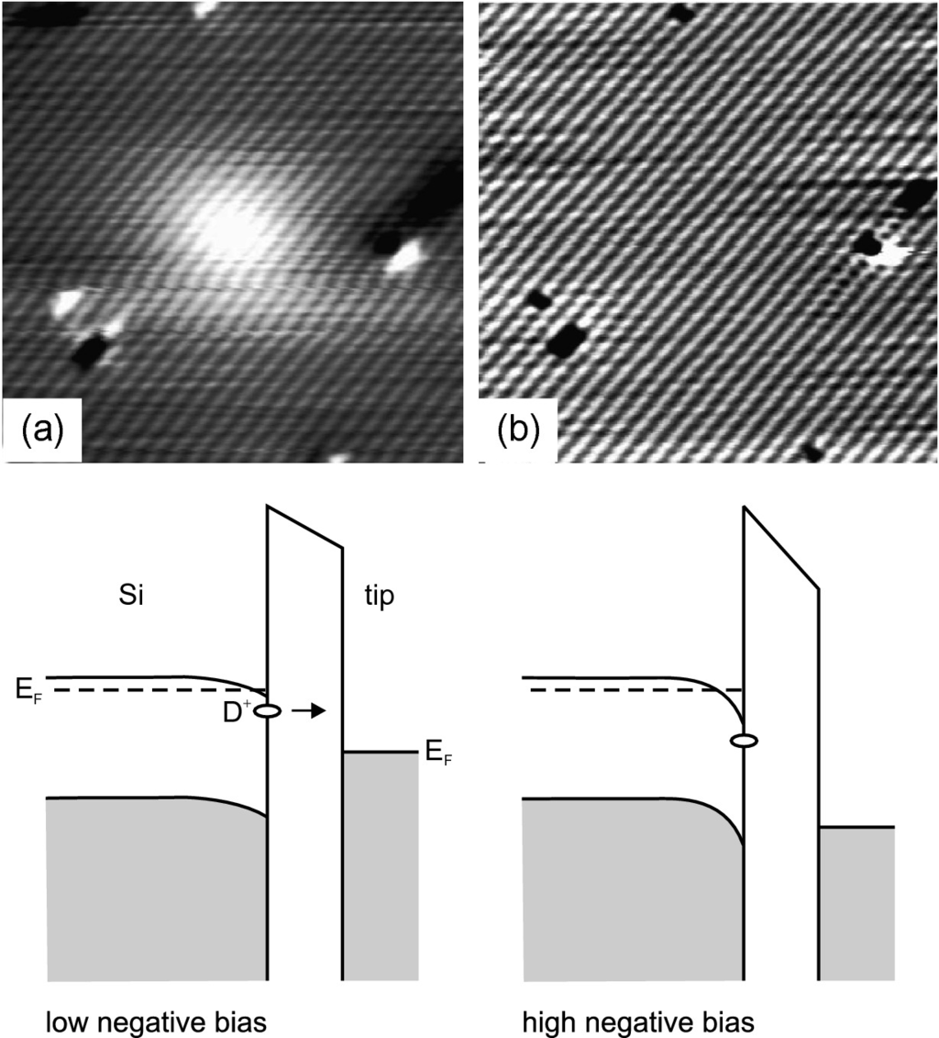

Fig. 7.13

Filled-state image of a phosphorus atom underneath a Si (001) surface at a tunneling current of 110 pA. The doping level is

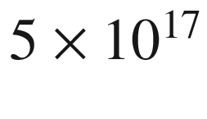

 cm



. **a** Sample bias

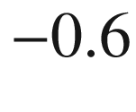

 V, **b** sample bias

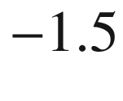

 V between Si:P and tip. Image sizes are

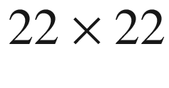

 nm

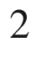

.

Reprinted with permission from [595], ©2004 APS. *Lower row* under parts **b**, **c**: Schematic band diagrams for the two bias situations

#### 7.5.2 Acceptors

A group-III atom in Si has one electron too few for the tetrahedral bond. Thus, it ‘borrows’ an electron from the electron gas (in the valence band) and thus leaves a missing electron (termed hole) in the valence band (Fig. [7.14](#u116076_4_En_7_Chapter-Fig14)). The energy level of the impurity is in the gap close to the valence-band edge. The latter consideration is made in the electron picture. In the hole picture, the acceptor ion has a hole and the hole ionizes (at sufficient temperature) into the valence band. After ionization the acceptor is charged negatively. Also, for this system a hydrogen-like situation arises that is, however, more complicated than for donors because of the degeneracy of the valence bands and their warping.

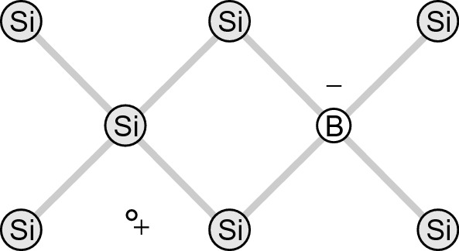

Fig. 7.14

Boron impurity in silicon. Boron accepts one electron and a fixed negative charge remains

In Table [7.4](#u116076_4_En_7_Chapter-Tab4) the acceptor binding energies

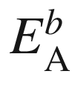

for group-III atoms in C, Ge and Si are listed. The absolute acceptor energy is given as

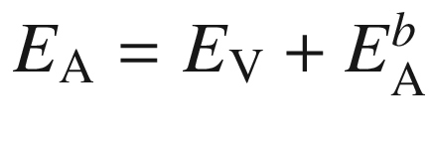

. In Table [7.5](#u116076_4_En_7_Chapter-Tab5) acceptor binding energies are listed for GaAs, GaP and GaN. While in GaAs some acceptors are close to the effective mass value of 27 meV, in GaP the deviation from the effective-mass value



50 meV is large.

When the conductivity is determined by holes or electrons, the material is called p-type or n-type,  respectively. We note that some metals also show hole conduction (e.g. Al). However, for metals the conductivity type is fixed, while the same semiconductor can be made n- or p-type with the appropriate doping.Table 7.4

Binding energies

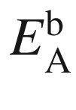

of group-III acceptors in elemental semiconductors. Data for diamond from [596, 597]. All values in meV

|  | B | Al | Ga | In |
| --- | --- | --- | --- | --- |
| C | 369 |  |  |  |
| Si | 45 | 57 | 65 | 16 |
| Ge | 10.4 | 10.2 | 10.8 | 11.2 |

Table 7.5

Binding energies

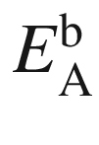

of acceptors in GaAs, GaP and GaN (low concentration values, data from [598, 599]). All values in meV

|  | V site | | III site | |
| --- | --- | --- | --- | --- |
| GaAs | C | 27 | Be | 28 |
| Si | 34.8 | Mg | 28.8 |
| Ge | 40.4 | Zn | 30.7 |
| Sn | 167 | Cd | 34.7 |
| GaP | C | 54 | Be | 57 |
| Si | 210 | Mg | 60 |
| Ge | 265 | Zn | 70 |
| Cd | 102 |
| GaN | C | 230 | Mg | 220 |
| Si | 224 | Zn | 340 |
| Cd | 550 |

The acceptor concentration is denoted by

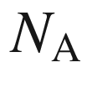

. The concentration of neutral acceptors is

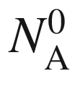

, the concentration of charged acceptors is

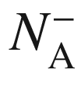

. Of course

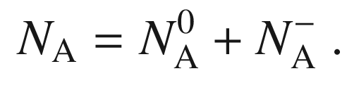

(7.37)

The ratio of the degeneracy of the (singly) filled and empty acceptor level is

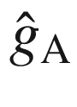

. In Ge

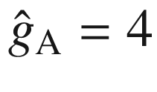

since the localized hole wave function may be formed in EMA with four Bloch wave functions (heavy and light holes) [600]. For Si with its small split-off energy (Table [6.​6](#u116076_4_En_6_Chapter-Tab6))

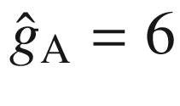

according to [601]. For doubly ionized acceptors, e.g. Zn in Si and Ge (see Sect. [7.7.3](The_Physics_of_Semiconductors00004.docx#u116076_4_En_7_Chapter-Sec19)), the more shallow level (Zn

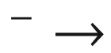

Zn

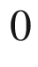

) has

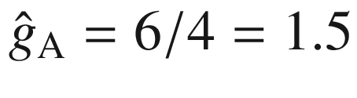

in Ge [601]. A more general discussion of the degeneracy factor for multiply charged acceptors can be found in [585, 602]. Similar to the considerations for electrons and donors we have

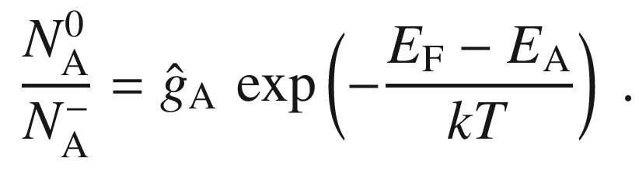

(7.38)

The population of the acceptor levels is given by

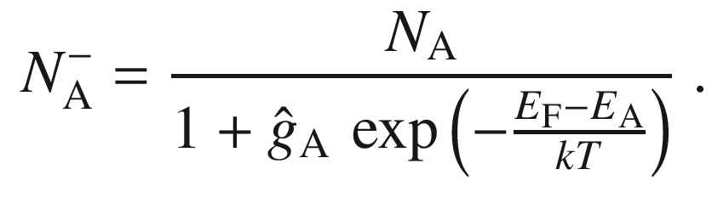

(7.39)

The formulas for the position of the Fermi level and the hole density are analogous to those obtained for electrons and donors and will not be explicitly given here. The analogue to Fig. [7.11](#u116076_4_En_7_Chapter-Fig11)b is shown for data on p-doped Ge [603, 604] in Fig. [7.15](#u116076_4_En_7_Chapter-Fig15). The acceptor activation energy is 11 meV which could be due to various impurities (cf. Table [7.4](#u116076_4_En_7_Chapter-Tab4)). The different impurities (B, Al, Ga) can be distinguished by photothermal ionization spectroscopy [604] (cmp. Sect. [9.​8](The_Physics_of_Semiconductors00004.docx#u116076_4_En_9_Chapter)).

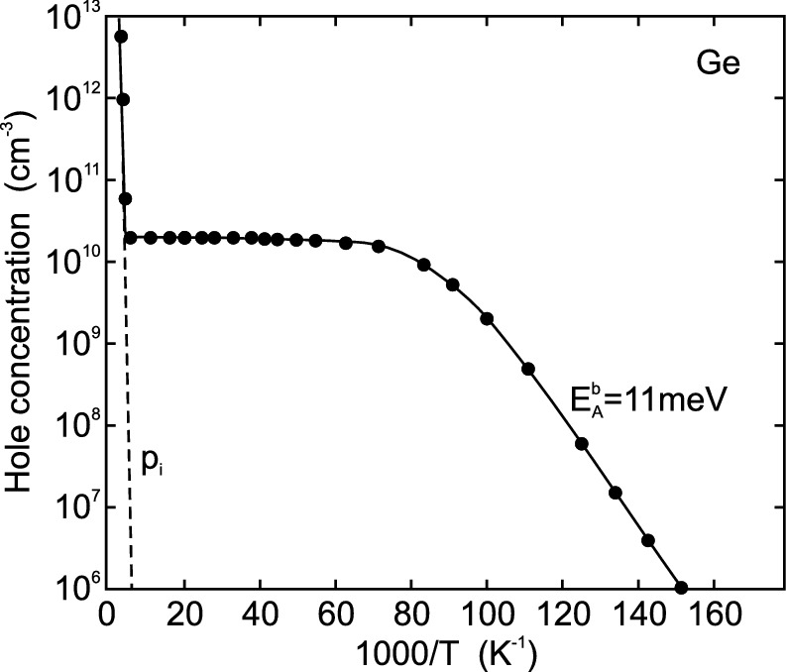

Fig. 7.15

Carrier concentration as a function of temperature for p-type Ge. The net shallow level concentration is

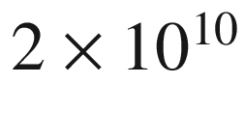

 cm



. *Solid line* is fit to the data, the *dashed line* indicates the intrinsic hole concentration

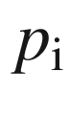

.

Adapted from [604]

In Fig. [7.12](#u116076_4_En_7_Chapter-Fig12), the temperature dependence of the Fermi level is included for p-type Si. With increasing temperature the Fermi level shifts from the valence-band edge (For

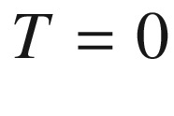

,

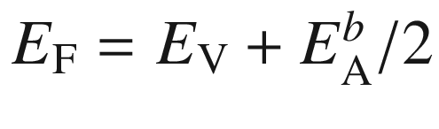

) towards the middle of the band gap  (intrinsic Fermi level).

Also, the wavefunction at acceptors can be imaged using scanning tunneling microscopy [605]. In [606] images of ionized and neutral Mn in GaAs have been reported (Fig. [7.16](#u116076_4_En_7_Chapter-Fig16)b). The tunneling *I*–*V* characteristics are shown in Fig. [7.16](#u116076_4_En_7_Chapter-Fig16)a. At negative bias, the acceptor is ionized and appears spherically symmetric due to the effect of the A

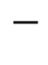

ion Coulomb potential on the valence-band states. At intermediate positive voltages, tunneling is through the neutral state. The wavefunction of A

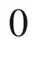

looks like a bow-tie due to the admixture of d-wavefunctions [607]. The Mn atom is presumably in the third subsurface atomic layer. At even higher positive bias the contrast due to the dopant is lost because the image is dominated by a large tunneling current from the tip to the empty conduction band.

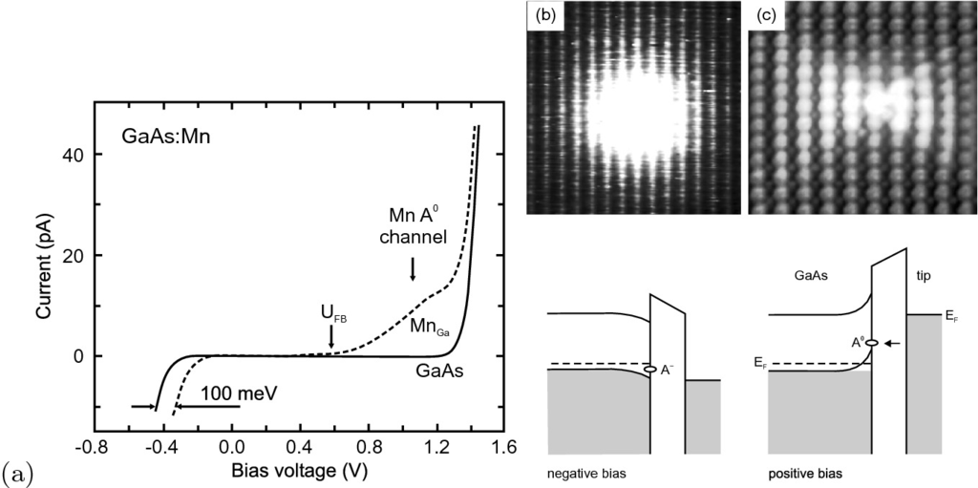

Fig. 7.16

**a** Tunneling *I*–*V* characteristic of GaAs:Mn sample. *Solid* (*dashed*) line is for pure GaAs (subsurface Mn on Ga site).

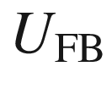

denotes the simulated flat-band voltage. Adapted from [606]. (**b**, **c**) STM images of a Mn atom underneath a GaAs (110) surface. The doping level is

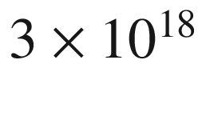

 cm



. **b** Sample bias

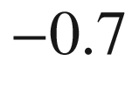

 V, **c** sample bias

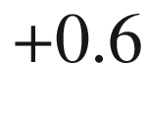

 V. Below the images are schematic band diagrams of GaAs:Mn and tip. Image sizes are **b**

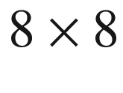

 nm



and **c**

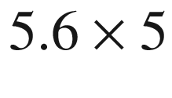

 nm



.

Reprinted with permission from [606], ©2004 APS. *Lower row* under parts **a**, **b**: Schematic band diagrams for the two bias situations

#### 7.5.3 Compensation

When donors *and* acceptors are simultaneously present, some of the impurities will compensate each other. Electrons from donors will recombine with holes on the acceptors. Depending on the quantitative situation the semiconductor can be n- or p-type. This situation can be invoked by intentional doping with donors or acceptors or by the unintentional background of donors (acceptors) in p-doped (n-doped) material. Also the formation of pairs, exhibiting a new defect level different from the single donor or single acceptor, has been described, e.g. for Se and B in silicon [308].

The charge-neutrality condition (now finally in its most general form) reads

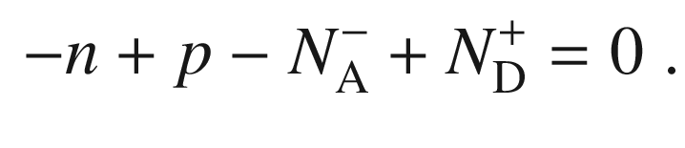

(7.40)

We will now discuss the case of the presence of donors and acceptors, but limit ourselves to sufficiently low temperatures (or wide band gaps) such that the intrinsic carrier density can be neglected. We assume Boltzmann statistics and assume here

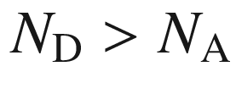

. Then it is a very good approximation to use

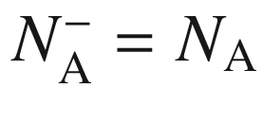

since there are enough electrons from the donors to recombine with (and thus compensate) all acceptors. Under the given assumptions regarding the temperature

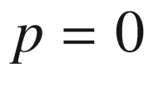

and the material is n-type. Thus, in order to determine the position of the Fermi level, the charge-neutrality condition

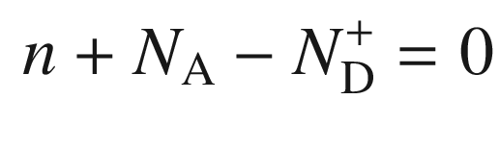

(7.41)

must be solved (compare to ([7.29](#u116076_4_En_7_Chapter-Equ31)))

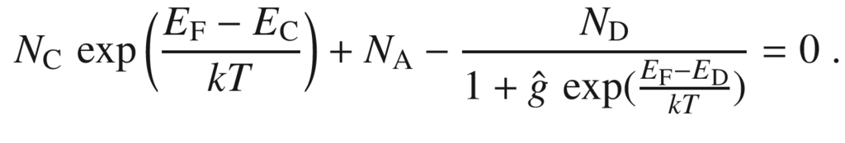

(7.42)

We rewrite ([7.41](#u116076_4_En_7_Chapter-Equ43)) and find

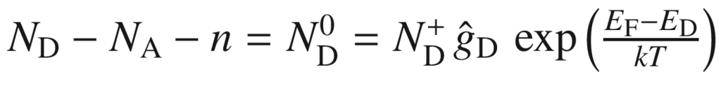

using ([7.26](#u116076_4_En_7_Chapter-Equ27)). Using again ([7.41](#u116076_4_En_7_Chapter-Equ43)) and also ([7.10](#u116076_4_En_7_Chapter-Equ10)), ([7.42](#u116076_4_En_7_Chapter-Equ44)) can be written as

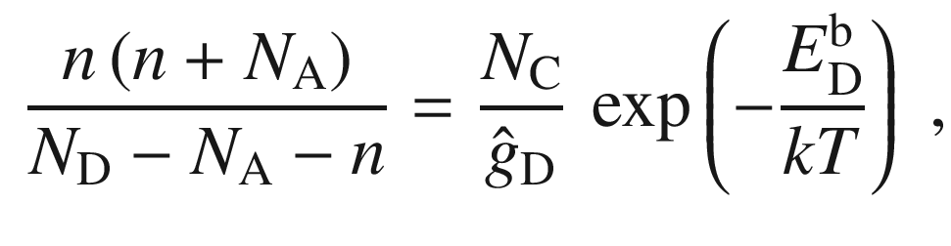

(7.43)

a form given in [608]. Analogously for compensated p-type material

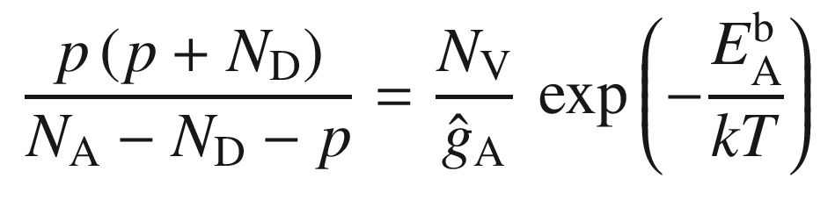

(7.44)

holds.

The solution of ([7.42](#u116076_4_En_7_Chapter-Equ44)) is

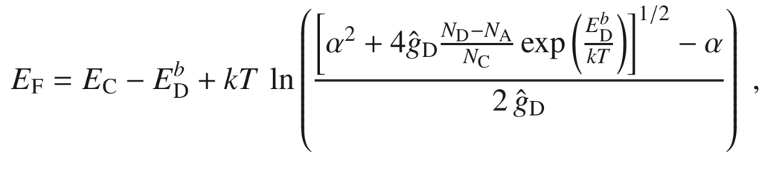

(7.45)

with

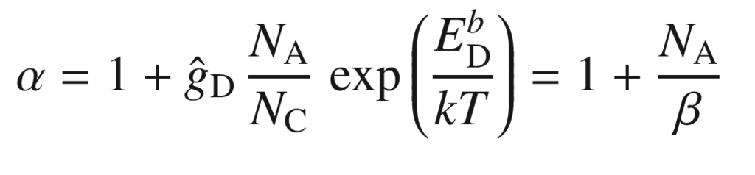

(7.46a)

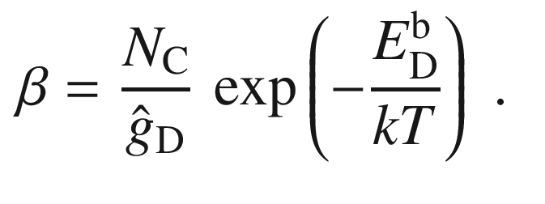

(7.46b)

The carrier density is best obtained from ([7.43](#u116076_4_En_7_Chapter-Equ45)),

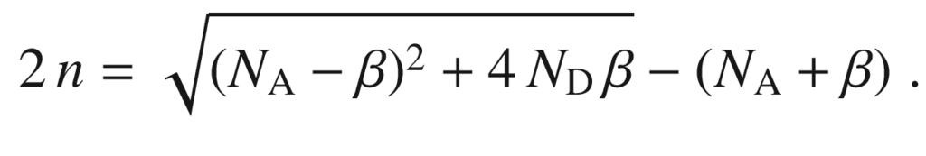

(7.47)

For

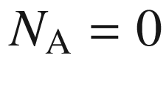

we have

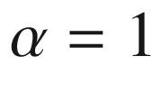

and ([7.30](#u116076_4_En_7_Chapter-Equ32)) is reproduced, as expected. For

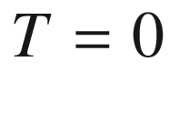

(and

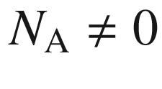

) the Fermi energy lies at

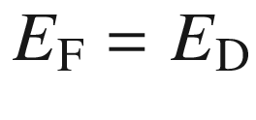

since the donor level is *partially* filled (

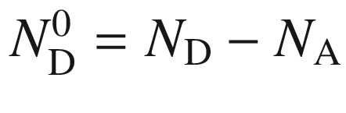

). For low temperatures the Fermi level is approximated by

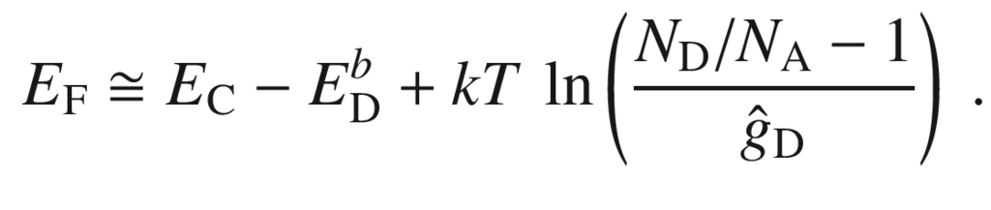

(7.48)

The corresponding carrier density at low temperatures is

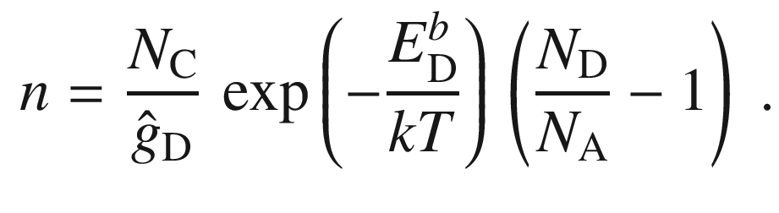

(7.49)

For higher temperatures ([7.34](#u116076_4_En_7_Chapter-Equ36)) holds approximately for

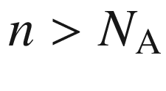

; the slope is now given by

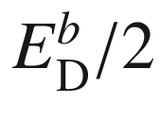

as in the uncompensated case (Fig. [7.17](#u116076_4_En_7_Chapter-Fig17)b). For sufficiently high temperatures in the exhaustion regime (but still

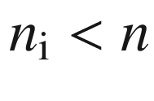

) the electron density is given by

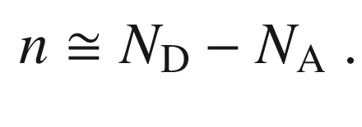

(7.50)

At even higher temperatures the electron density will be determined by the intrinsic carrier concentration. Only in this case

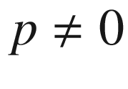

!

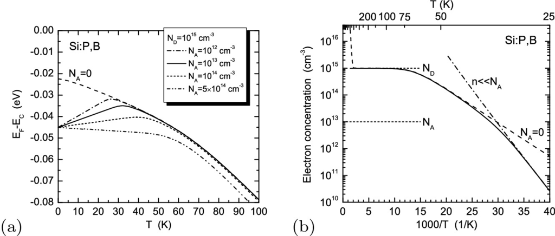

Fig. 7.17

**a** Position of Fermi level in partially compensated Si:P,B (

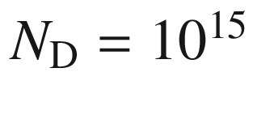

 cm



,

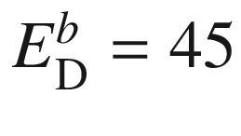

 meV,

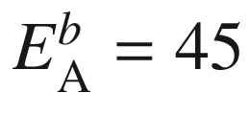

 meV, *solid line*:

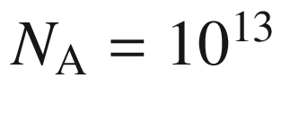

 cm

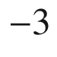

, *dashed line*:

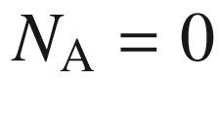

, *dash-dotted line*:

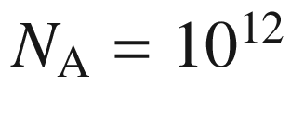

 cm

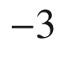

, *short-dashed line*:

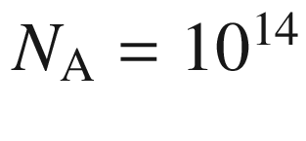

 cm



, *dash-double dotted line*:

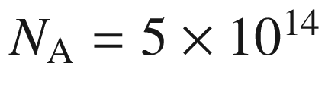

 cm



) as a function of temperature. **b** Corresponding electron concentration for

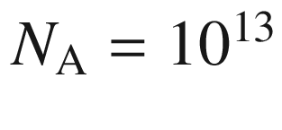

 cm



as a function of temperature (neglecting intrinsic carriers), *dashed line* for



according to ([7.34](#u116076_4_En_7_Chapter-Equ36)), *dash-dotted line* approximation for

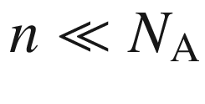

as in ([7.49](#u116076_4_En_7_Chapter-Equ52))

An experimental example is shown in Fig. [7.18](#u116076_4_En_7_Chapter-Fig18) for partially compensated p-Si (with

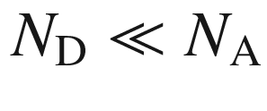

). The change of slope around

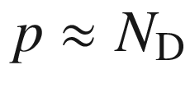

is obvious.

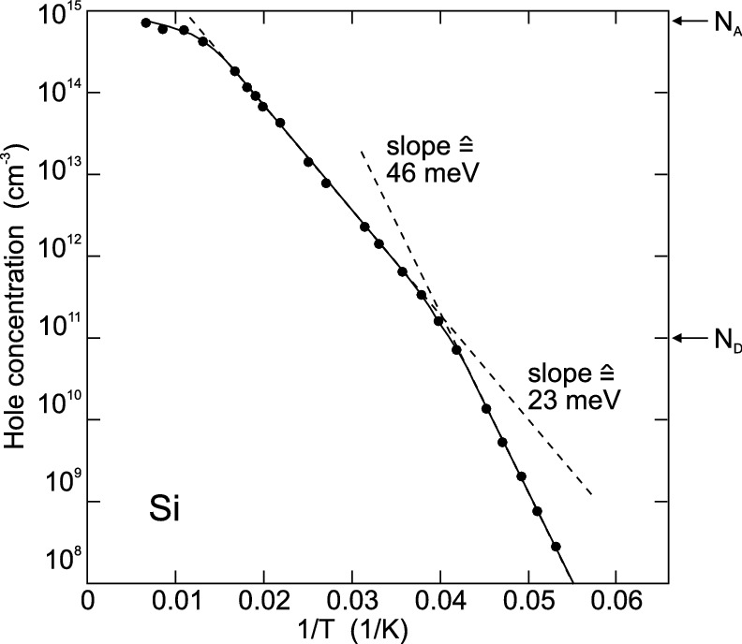

Fig. 7.18

Hole density in p-type silicon (

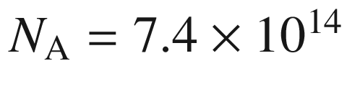

 cm



,

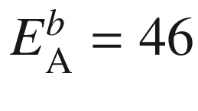

 meV (probably boron) and partial compensation with

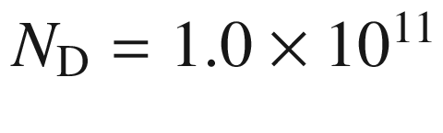

 cm



).

Adapted from [609]

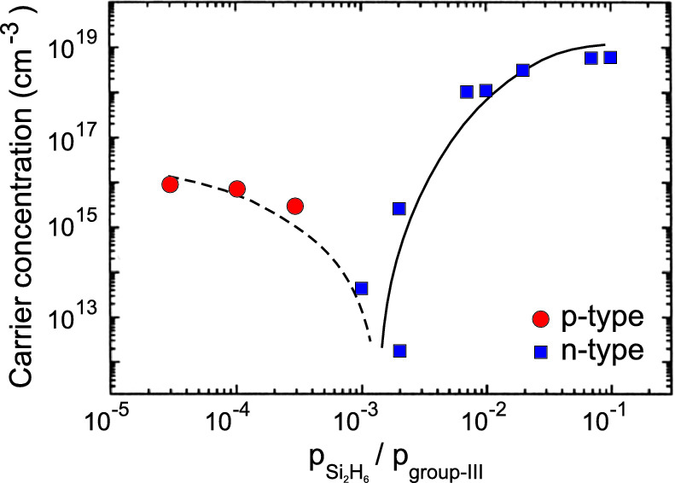

Fig. 7.19

Carrier concentration and conductivity type (*red circles*: p, *blue squares*: n) for MOVPE-grown In

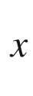

Ga

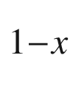

As

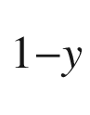

N

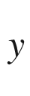

layers on GaAs (001) (layer thickness

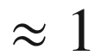

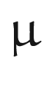

m,

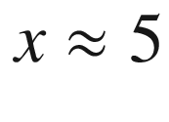

%,

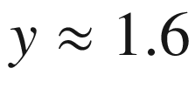

%) doped with different amounts of silicon. The ordinate is the ratio of the partial pressures of disilane and the group-III precursors (TMIn and TMGa) in the gas phase entering the MOVPE reactor. *Lines* are guides to the eye.

Experimental data from [610]

If donors are added to a p-type semiconductor, first the semiconductor remains p-conducting as long as

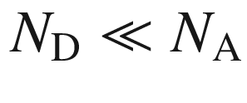

. If the donor concentration becomes larger than the acceptor concentration, the conductivity type switches from p- to n-conduction. If the impurities are exhausted at room temperature, the lowest carrier concentration is reached for

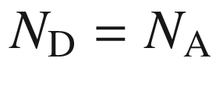

. Such a scenario is shown for p-type In

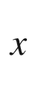

Ga

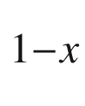

As

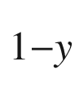

N

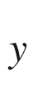

doped with various concentrations of Si in Fig. [7.19](#u116076_4_En_7_Chapter-Fig19). At high Si incorporation, the number of charge carriers saturates due to autocompensation (see Sect. [7.5.5](The_Physics_of_Semiconductors00004.docx#u116076_4_En_7_Chapter-Sec12)) and the formation of Si precipitates. Since the ionization energies of donors and acceptors are typically different, the situation for

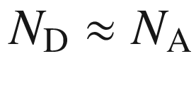

needs, in general, to be investigated carefully and will depend on the temperature.

#### 7.5.4 Multiple Impurities

If more than one donor species is present, ([7.42](#u116076_4_En_7_Chapter-Equ44)) can be generalized, e.g. for the case of two donors D1 and D2 in the presence of compensating acceptors,

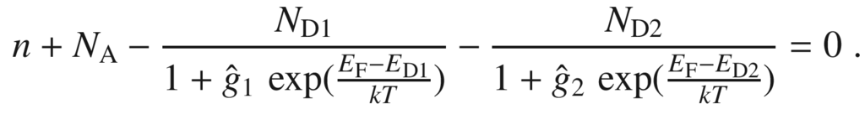

(7.51)

This case is treated in [611]. Simple high and low temperature approximations can be found where the trap with the larger and smaller activation energy, respectively, dominates. The case for multiple acceptors (and compensating donors) is treated analogously. As detailed in [612], the function

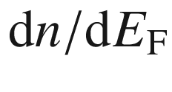

has a maximum at the donor level position; this can be used to visualize the contribution of several donors (with sufficiently different binding energies) from *n*(*T*) as measured by Hall effect (Fig. [7.20](#u116076_4_En_7_Chapter-Fig20)).

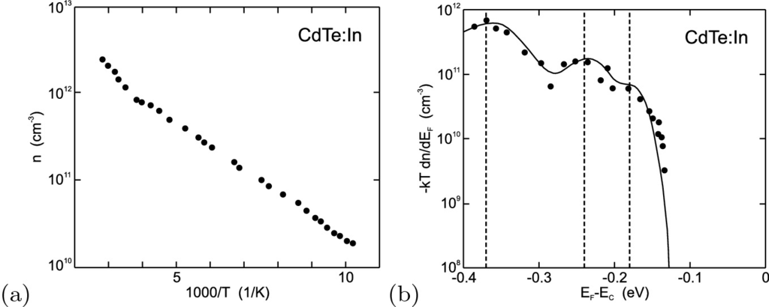

Fig. 7.20

**a** Electron concentration versus temperature as determined from Hall effect for a CdTe sample doped with indium. **b**

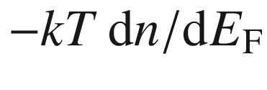

, as determined from the experimental Hall data (*symbols*). The *solid line* is theory for three donor levels (

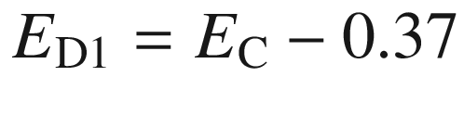

 eV,

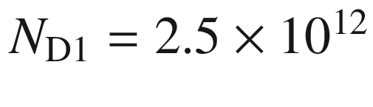

 cm



;

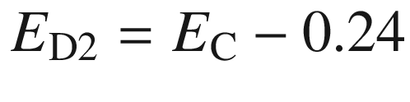

 eV,

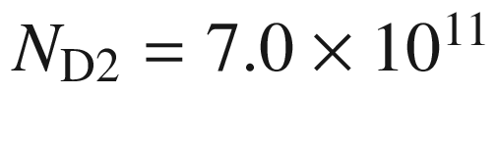

 cm



;

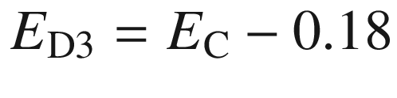

 eV,

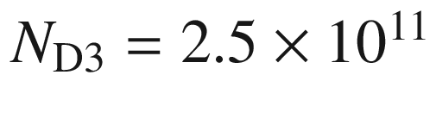

 cm



) whose energy positions are indicated by *dashed lines*.

Adapted from [612]